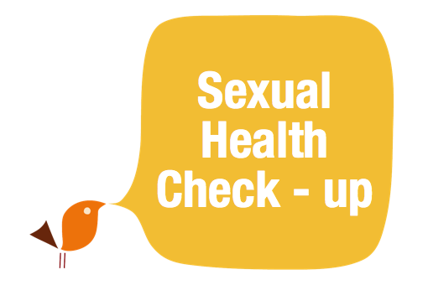

Did you know you can have a
sexual health check-up
without
needing an intimate
examination?
Bangor clinic | Mon 9:30am - 12pm
Downpatrick clinic | Mon 8:50am - 12pm  Wed 3pm - 6:30pm  Fri 8:30am - 12pm
Your local Sexual Health Clinic

Call to book an appointment on:
028 44838133
Patient
Information
What’s involved in an STI screen?

A basic STI check up includes tests for chlamydia, gonorrhoea, HIV and syphilis. These are checked by sending a blood and urine sample or self-taken
vaginal swab to the laboratory.

How soon after unprotected sex can I be checked?

Some infections have different incubation periods and some tests are also only reliable after a certain length of time. In
general, if you do not have any symptoms it would be best to wait until at least two weeks
after your last unprotected sex before having a check up.
However, you may also be
advised to repeat the syphilis and HIV test in another 3 months to make sure the result is reliable.
How soon will I get my results?

It may take up to 2 weeks for all of your results to be available and your doctor or nurse should discuss how these will be communicated to you. It is important that you provide
reliable contact details and give your clinic permission to contact you.

What happens if any of the test results are positive?

In the event of any positive result, our primary concern will be for your health and well being. You may be able to get treatment from your GP for some infections, including
Chlamydia. However, positive results for gonorrhoea, HIV or syphilis will be referred to your local
genitourinary clinic (GUM) where experienced staff will provide
treatment, advice and support. If you are treated for a sexually
transmitted infection it is important that relevant sexual partners are also advised and treated. Staff will discuss this with you and help you to find the best way to inform sexual
partners. We will make every effort

to protect your confidentiality. The only exception to this would be if something indicated that
you or someone else continued to be at risk of harm.

IF YOU HAVE TESTED POSITIVE

If you test positive for
Chlamydia or gonorrhoea it is very important that you avoid sexual contact for one week
following your treatment with antibiotics. If you are in a
relationship your partner must be treated as well. You must then ensure that you both avoid
sexual contact for one week
after your partner’s treatment date.

For further advice speak to your local GP or practice nurse or contact the sexual health advice nurse on 028 4483 8392.

