Workplace COVID-19 Risk Assessments – Mereside Medical Services
Risk assessments carried out: 22 May 2020. COVID-19 risk assessments will be reviewed whenever there is any change to government guidance or knowledge of risks around transmission modalities and rates.

These workplace risk assessments follow the 4x4 risk ranking matrix:

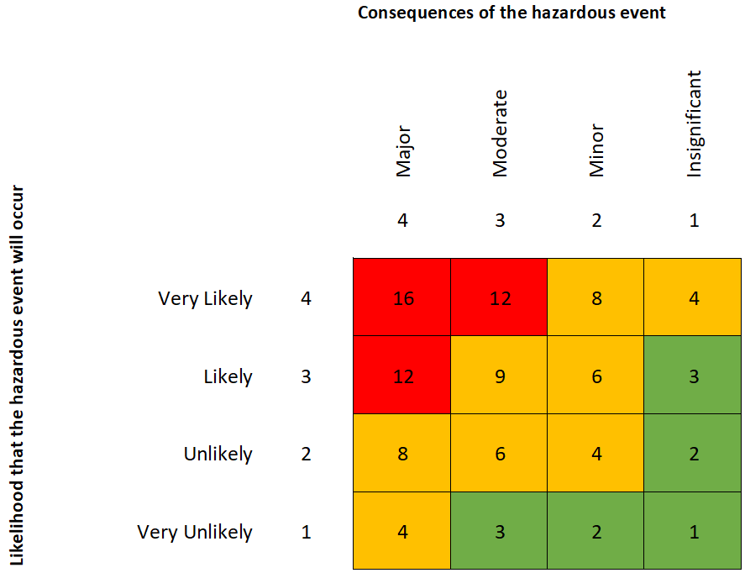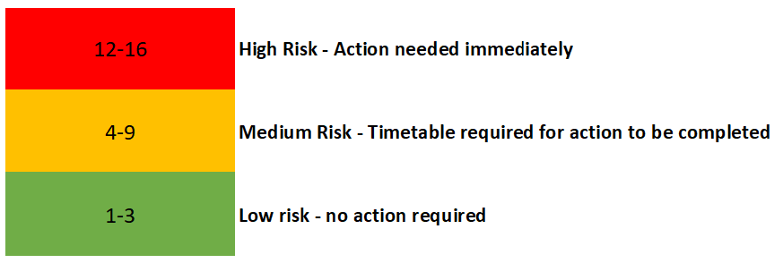

Company name: Mereside Medical Services Site: Cathedral Medical Centre Date of assessment: 22 May 2020
Risk No. | What are the hazards? | Who might be harmed and how? | What are you already doing? | Risk Rating |  | Score | Do you need to do anything else to control this risk? | Action by who? | Action by when?
 |  |  |  | Likelihood | Impact
1 | COVID-19 – social distancing patients | Staff could contract Covid-19 from patients, or patients could transmit to each other | - Different entrance for patients with respiratory symptoms  - Only running F2F appointments where clinically necessary  - Spacing of chairs in waiting area  - Hand hygiene – sanitiser available  - Regular cleaning of communal areas and high frequency contact areas (door handles, etc)  - PPE as per protocol | 1 | 3 | 3 | Perspex screen to be added to reception window 1 to protect patients and staff when patients come into the practice  All staff to remain vigilant to ensure risk reduction activities are maintained | Assistant PM  All staff
2 | COVID-19  Social Distancing  Admin Area | Staff and visitors (e.g. delivery personnel) could contract COVID-19 from staff | - All staff risk assessed using NHS risk reduction framework; at risk staff to work remotely or be non-patient-facing  - Limit number of staff in the building to only those required in the building to carry out work; all other staff to work remotely  - Occupied workstations >2m apart  - Regular cleaning of work areas  - Regular hand washing  - Maximize ventilation  - Symptomatic staff are tested for COVID-19 and follow self-isolation guidelines | 1 | 2 | 2 | Poster to display reminder re cleaning and hand washing  All staff to remain vigilant to ensure risk reduction activities are maintained | Assistant PM  All staff
3 | COVID-19  Social Distancing  Clinical Area | Staff could contract COVID-19 from patients  Patients could contract COVID-19 from staff / other patients | - All staff risk assessed using NHS risk reduction framework; at risk staff to work remotely or be non-patient-facing  - Limit number of staff in the building to only those required in the building to carry out work; all other staff to work remotely  - Specific clinic rooms for routine and Isolation work.  - Appointments spaced to ensure no more than 4 patients waiting at any one time  - Higher risk patients to use a separate entrance to the building  - Higher risk patients to be provided masks to wear on entry to building  - Cleaning schedule for rooms after consultation  - PPE as per protocol for all staff seeing patients  - Cleaning schedule of waiting areas  - Symptomatic staff are tested for COVID-19 and follow self-isolation guidelines | 2 | 2 | 4 | Perspex screen to be added to reception window 1 to protect patients/staff when patients come into the practice  Perspex screen to be added between reception desks 3 and 4  Remind clinicians of cleaning schedule  All staff to remain vigilant to ensure risk reduction activities are maintained | Assistant PM  Assistant PM  Assistant PM  All staff

Review: Whenever there is any change to government guidance or knowledge of risks around transmission modalities and rates.

