St Isan Road Surgery
46 St Isan Road, Heath, Cardiff, CF14 4UU Tel: (029) 2061 2333 Fax: (029) 2052 2886
Website: www.stisanroadsurgery.co.uk
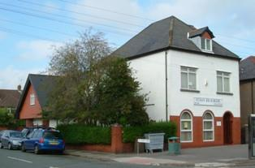

Dr NPT Mcloughlin MB BCh MRCGP, Dr M Bagshaw MB BS MRCGP,
Dr B Brooks MB BCh MRCGP, Dr I Williams MB BCh MRCGP

Request for a My Health Online Account

My Health Online is a new online service brought to you from NHS Wales. My Health Online offers patients the convenience to book appointments and request repeat prescriptions using the internet.

If you wish to register to use My Health Online please fill in the boxes below.

Please set up a My Health Online Account and issue me with a letter containing my account details.
Full Name
Date of Birth
Address

Phone Number |  | Email :
Signature |  | Date:

The following sections to be completed by practice staff.
Practice Checklist
The following checks should be completed before a patient can receive access to My Health Online.
- Patient’s identity verified by document (drivers licence/passport)
Details of documents checked and added to the GP system
- Patient’s name and date of birth checked on this form and updated on the clinical system. (if necessary)
- Registration process and next steps to registration explained
- Patient Guide and Frequently Asked Questions provided to patient
- Advise patients to register their online account over the next 24 – 48 hours

