PARKGROVE
AND
EAST CRAIGS MEDICAL PRACTICE

EAST CRAIGS MEDICAL CENTRE
10 BUGHTLIN MARKET
EDINBURGH TEL: 0131 339 6670
EH12 8XP FAX: 0131 317 8629

PARKGROVE MEDICAL CENTRE
22B PARKGROVE TERRACE
EDINBURGH TEL: 0131 312 6600
EH4 7NX FAX: 0131 312 7798

Partners
Dr Anne Curtis

Dr David Crookes
Dr Rose Haining

Dr Adrian Cullen
Dr Louise Dixon
Dr Richard Stewart
Dec 2014

HOME VISITS
If you are disabled, or too ill to attend the medical centre you may request a home visit. If it is not an emergency, please telephone before 10.00am if possible. The receptionist may ask for some details to determine the urgency of the request. The Doctor may phone you back to ask for more information and to decide if a visit is necessary.
YOU CAN HELP US BY:
- Being on time for your appointment
- Letting us know if you need to cancel
- Calling for a home visit or urgent appointment before 10am
- Ringing for results between 11-12 & 3-5

REPEAT PRESCRIPTIONS
If you are on regular treatment you may be given a prescription check sheet listing your medicines. Repeat prescriptions can be ordered by ticking the items required and either posting it in the red box beside reception, faxing it to the surgery or posting to the surgery with a stamped addressed envelope for reply. Please allow 48 hours for the prescription to be prepared. Because of the very large numbers of patients requiring repeat prescriptions, and to avoid mistakes being made, telephone requests for prescriptions can be accepted only in exceptional circumstances. If the medicine you require is not on your repeat list, then you may have to see a doctor to obtain this. This policy reduces the risk of errors. At intervals you may be asked to see a doctor for review of your medicines.

TEST RESULTS
For the results of tests organised by your GP (except cervical smear results) please call personally at the medical centre or telephone between 11-12 & 3-5. Results can normally only be given to the patient involved and not to relatives or friends.
Simple tests e.g. pregnancy test results will be back in 4-5 days. Other results usually take between 7 – 10 days.
Cervical smear results will be posted to you and usually take about 3 –4 weeks.

TELEPHONE CONSULTATIONS
The practice offers telephone appointments for the convenience of our patients. When requesting telephone consultations please ensure the receptionist has current up to date contact details.

NEW PATIENTS
If you live in our practice area and have not yet registered with a local doctor, you may register at East Craigs Medical Centre or Parkgrove Medical Centre. If you are not sure if you are in our practice area, our receptionists will be happy to give you this information. When you come to register, please bring your medical card with you and the cards of any of your family who also wish to register with us. Other documentation may be required, details of which are available at reception.
The receptionist will be happy to advise you – even if you can’t find your medical card. Routine appointments can only be made at the medical centre with which you are registered. You can make an appointment to see any of the doctors in the practice.
We offer a short medical check up to all our new patients and ask you to complete a short questionnaire. This is to help us until your medical records arrive from your previous doctor.
If you will be in our practice area for less than 3 months and do not have a local doctor, we can treat you as a temporary patient, if you are eligible for NHS care.

APPOINTMENTS
All consultations are by appointment only and are usually for 10 minutes. We do try to run on time, however, if a patient has a complex problem or requires an emergency call during the surgery, delays can result. We appreciate your patience should you experience a delay. Consulting hours run from 8.30-10.30am and 3.00 – 5.30pm.

EMERGENCY APPOINTMENTS
If you have a problem that you feel is so urgent that it cannot wait until a routine consultation, please explain this to the receptionist and you will either be given an appointment for the same day or the Duty Doctor will contact you directly. An emergency appointment is for 5 minutes and suitable only for urgent problems. It will not be possible to deal with repeat prescriptions, certificates and review of ongoing problems

OPENING HOURS

EC PG
MONDAY 8.00AM - 6.00PM 8.00AM - 1PM 2PM - 6PM
TUESDAY 8.00AM - 6.00PM 8.00AM - 1PM 2PM - 6PM
WEDNESDAY 8.00AM - 6.00PM 8.00AM - 12.30
THURSDAY 8.00AM - 6.00PM 8.00AM - 1PM 2PM - 6PM
FRIDAY 8.00AM - 6.00PM 8.00AM - 1PM 2PM - 4.00PM

SATURDAY & SUNDAY - CLOSED

Evening Surgery from 6pm – Mondays at East Craigs only. For the convenience of those patients who cannot attend the practice during normal consulting hours due to work commitments.

Thursday - Early morning phlebotomy service from 7.30am at East Craigs

EMERGENCIES WHEN SURGERY IS CLOSED
Please telephone the surgery on 312 6600/339 6670 and you will be given a telephone number to call. . NHS 24 covers our practice when the surgery is closed in the evening and weekends.

Alternatively call NHS 24 on 111

IF THERE IS A LIFE THREATENING EMERGENCY - CALL 999 IMMEDIATELY.

DOCTORS
ANNE CURTIS M.B.Ch.B., (1980) M.R.C.G.P., D.R.C.O.G.
DAVID CROOKES M.B.Ch.B., (1983) M.R.C.G.P., Dip Obs.
ROSE HAINING M.B.Ch.B., (1983) M.R.C.G.P.,
ADRIAN CULLEN M.R.Ch.B., (1989) M.R.C.G.P., D.R.C.O.G., D.C.C.H.
RICHARD STEWART M.B.Ch.B (2006) M.R.C.G.P. 2013 Dip Med Ed 2012
LOUISE DIXON M.B.Ch.B. (1997) D.R.C.O.G. M.R.C.G.P. D.F.F.P.
ABIGAIL HUNTER M.B.Ch.B, (1995) M.R.C.G.P., D.F.F.P.
FIONA REID M.B.Ch.B, (2001) M.R.C.G.P., D.F.F.P., D.R.C.O.G. M.R.C.S.
RICHARD JACK M.R.C.G.P. (2012) M.B.Ch.B.

PRACTICE MANAGER
Jim Aitken

Practice Support Team

Terry Kennedy Reception Margaret Murdoch Reception
Davina Taylor Reception Bea Allan Reception
Shirley Leslie Reception Elaine Young Reception
Alan MacGill Reception Brenda McBride Reception
Liz Thomson I.T. Gail Dewar Reception
Frances Taylor Secretary Kirsty Haldane Admin
Kirsten Fraser Admin Joann Longwell Reception

We feel it is important you know who you are speaking to, so our Reception/Admin staff wear a name badge.

Practice Nurses –Frances Tait, Lorraine Maxwell, Pauline Tang 312 6600 (PG) 339 6670 (EC) Health Care Assistant/Phlebotomist – Gillian Pirret & Alison McMorrin

District Nurses – (at Parkgrove) 312 8210 Philippa Smith, Claire Menzies, Carol Johnston, Veronica Fernandez

Health Visitor Team –Fiona Laing & Lynn Ward- health visitors, Staff Nurse – Kayleigh Stenhouse
East Craigs & Parkgrove 339 5107

PATIENTS RIGHTS AND RESPONSIBILITIES
You will be treated with dignity, courtesy and respect at all times, irrespective of your ethnic origin, religious belief, sex or sexuality, personal attributes or the nature of your health problem.
Our staff have the right to work in an environment free of violence or threats of violence. Any such action from a patient will result in immediate removal from the practice list.

We will:
- Ensure our patients have 24 hour access to medical advice.
- Work in partnership with you to meet your medical needs.
- Give advice on health promotion and illness prevention.

We respectfully ask that you:-
- Be on time for appointments
- Inform the surgery in good time if you are unable to attend.
- Treat all healthcare staff with courtesy and respect.
- Inform the practice and any hospital you are attending of any alterations in your circumstances, such as change of surname, address or telephone number.
- Please ensure we have your correct telephone number, even if it is ex-directory.

OTHER LOCAL NHS SERVICES

As well as our practice, there are many other local NHS services you can
contact for health advice, information and treatment. Before you do, remember that you can treat many minor ailments such as colds, coughs and indigestion by keeping a well-stocked medicine cabinet at home. We suggest you keep the following:-

- Paracetamol and aspirin (children under 16 and people with asthma should not take Aspirin).
- Indigestion remedy (for example, antacids)
- Sunscreen – SP15 or higher
- Sunburn treatment (e.g. moisturiser)

Or see your local community pharmacist for advice

REMEMBER
Keep the medicine chest in a secure, locked place out of reach of small children.
Always read the instructions and use the suggested dose
Watch expiry dates – don’t keep/use medicines past their sell-by date
Take all unwanted and out-of-date medicines back to the pharmacy

LOCAL PHARMACIES
Your local pharmacist is able to give free health advice and you don’t need an appointment.

SERVICES OFFERED
We offer a personal medical service to all of our patients. Some of our services are available during our usual consulting times and some during
special clinics. Please ask our receptionists about any of the following services.

We also offer:
Annual health checks for over 75s
Antenatal and postnatal care
Asthma clinics & COPD clinics
Cervical smears
Child health care
Community Midwives (at East Craigs)
Contraception – including IUCD fitting
Diabetes clinics
Heart disease clinics
Minor surgery (at East Craigs)
Travel advice and vaccinations

NHS 24
For free expert NHS health advice and information 24 hours a day. Telephone 111 Website address: www.nhs24.com
Lothian Health Board have a contract with NHS 24 to cover medical services when this medical centre is closed. To contact them for information on any primary care medical services either write or telephone to:-

PCCO
Pentland House
47 Robb’s Loan
EDINBURGH EH14 1TY
Tel: 0131 537 8419

MINOR INJURIES CLINIC
Walk in service at the Western General Hospital from 9am – 9pm. Minor injuries, sprains, cuts, bites, minor burns. X-ray service below the elbow and below the knee on over 12’s only. No appointments necessary.

FREEDOM OF INFORMATION ACT
We adhere to the FOI (Scotland) Act 2001 and have adopted the BMA model publication scheme. Access to information under this act can be obtained by contacting the Practice Manager.
You have a right to know what information we hold on you. If you would like to see your records a written request should be sent to the Practice Manager. Access and/or photocopies of medical records can be arranged at a fee of £10 – £50.

PATIENT CONFIDENTIALITY & THE EMERGENCY CARE SUMMARY
We respect your right to privacy and keep all your health information confidential and secure. It is important that the NHS keep accurate and up to date records about your health and treatment so that those treating you can give you the best possible advice and care. This information is available to those involved in your care. This includes the sharing of information between the practice and secondary care providers e.g. hospital clinics, on disease registers e.g. the diabetes register.
For example if you or someone acting on your behalf contacts the out-of-hours service for health care while the practice is closed, the nurse or doctor will ask if they can look up your emergency care summary from your GP medical records. The doctor is then able to know which drugs you are normally prescribed or any recorded allergies, even if you are too ill to tell them. If you do not want the information to be available, then please let the practice know in writing. This however may mean that the out-of-hours service is not able to give you the best treatment if they do not know your current medication etc.
The local Health board can also obtain information for administrative purposes e.g. post-payment verification for treatment provided.
Any information held by this practice is used under the guidelines of the Data Protection Act 1998.

Drug Addiction: substitute prescribing*
The practice regrets that due to pressure on it’s services at the moment:
- We will not start long term substitute prescribing for any more patients
- We will not take on long term substitute prescribing for patients who join the practice as new patients.
If you have a drug problem, you are free to discuss this with your GP but you should not expect a prescription. You may be offered a referral to a drug agency.
If you are a new patient to the practice and already stable on a substitute prescription, please ensure that you have an adequate supply from your previous GP. Please make an appointment with one of the partners in this practice (Drs Curtis, Crookes, Haining, Cullen, Dixon or Stewart). If the partner agrees to prescribe for you (after checking with your previous GP), this will only be for a temporary period until you are offered an appointment with a drug agency e.g. CDPS. If you do not keep an appointment with this agency or with the GP, the prescription will stop.
* Includes drugs like: diazepam, dihydrocodeine, & methadone for heroin addiction

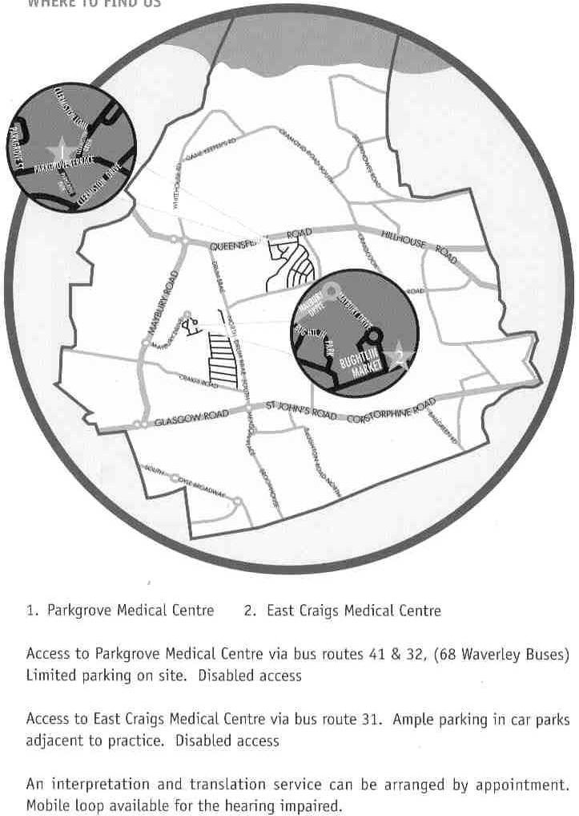

TRAINING/TEACHING/RESEARCH

This is a training practice and we may have fully qualified doctors attached to the practice to gain experience in general practice for 6-18 months. Please treat the GP Registrar as one of us.

We are also involved with the education and training of medical and nursing students. We would be grateful if you would accept them as part of the practice. The Doctor will inform you if a student is in attendance and you will be asked if you are agreeable to them staying during the consultation. You have the right to decline.

We sometimes record consultations on video for teaching purposes but your permission will always be asked and you will be free to consult in private if you prefer. Intimate examinations are never recorded.
The practice is involved from time to time in research studies, which we believe may be of benefit to patients and of no risk to them. We are grateful to patients who volunteer to take part in any of these research studies.

COMMENTS, COMPLAINTS & SUGGESTIONS
We are always trying to improve our service to you. If you have any suggestions we are happy to consider them. If you would like to comment on the service provided please contact the practice manager, Mr. James Aitken, as soon as possible. He is the practice complaints manager and a practice complaints procedure is available to help resolve any difficulties

