PRESCRIPTION REQUESTS
We no longer accept paper requests or produce paper prescriptions

To reduce the risks of spreading Coronavirus for patients and
Staff

We will NOT accept paper prescription requests until further notice

We do not want patients entering the practice exposing themselves
or our staff to risk of infection

You should request your repeat prescription in one of the following ways:-
NHS App - available in the App Store (Apple or Android). It’s easy to use and you can order your prescriptions quickly and easily.
All you need to do is:
- Download the app to your device
- Register yourself
- Email the surgery on sls.rec@nhs.net with full name and DOB, address and list two items off your repeat medication list (for verification only)
- Request your credentials
- Confirm your nominated pharmacy
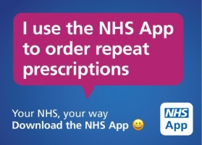

Go to PatientAccess.com and follow the instructions as above.

You can email us at sls.rec@nhs.net

You can post your prescription to: Sandy Lane Surgery, Sandy Lane, Leyland, PR25 2EB

If you require medication that is NOT on your repeat list, but you have had it before please complete the acute prescription form on the practice website www.sandylanesurgery.co.uk.
You need to decide where we should send your prescription electronically. It can be to any pharmacy. You will not be able to collect from the Reception desk - please let us know your pharmacy preference. If you do not nominate a pharmacy then it will be automatically be sent to Rowland Pharmacy, Sandy Lane Surgery.

In exceptional circumstances during this pandemic we will accept telephone requests for those unable to use the alternatives

