Winter 2019/20
Wishing everyone a Merry Christmas and a Happy New Year from all the staff at Duncan Street




Christmas Opening Times

24th December –Open as usual
8.30am to 6.00pm
Please note we will be closed between 1pm – 3pm
(phonelines 8.00am to 6.30pm)

25th December – CLOSED
26th December – CLOSED

27th December – Open as usual
28th December – Open as usual
30th December – Open as usual
31st December – Open as usual
8.30am to 6.00pm
(phonelines 8.00am to 6.30pm)

01st January – CLOSED

02nd January – Open as usual
03rd January – Open as usual


Working Together – The Hub

This surgery is now part of something called a hub. This means that if you are trying to make an appointment at the surgery but find that there are no available or suitable appointments available then it possible to see if an appointment is available at another surgery. With your consent the clinicians at the other surgery will be to access your medical information so you can be sure that you are still receiving the best possible care to help deal with your medical complaint.

The appointments for these surgeries will be available for evenings and also weekends.

** If you require prescriptions over the Christmas period please make sure you order in plenty of time to allow for the closure dates as this will cause a delay on prescriptions.
Please note: As a rule we say that it takes 48hrs for a prescription request, over the Christmas period this may be longer.

PTO

Patient Participation Group

The Partners and Practice Manager of Duncan Street Surgery have always valued the views of our patients and so hold regular meetings for you to give us feedback on the quality and range of our services.
If you are one of our patients, and would like to have your say in how we can improve services and would like to take part in discussions and decision making then please consider joining us for the next meeting. More information about this can be found in the surgery waiting room or on our website.

Our next PPG meeting will be on:

Thursday 12th March at 2pm

To find out more or to sign up then please email our Practice Manager Jacqui on:

Jacqui.squire@nhs.net


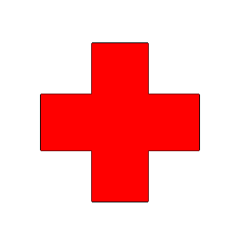
Coughs & Colds
A runny or blocked nose, sore throat, sinus pain, cough and earache are all symptoms of an upper respiratory tract (upper airway) infection. This is most likely to be caused by coming into contact with a virus.
Anti-biotics are not recommended for most upper respiratory tract infections. And it is normal for these infections to take a while to clear up. In general:
- Earache- usually lasts 4days
- Sore throat- lasts up to 1 week
- Common cold- usually lasts 7-10days
- Flu- Lasts up to 2 weeks
- Runny nose/ nasal congestion- usually lasts 7-10days
- Dry/ tickly cough- Lasts up to 3 weeks
You can treat many of these symptoms at home and can ask your local pharmacist for advice on symptom relief to help you.
If you are over 65 or have a health condition such as asthma, diabetes, a chest, heart, liver or kidney complaint, or lowered immunity then you are entitled to have an annual flu jab to help protect you against flu this winter. Just contact the surgery to arrange an appointment.

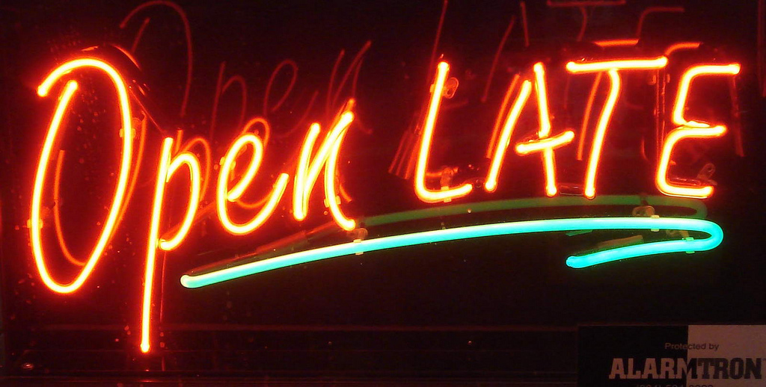
Late Night Opening
We now open the surgery every Wednesday until 8pm.
Please note - The surgery will only be open for pre-booked appointments between the hours 6.30pm to 8.00pm during the late night opening.


On-line Access
You can now book appointments and view you medical records online. To get on-line access just pop in to the surgery and request an online access form from the front reception desk. Please bring photographic I.D with you. Signing up only takes a few moments and you will be issued with a passcode and signing in details whilst you wait.
With your online access you will be able to print off any medical letters you may require.

Please note you cannot request online access for another person if they are not present with you.


Are your contact details up to date?
If you have recently moved house or changed your telephone/mobile number please make sure to let the surgery know so that we can update your health records.
Just ask at the reception desk for a change of details form or alternatively you can also change your details online on the Duncan Street Surgery Website.


Missed Appointments
So far this year there have been 1409 missed appointments with the clinicians.
If you need to cancel an appointment for whatever reason then please contact the surgery as soon as possible to let us know. By not informing the surgery you are wasting an appointment slot which could be re-allocated to another patient who needs to be seen.
Thank you

Duncan Street Primary Care Centre
Blakenhall, Wolverhampton
WV2 3AN
Telephone: 01902 459076 Fax: 01902 455309
Email: wolccg.duncanstreet@nhs.net (incoming only)
Website: www.duncanstreetprimarycarecentre.co.uk

