Hartwood Newsletter Jan 2023 – NOV 2023

This Newsletter has majority of things that has been posted on Facebook and our surgery page. It has useful information that we want you to be able to access.

Feeding Bristol’s food support list:
Please click on the link below, Feeding Bristol's food support lists, which list the various areas where people can go for support.

BFPL Hartcliffe, Withywood, Whitchurch, Bishopsworth (2).pdf
https://www.hartwood.nhs.uk/website/L81083/files/BFPL%20Hartcliffe,%20Withywood,%20Whitchurch,%20Bishopsworth%20(2).pdf

The Harbour Counselling Service
The Harbour is a Bristol-based charity providing a professional counselling and psychotherapy service to people affected by death or dying. We have over three decades’ experience of providing thousands of people with vital counselling sessions. This includes adults who are facing death and dying themselves; their family members and people close to them; and people bereaved due to illness.
We will be offering sessions at Knowle West Health Park every Monday from 17th April 2023 and we are welcoming new referrals from clients seeking therapy. (This is a 6-month pilot)
Our service criteria:
We offer individual, couple, and group therapy to adults meeting the following criteria:
1. Adults facing death or dying, and/or who are close to someone who is facing death or dying
2. Adults who have recently been bereaved as the result of a life-threatening illness (recently being defined as more than 3 months, and less than two years)
Fees -
We ask all clients, if they are able, to contribute toward the cost of their therapy at a rate of £65 per session. If the fee of £65 is not possible for clients, we invite them to determine a sum which feels right for them. For those clients for whom a contribution is not possible owing to their being on a very low/no income we offer fully funded sessions.
https://the-harbour.org.uk/

Discharge grants available to help people home from hospital.

One-off grants of up to £1,200 are available in BNSSG to help people stay well at home following a hospital stay.
The discharge support grant scheme aims to help improve ‘flow’ through local hospitals and free up beds for those who are medically unwell, by supporting carers, families, friends or voluntary supporters with minor costs associated with keeping a loved one well at home following their discharge.
It can be used to support costs including childcare support, pet care and equipment. Funding can also pay for short-term personal care from a self-employed personal assistant, to help with day-to-day activities. It may be possible for a family member or friend to be supported to provide personal care.
https://sirona-cic.org.uk/services/grants-to-support-discharge-from-hospital/#:~:text=What%20is%20the%20Discharge%20Support,friends%2C%20carers%20or%20voluntary%20supporters.

Who is eligible for a seasonal COVID-19 vaccine

You or your child may be offered a seasonal COVID-19 vaccine if you are:

- aged 65 years old or over (you need to be 65 years old by 31 March 2024)
- aged 6 months to 64 years old and are at increased risk
- living in a care home for older adults
- a frontline health or social care worker
- aged 16 to 64 years old and are a carer
- aged 12 to 64 years old and live with someone with a weakened immune system

https://www.nhs.uk/nhs-services/covid-19-services/covid-19-vaccination-services/book-covid-19-vaccination/

Find a walk-in COVID-19 vaccination site.

https://www.nhs.uk/nhs-services/covid-19-services/covid-19-vaccination-services/find-a-walk-in-covid-19-vaccination-site/

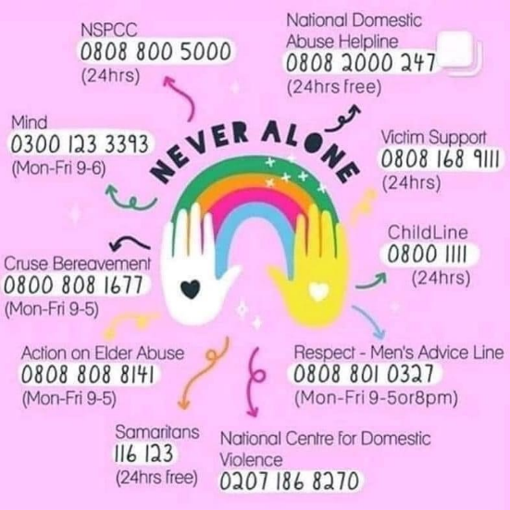

Covid-19 Vaccine Boosters
Changes to the Covid vaccination programme for 2023 after new advice from the Joint Committee on Vaccination & Immunisation (JCVI).
This year:
▶️ autumn boosters will be offered to those at higher risk of severe disease
▶️ spring boosters may be offered to those at greatest risk
On 12 February in England:
▶️ the autumn vaccination campaign 2022 will close
▶️ initial boosters for 16-49 year-olds not in a clinical risk group will end
Please come forward if you're eligible and haven’t been vaccinated yet.

Community Walk. Every Wednesday 10.30am see poster below for meeting places:

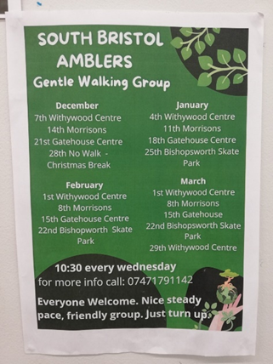

Your next poo could save your life. Detecting bowel cancer at the earliest stage makes you up to 9 times more likely to be successfully treated.
If you’re sent a bowel cancer screening kit, put it by the loo. Don’t put it off.
➡️ nhs.uk/bowel-screening - https://www.nhs.uk/conditions/bowel-cancer-screening/

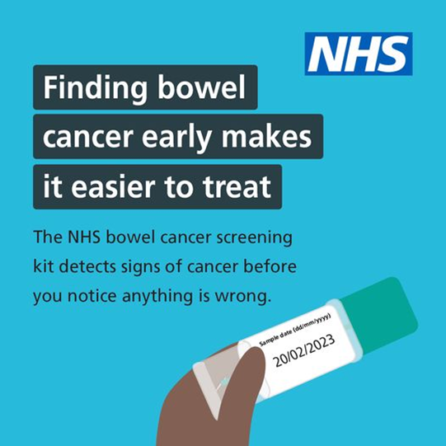

If you have norovirus, stay at home until 48 hours after your symptoms clear.
Protect others by not going to work, school & not visiting care homes or hospitals.
More info: https://www.nhs.uk/conditions/norovirus/
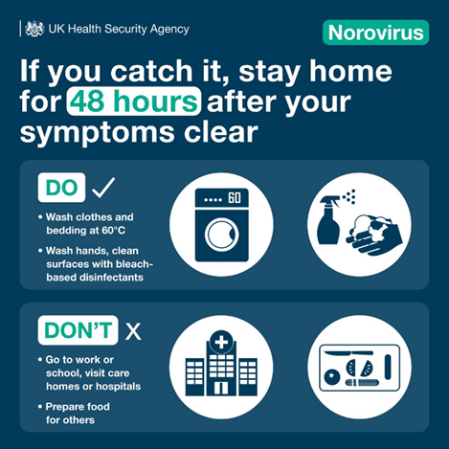

Dementia Safeguarding scheme.

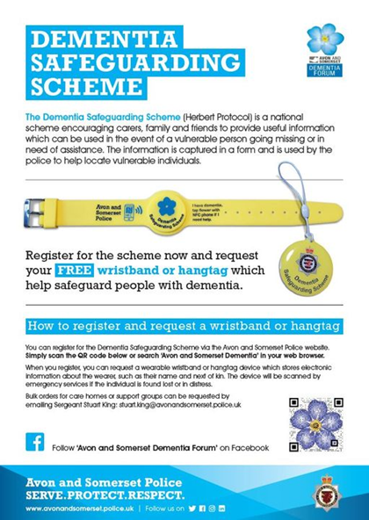

**New Welcoming Spaces**
Bristol City Council (BCC) have recently launched 'Welcoming Spaces' in partnership with VCSE organisation across Bristol.
A Welcoming Space is a place of connection already established in the community (such as a community centre, children's centre or place of faith), where people can meet up, socialise, and access support, relating to the cost of living.
Tier 1: These spaces are seen as ‘community living rooms’, where people can spend time and socialise. They offer an opportunity for people to come together, share and use resources, join a range of activities, and/or seek advice and support relating to the cost-of-living crisis.
Tier 2: The opening times are more restricted. They are open to all but may have some activity restricted to a specific community.
Children’s Centre opposite the Health Centre
Waverley Gardens
Withywood Church
Bishopsworth Children’s Centre Lakemead Grove
All Welcoming Spaces are wheelchair accessible with an accessible toilet.
Welcoming Spaces (arcgis.com) https://bcc.maps.arcgis.com/apps/webappviewer/index.html?id=4c5e933568424768bd871cea2003da34

Group A Streptococcus – information for families and carers of children.
You may have seen reports about a higher-than-usual level of Group A streptococcus (GAS) infections in children this year, and we understand if you are concerned.

GAS is a common bacteria – lots of people carry it without being unwell.

It can cause many common mild infections, including sore throats or scarlet fever, which can be easily treated with antibiotics.

The information below explains how it is spread, and what to look for when your child is unwell.

How is it spread?

GAS spreads by close contact with an infected person. It can be passed on through coughs and sneezes, or from a wound.

Which infections does GAS cause?

The bacteria usually causes a mild infection, producing sore throats or scarlet fever, which can be easily treated with antibiotics.

What is invasive group A strep?

This is when the bacteria gets into the bloodstream and causes serious illness – called invasive Group A strep (iGAS). These cases are very rare.

Symptoms of mild GAS infections

Symptoms of mild infections include sore throat; fever; chills; muscle aches; and in cases of scarlet fever, a rash and a white coating on the tongue, which peels leaving the tongue red, swollen and covered in bumps

When to contact us:

· If your child is not recovering after a bout of scarlet fever, a sore throat, or a respiratory infection, and you are concerned they are becoming more unwell

· If your child is drinking much less (50% less) than normal · If your child has had a dry nappy for 12 hours or more, or shows other signs of dehydration

· If your baby is under three months and has a temperature of 38C, or is three to six months old and has a temperature of 39C or higher

· If your child is very tired or irritable

Call 999 or go to A&E if:

· Your child is having difficulty breathing – you may notice grunting noises or their tummy sucking under their ribs

· There are pauses when your child breathes

· Your child’s tongue or lips are blue, or their skin is mottled/pale

· Your child is floppy and will not wake up or stay awake

· Your child has a weak, continuous, or high-pitched cry

Group A Strep: The symptoms to look out for - https://bnssg.icb.nhs.uk/news/group-strep-a/

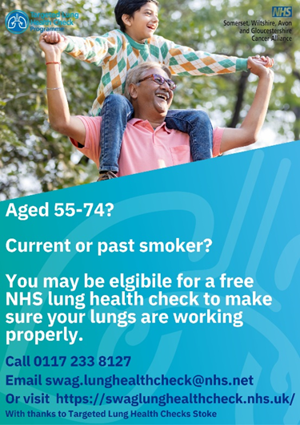

Caring for a poorly child? The NHS HANDi App has a quick, easy to use child symptom checker for common childhood illnesses and advises on how best to treat them. Download the HANDi App today: https://bnssg.icb.nhs.uk/about-us/campaigns/handi-app/

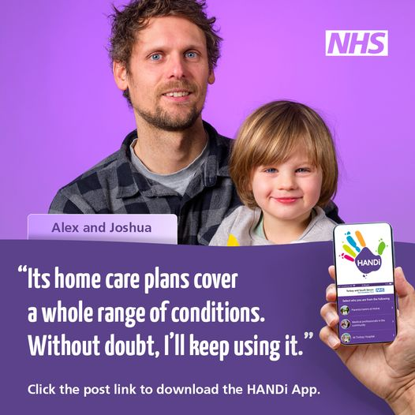
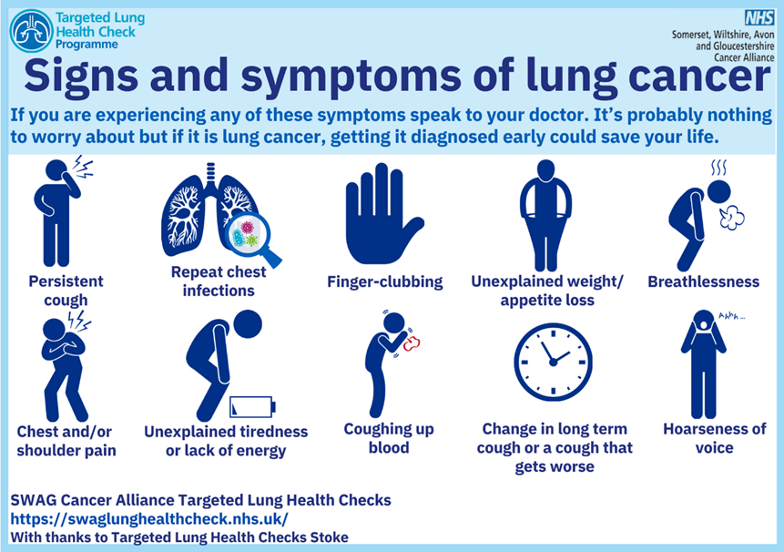

A new confidential messaging service called ChatHealth has been launched to enable 11–19 year old's to text a school nurse when they need support.

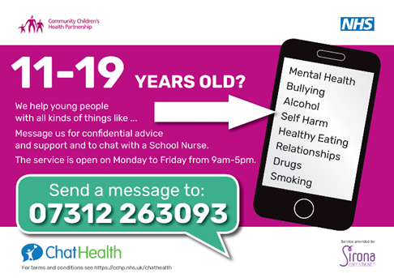

NEVER ALONE
Here are some useful helpline phone numbers for those in need.

