Dear Patient

We are here to help

It is fantastic that lockdown measures are easing and we are more able to meet up with friends and family. However, the safety of you, our patients, is still our priority and we need to continue to take more precautions than shops, pubs and schools etc due to some patients being more vulnerable than others.

As we are still in the COVID pandemic, the NHS recommends that we triage or phone back every patient who wants advice from a nurse, doctor or other healthcare professional.

Like you, we must avoid transmission of infection and therefore our surgery is having to work a bit differently from how it used to. The changes you can expect are:
- The doors to the waiting room are now open
- Social distancing allows a maximum of eight patients in the waiting room plus two at the Reception desk
- Patients will need to queue outside if these numbers are exceeded
- If you need medical advice, ring us on 023 9223 9630 to book, or send an eConsult, or visit the surgery as described above.

If you feel you need to attend the surgery in person, remember your mask and be prepared to queue outside as explained above.

Thank you for your patience and understanding

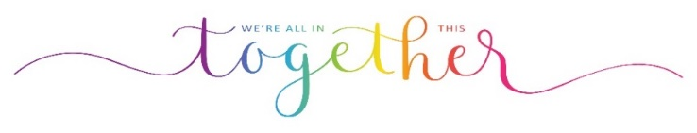
Denmead Practice 19th May 2021

