
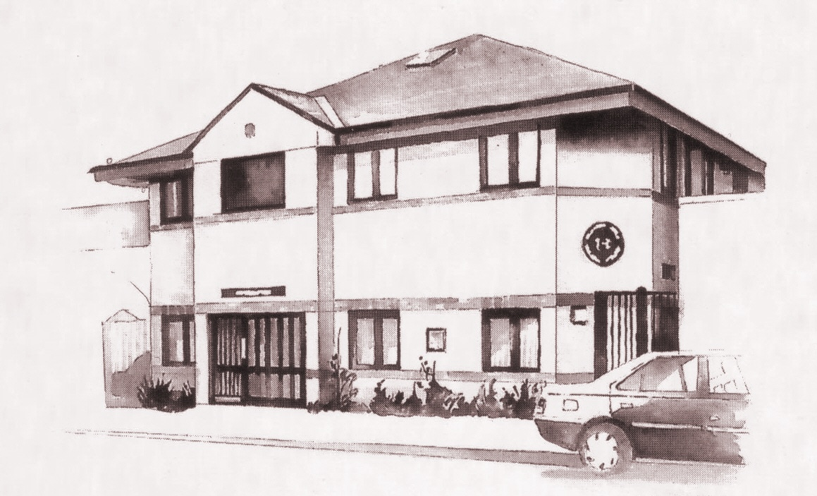




The Team
There have been a few changes to members of staff this year and we have sadly said goodbye to Sarah, receptionist/phlebotomist, Evelyn, Practice Nurse and Dr Morel, GP. They are sadly missed by all the team and we wish them well for the future.

We would like to warmly welcome Cree, receptionist, Michelle, Practice Nurse and Dr Gill and Dr Pattekar to the team.

Here’s a photo of the HHR team!

The Lammy Awards
Launched by NHS Lambeth CCG the Lammy Awards recognise people in the borough who go the extra mile to provide exceptional health and care services. Our PPG nominated Bernadette, Practice Manager and June, Receptionist, for the Kindness Award and we are delighted to announce that they won!

Lambeth Hub’s

We are pleased to announce a new service called Lambeth GP Hubs which is an extended appointment system of HHR Medical. This service enables us to offer you a GP or nurse appointment at one of the four hubs across Lambeth. We can book this appointment for you. The clinician you will see will have access to your medical records so they can provide the same level of service as we can. The hubs are open from 08.00am – 8.00pm Monday to Friday and from 10.00am -6.00pm weekends and bank holidays. The Hubs are based at the following practices;

Knights Hill Surgery
West Norwood Health and Leisure Centre, 25 Devanne Way, London, SE27 0DF.

Streatham High Practice
2-8 Gracefield Gardens, London SW16 2ST.

Clapham Family Practice
89 Clapham High Street, London, SW4 7DB.

The South Lambeth Road Practice
1 Selway House, 272 South Lambeth Road, London, SW8 1UL.

Further information can be found at www.lambethgpaccesshubs.co.uk

Herne Hill Road Medical Practice
Newsletter

Health Events 2015-2016
December - February

Here are just some of the
events being highlighted over
the next few months.

December 1-31
Decembeard
www.beatingbowelcancer.org/decembeard

December 10
Human Rights Day
www.un.org/events/humanrightsday

January 24-30
Cervical Cancer Prevention Week
www.jotrust.org.uk

January 31
National Bug Busting Day
(head lice)
www.chc.org

February 1-28
Prenatal Infection Prevention Month
www.groupbstrepinternational.org

February 6
Wear it, Beat it
www.earitbeatitbhf.org.uk

February 8-14
Tinnitus Awareness Week
www.tinnitus.org.uk

February 10
Safer Internet Day
www.saferinternetday.org

February 14-19
OCD Week of Action
www.ocdaction.org.uk

February 22-28
Eating Disorders Awareness Week
www.b-eat.co.uk
Quarterly issue 45
December 2015


Fund Raising

Thanks to the generosity of our lovely patients we were able to raise an incredible £287.84 at our coffee morning to raise money for Macmillan Cancer Support. Cakes were very generously donated for the day and we would like to say a massive thank you to the Patient Participation Group, June from reception and to all those who brought a cup of tea and slice of cake on the day.

In October we fundraised for Wear it Pink and thanks again to our patients we
raised an amazing £544! This helps give more hope to the thousands of mums,
daughters, sisters, families and friends whose lives are affected by breast cancer
each year. Thank you for your generous donations!

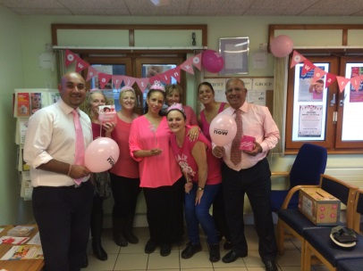

Local Care Record
Sometimes the people caring for you need to share some of your information with others that are also supporting you. This could include GPs, hospital based specialists, nurses and health visitors.
To enable this information sharing to happen more quickly and to improve the care you receive, a new process has been put in place in Lambeth called the Local Care Record. Through existing computer systems, this will join up care records held in your GP practice with the three main local hospital organisations: Guy's and St Thomas', King's College Hospital and South London and Maudsley NHS Foundation Trusts.

Information is only shared when it is needed to make your care and treatment safer, easier and faster and only with those people directly involved in your care. This could include allowing a hospital doctor to see the medication that a GP has prescribed for you or allowing a GP to see what care, tests or treatment you received while in hospital. Whenever possible, professionals will inform you that they are accessing your care record. This may not be possible every time, for example in an emergency, however each time a person accesses your information there is a clear record of it. Above all the Local Care Record will allow professionals supporting you to work with you to make safer and better decisions about your care. ​To find out how to opt out (should you wish to) please contact the practice or the hospital team currently looking after you.​​

Monday 21st December | AM: Normal  PM: Normal
Tuesday 22nd December | AM: Normal  PM: Normal
Wednesday 23rd December | AM: Normal  PM: Normal
Thursday 24th December (Christmas Eve) | AM: Same day appointments  PM: By appointment
Friday 25th December (Christmas Day) | Closed
Saturday 26th December | Closed
Sunday 27th December | Closed
Monday 28th December | Closed
Tuesday 29th December | AM: Same day appointments  PM: By appointment
Wednesday 30th December | AM: Same day appointments  PM: By appointment
Thursday 31st December (New Year’s Eve) | AM: Same day appointments  PM: By appointment
Friday 1st January (New Year’s Day) | Closed

Christmas Opening Times
Emergency Contact Numbers. Out of hours: 020 8693 9066 or NHS 111

Merry Christmas & A Happy New Year from all the team
HHR Patient Participation Group would like to invite you to our Christmas PARTY
Wednesday 16th December
1.30pm – 3.30pm
As well as mince pies and nibbles, there will be fantastic raffle prizes up for grabs and locally grown fresh vegetables on sale.

