2012-13 PATIENT PARTICIPATION REPORT
HGP at Pavilion Medical Centre (PMC)
A description of the profile of the members of the PRG/PPG | There are 3 patients in the PRG/PPG from the PMC list.  All meetings are face-to-face. The practice aims to increase participation in the future to achieve a larger size; a virtual group is planned to this end.  The PRG/PPG convened ten times in 2012-13; practice staff were present at five meetings.  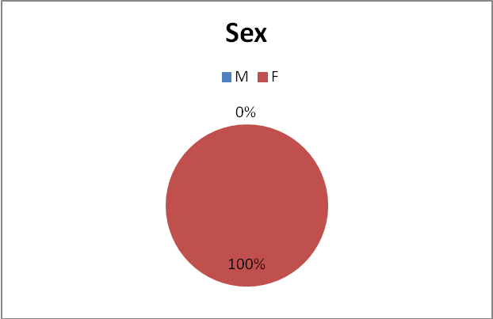  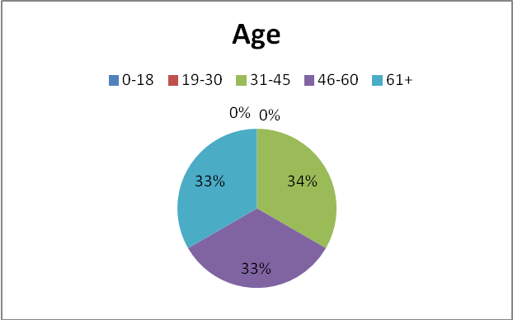  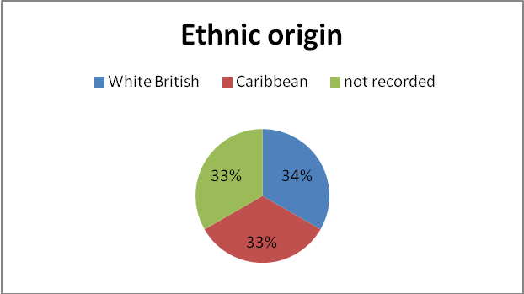
The steps taken to ensure that the PRG/PPG is representative of our registered patients and where a category of patients is not represented, the steps we took in an attempt to engage that category | As illustrated above, the PRG/PPG members from PMC’s list are currently exclusively female and not representative of the range of ages of the patient list as a whole. There has been some difficulty engaging patients in participation at this site, and we aim to promote the benefits of the PPG more actively in the coming year. The low number of participants from PMC is one of the reasons we hold joint PRG/PPG meetings, since the partnership’s practices are geographically close together and have similar populations, as we believe the larger overall participation number helps promote the benefits of the group.  The PRG/PPG is promoted on the website, and in the practice on noticeboards and the Jayex (automated call-in) boards. We are planning to improve accessibility of information on noticeboards in response to PRG/PPG feedback.  A text campaign is planned to invite participation in the 2013-14 year; by which the practice hopes to engage some younger patients in particular.  Staff are encouraged to promote participation to patients opportunistically.
Details of the steps taken to determine and reach agreement on the issues which had priority and were included in the local practice survey | The PRG/PPG elected a Chair, who recently stepped down. The group has chosen not to elect a replacement at this time as they prefer to focus on consolidating the group as a whole. The group will keep this matter under review during future meetings.
The manner in which we sought to obtain the views of our patients | GPAQv3 questionnaire (300 copies) distributed via reception – blank copy enclosed  Comment book available at reception desk  Feedback form on website  Comments received via NHS Choices (www.nhs.uk)  Regular PRG/PPG meetings (practice staff attend only alternate meetings)
Details of the steps taken by the practice to provide an opportunity for the PRG/PPG to discuss the contents of the action plan | The action plan was discussed at the year-end meeting of the PRG/PPG.  Unfortunately a date could not be found when all members who wished to attend were available, but we were able to receive input by one non-attendee by e-mail and incorporate it into the meeting. We aim to provide longer notice for future meetings and offer several dates in an attempt to maximise attendance.
Details of the action plan setting out how the finding or proposals arising out of the local practice survey can be implemented and, if appropriate, reason why any such findings or proposals should not be implemented. | The action plan was based on the survey and conversations with patients at the PRG/PPG, as well as anecdotal feedback from patients to clinicians and other staff members relating to access arrangements at the practice.  Three options have been discussed with respect to the practice’s appointment booking system and accessibility of clinicians to patients, as follows:  i) Remain as-is; attempt to improve access through training and patient education  ii) Begin offering appointments daily on a walk-in basis  iii) To institute a full triage arrangement whereby all appointments, including non-emergency, will be controlled by clinicians, initially via telephone but with arrangements for face-to-face consultation where necessary.
A summary of the evidence including any statistical evidence relating to the findings or basis of proposals arising out of the local practice survey | Satisfaction with quality of service once seen has been found to be acceptable.  The current clear priority for a majority of patients is improving access – the areas where the practice is being rated relatively poorly are waiting times both to make an appointment and to be seen.  Please see the attached questionnaire averages (with traffic light grading according to range of values) for further detail.
Action Plan
Changes we intend to take as a consequence of discussions with the Patient Representative Group is respect of the results, findings and proposals arising out of the local practice survey | The current favoured solution to the practice’s access issues among the partners is a full triage system. A final decision will be determined at a partners’ meeting by May, after which and following further PRG/PPG consultation a new appointment/access system will be implemented. The PRG/PPG will be kept informed of developments and the new system will be requested as an agenda item on a group meeting within two months of implementation. Continuous monitoring to identify further room for improvement will be incorporated into any new system.
ii. where it has participated in the Scheme for the year, or any part thereof, ending 31 March 2012, has taken on issues and priorities as set out in the Local Patient Participation Report | The 2012 plan was implemented as far as possible given the changes within the partnership with regard to clinical staff, management and other team members due to reorganisation and natural wastage, and the major government policy changes currently being implemented by the NHS.
The opening hours of the practice premises and the method of obtaining access to services throughout the core hours and extended hours arrangements (the times at which individual healthcare professionals are accessible to registered patients. | The current opening times are:  Mon 08:00-18:30  Tue 08:00-18:30  Wed 08:00-18:30  Thu 08:00-20:00  Fri 08:00-18:30  Sat 09:00-12:00  Sun Closed  These are publicised on the practice website and leaflet, including extended hours and out-of-hours arrangements.

