
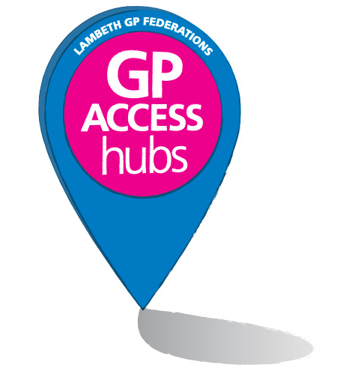

Lambeth
GP Access Hub Locations

Lambeth’s GP Federations are offering extended opening times at five specially selected GP Access Hubs. Our GP Access Hubs offer appointments seven days a week at the following times:

11:40am–8pm Monday to Friday | 8am–8pm weekends and bank holidays

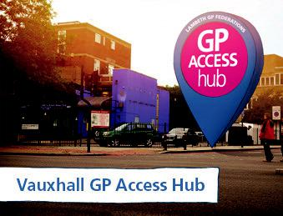
Vauxhall GP Access Hub

South Lambeth Road Practice

1 Selway House

272 South Lambeth Road

London SW8 1UL

Stockwell – 8 min walk


Oval – 16 min walk

Vauxhall – 15 min walk

Bus numbers 2 & 88 stop outside the surgery.


77, 87 & 196 stops are a 5 min walk to the surgery

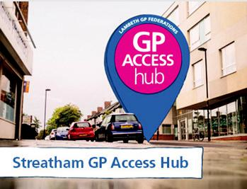
Streatham GP Access Hub

Streatham High Practice

2-8 Gracefield Gardens

Streatham

London SW16 2ST

Streatham – 11 min walk


Streatham Hill – 8 min walk

Bus numbers 50, 57, 109, 118, 133, 159, 201, 250, 255, 319, 333 & 417 are a 2 minute walk to the surgery

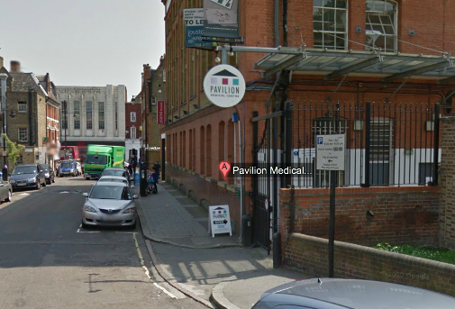
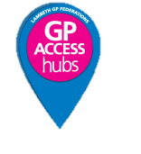
Pavilion GP Access Hub
Pavilion GP Access Hub

Pavilion Medical Centre 9 Brighton Terrace, Brixton

London SW9 8DJ
Brixton Underground Station – 3 min walk

Bus numbers 2, 3, 35, 45, 59, 109, 159, 196, 250, 322, 333, 355, 432, N109, N2, N3, P4 stop on Brixton Road, a 2 minute walk to the surgery. 37, 690, and P5 stop on Acre Lane, a 3 minute walk to the surgery.

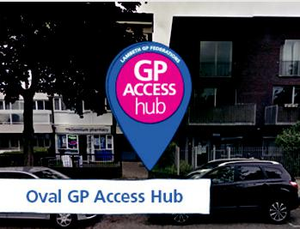
Oval GP Access Hub


Vassall Medical Centre 89 Vassall Road London SW9 6NA

Oval – 10 min walk

Bus numbers 3, 59, 133, 159 & 415 stop on Brixton Road. 36, 185 & 436 stops on Camberwell New Road, all a 5 min walk to the surgery.

To book a Hub appointment, simply call your usual GP surgery
To cancel your Hub appointment, please call: 07378604214 or reply “CANCEL” to the confirmation text sent to you

For more information visit lambethgpaccesshubs.co.uk

