The Green Medical Practice

The Practice Area

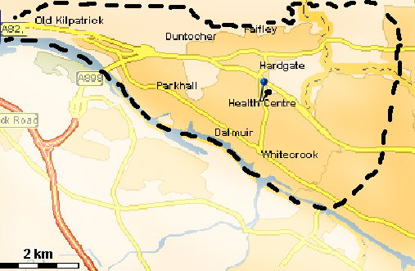

Clydebank Health Centre

The Health Centre is situated centrally in Kilbowie Rd, Clydebank. It is easily accessible by bus (No 62 & 11) and train (Singer Station, Kilbowie Rd) and has a large car park to the rear. It is fully accessible for the disabled. The Health centre offers a number of specialised facilities including physiotherapy, dietetics, podiatry, psychology and X-ray facilities.

