Hello and welcome to our latest newsletter!

This newsletter has been written after the surgeries PPG meeting which took place on Wednesday 3rd August 2022.

It’s certainly been a while since the last one and so much has happened
since then.

Covid-19

Now this almost seems like a distant memory and the early days of the first vaccination programme, believe it or not, are a very fond memory. The Community Practice was running the clinics on behalf of the PCN, where most of the surgeries PPG members were volunteers.

The sense of helping our community was immense for all involved; admin right through to the volunteers who gave their time without thought.
Of course, now almost two years on, the vaccinations are still going ahead at The Paddocks being run by GPHA still on behalf of the PCN, so if you receive an invitation for the vaccine, please give it consideration; Covid hasn’t gone away and we still need to be careful. If you do decide to have the vaccine, please make sure that you attend the appointment, more about that later.
FLU VACCINE
It’s that time of year again……
The Community Practice will be getting in touch with patients who are eligible.

Aged 2 and 3 years old
Aged 65 and over
Aged 6 months to under 65 years old in clinical risk groups
Care home residents
Close contact of Immunocompromised individuals
Frontline health and social care workers
Pregnant women CD

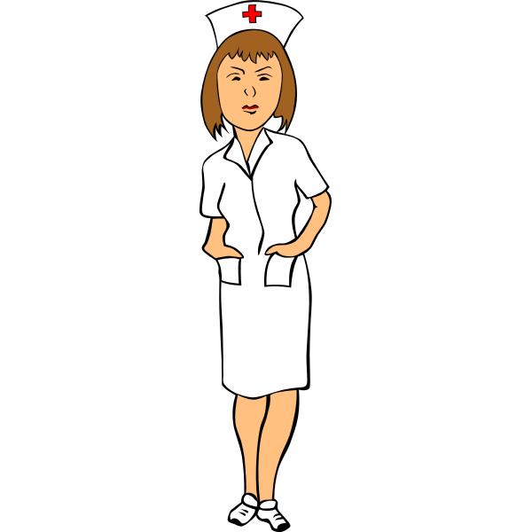Staff Changes
We have had a few staff changes at The Community Practice recently. Dr Ellen MacInnes and Advanced Nurse Practitioners Olanike Williams and Elizabeth Harrison have moved on.
Dr Ramjan is now back with us and resumes his normal Wednesday clinics along with his Wednesday afternoon steroid clinic.
Also, Dr Chaudhury has come out of retirement! During the months of July and August he has been running the triage appointment sessions as a locum on Monday, Wednesday, and Friday afternoons.
The practice is currently looking for a female GP to join us on a permanent basis.
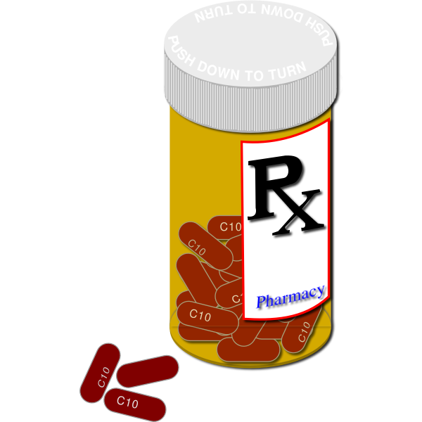Lisa, who worked on reception/care navigation has been appointed as our Prescription Clerk. She is available to talk to Monday to Friday 10.00am – 13.00pm if you need to speak to her, call the surgery on 01268 222188 and press option 2. Unfortunately, she is unable to take prescription requests over the telephone unless you are registered as housebound.

The rest of the Team
Dr N Ratnaingham – GP Partner
Dr Mir – Monday & Tuesday
Donna – Healthcare assistant
Lynn – Practice Nurse
Caroline – Practice manager
Danielle – Non-NHS work / Administrator
Jade – Complaint’s advisor / Administrator
Lara – Medical secretary / Administrator
Nadine – Receptionist
Millie - Receptionist

Weekend Appointments

There are weekend appointments available too. The GPHA (General Practioners Healthcare Alliance) are now running weekend surgeries from our consulting rooms. These appointments can be booked via our surgery or on Saturday & Sunday morning by calling 01268 222193 please call early if possible. This service opens from 9am.
We now have an excellent website too. On the site there is E-Consult, here you can request a doctor’s certificate and submit electronic consultation requests. It’s a handy tool which I used a few days ago to request a certificate for a friend, it’s quick and easy.

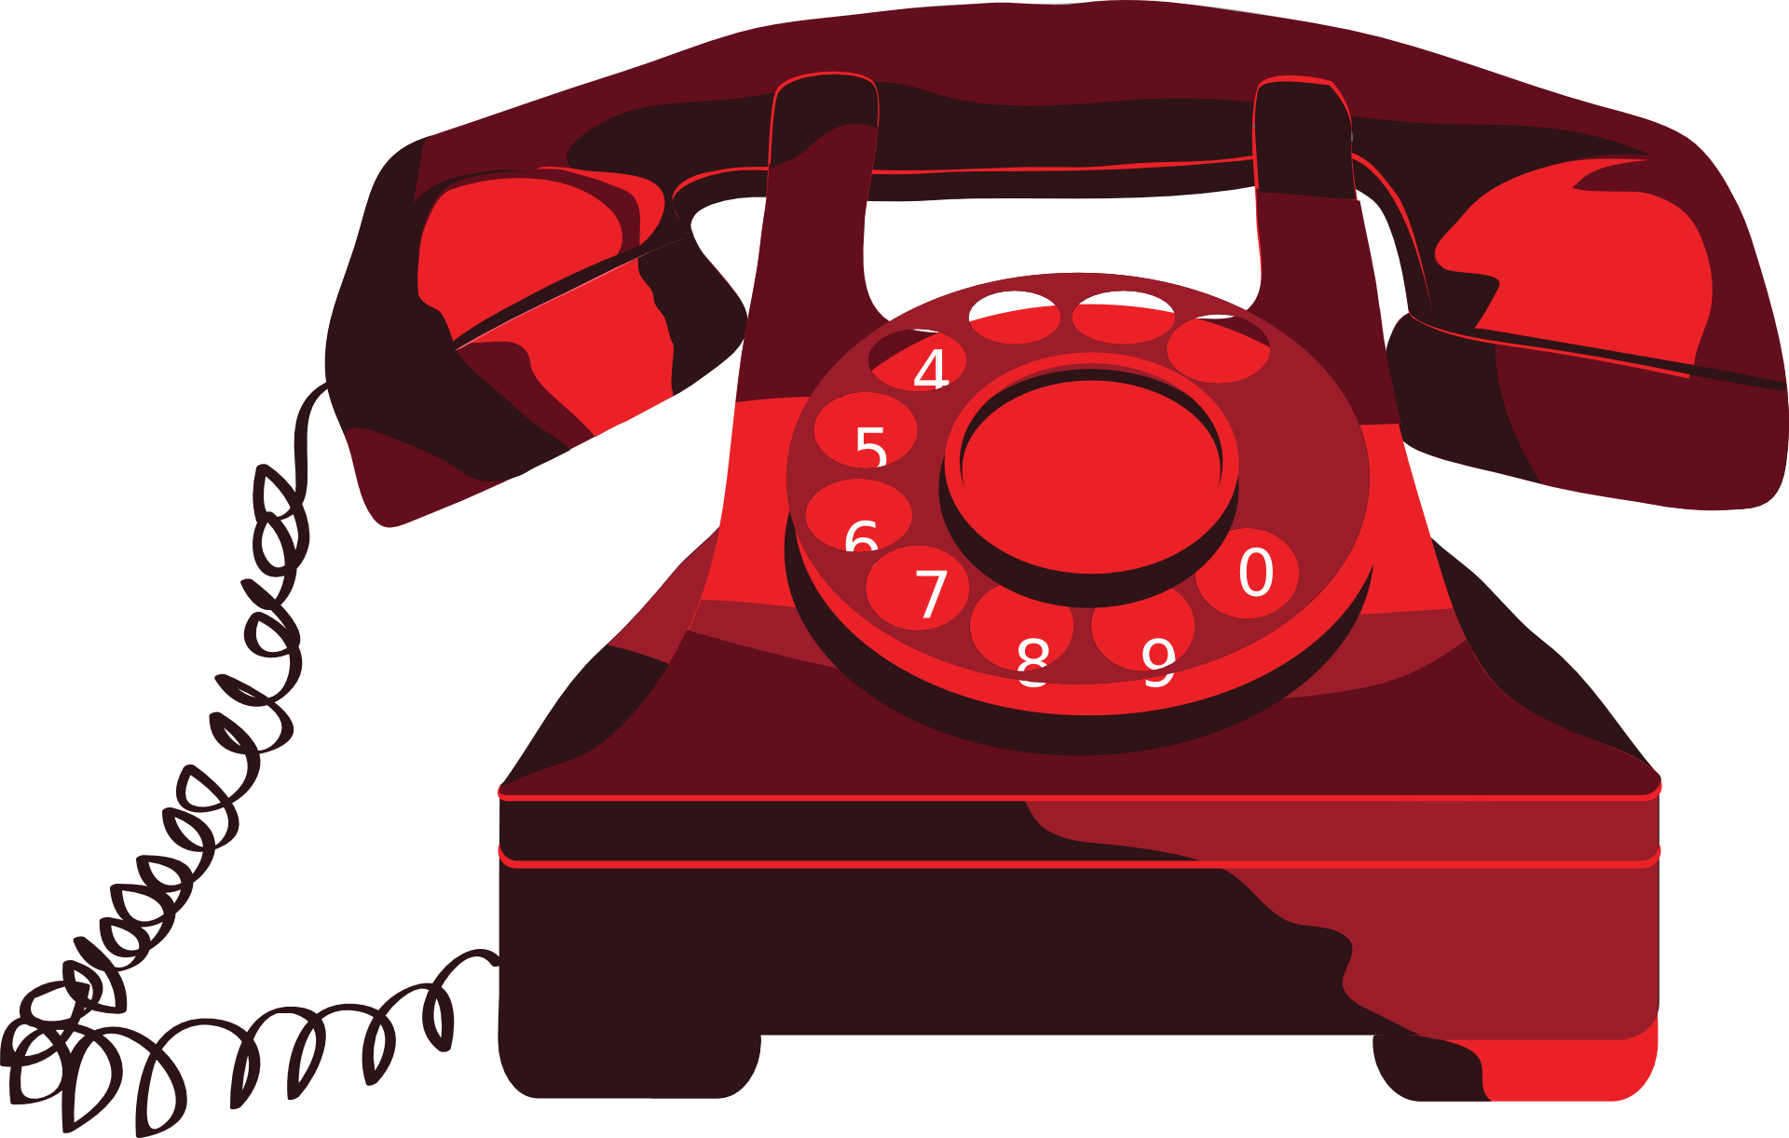 The Triage System
It seems it is still causing a little confusion for some patients.
Just for the record, here’s how it works; you feel unwell you call the surgery.
Please call between 8am – 10am where the care navigator will add you to the
telephone triage list.
That doesn’t mean that if you call after 10.00am you will not be called back, it will depend on why you are calling. When the receptionist/care navigator asks you what the reason is for requesting a call-back, they are not being nosey or acting above their station, they are simple trying to direct you to the best possible person to help you, so please bear
this in mind.

The reception staff are not refusing to give you an appointment, the doctors and nurses look after their own appointment diary’s and if during the telephone consultation they (the doctors/nurses) feel you need a face-to-face appointment, they will book it with you.

Patient DNA; not what you’re thinking! I’d like to think that my DNA goes back to the Vikings! But the DNA to which I refer to is; Did Not Attend. I often hear people say that it’s so hard to get to see a doctor or nurse these days but so many people who have an appointment just don’t show up! One Friday in July, 7 patients who had an appointment to see the nurse did not attend. That’s approximately 2 hours of consulting/treatment time. These are appointments that could have been given to those who need to see someone. If you have an appointment that you find you don’t need after all, please let the surgery know as soon as you realise that you will not be attending, it can then be offered to someone else.

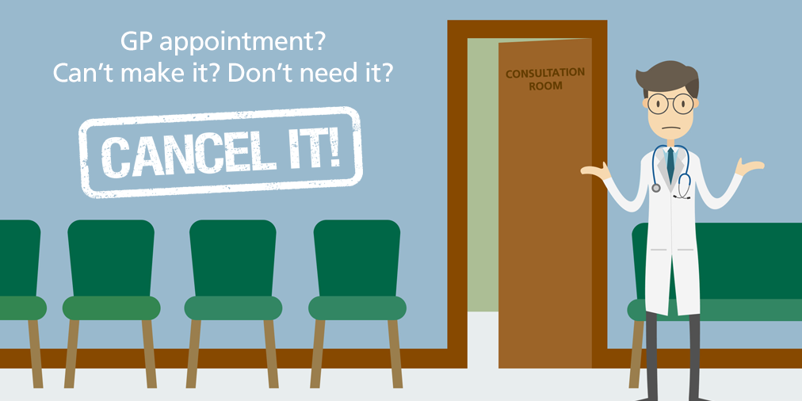

Orsett Minor Injuries Unit; just to remind you that there is a minor injuries unit at Orsett, it can often be a lot faster than waiting at A&E for things that are not life-threatening. The unit can deal with things like, head injuries with no loss of consciousness, uncomplicated fractures, minor burns, bites/stings, animal and human bites. These are just some of the things that can be treated there.

Gentlemen, this is aimed mostly at you! But ladies, please take the advice on board! Generally none of us like to have to go and see our doctors, but when the problem is in a sensitive area, ‘south of the border’, we blokes tend to sit on things (no pun intended!) in the hope that it might just go away. Please remember that the earlier any condition/problem is detected, the earlier treatment starts, the sooner it is treated, the more successful that treatment can be. So please guys, check things out every now and then and if you find a lump, bump or something that just doesn’t feel right, please contact the surgery at once and this also rings true for you ladies, occasional self-examination is a good habit.
Leave being bashful to Snow White and Co, if you find something that isn’t right, make that call!

Author is licensed under CC BY-NC-ND
False Information; we are still finding that some people think that we are Grafton Surgery. Quite simply, we are NOT! It is true however, that we occupy the same consulting/office space as Grafton surgery did but that’s where the similarity ends. The Patients Participation Group was active back then and continued to work alongside The Ashingdon Surgery when they assumed responsibility of the running of what was Grafton Surgery. Ashingdon eventually closed Grafton Surgery down in 2020. Some of the staff, admin, and nurses, were taken on by Dr Ranj who had become a partner in Dr Chauhdury’s Practice. Dr Chaudhury then retired leaving Dr Ranj the lead partner GP and the surgery was renamed The Community Practice.
The Community Practice relocated sites from the former Dr Chaudhury site to the former Grafton premises as it has gained many of Grafton’s former patients, meaning that the Chaudhury site was too small for our patient capacity.
The old Dr Chaudhury site is now occupied by the PCN.
I appreciate that it can be misleading as the building signage still points patients upstairs to Grafton surgery, this is an issue that is being dealt with and should be changed soon.

That’s all for now. On behalf of the practice and the PPG, stay safe and healthy!!!

If you need to speak to someone regarding joining the practice or have any comments, you are welcome to email me at; brianbppg@aol.com

