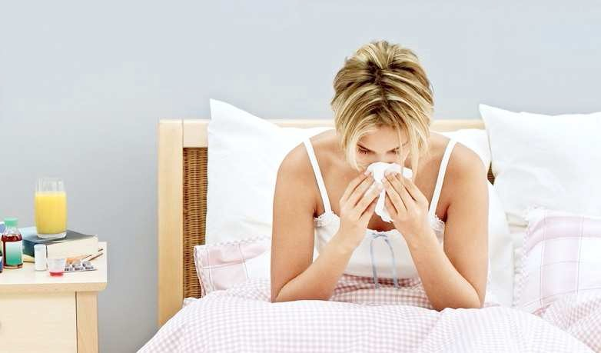

Infectious Disease amongst Students: Quarantine Arrangements

From time to time students contract an infectious disease that requires them to be isolated from other students to avoid the spread of the disease across the campus.

When it is possible for students to return to their own/parents’ home without risking infecting others on the journey, we usually advise them to do so. When this is not possible or advisable, we arrange for students to be put into quarantine for the period of their infectivity.

This document has been written for students who have contracted infectious diseases and also provides useful information for those who may come into contact with them. It explains UEA’s isolation procedures and gives basic information about the most common infectious diseases.

Isolation procedures for students in UEA Residences

When a student requires isolation, the UEA Medical Service (UMS) will contact Student Support Services to ask for this to be arranged.

If you are in UEA Residences and in an en-suite room, we will usually suggest that you stay where you are. If you are living in a standard room, we will arrange for you to be moved to an en-suite room for the duration of your illness (you will not be charged for this).

The Student Support Services (SSS) will attempt to make contact with you as soon as possible, so please ensure that your mobile is switched on, and that you have given the number to the UMS.

SSS will discuss with you the catering and other practical arrangements for your isolation. UEA Catering Services are able to deliver daily meal packs (normally vegetarian) if you wish. They will invoice you for these meals afterwards at the cost of the individual items in the pack. You may, however, prefer to ask your friends to organise the delivery of meals and other supplies for you. If this is your preference it is crucial to ensure that your friends do not enter your room, but leave items outside your room for you to pick up after they have left the vicinity of your room.

Cleaners will provide you with a rubbish bag for each day of your quarantine. Please use these for the disposal of used tissues and food refuse. You should tie the bags up and leave them outside your door for collection by 12 midday each day.

SSS will give you contact numbers to phone if you need further supplies, help or advice. Other than in a real emergency, do not leave your room to summon assistance. SSS will also maintain regular contact with you, and inform the relevant SRs that you are in isolation. SSS will be able to contact your School for you if you have not done this yourself. You will need to ensure that you obtain a doctor’s note to cover your absence.

If there is a fire alarm, you will need to leave your room. Make sure that you have suitable clothing readily available to keep you warm and dry. Try to avoid touching handrails and door handles as much as possible, and avoid close contact with others – the general guidance is to ensure that you try to keep at a distance of a least 6 feet. Try to make contact with the fire warden to let them know that you are in isolation so that they can let you back into your room as a priority. If you have flu or any other illness spread by coughs and sneezes, you should cover your face with a facemask before leaving your room (we will hope to be able to supply you with these). If you don’t have a facemask, then cover your mouth and nose with a scarf, handkerchief or something similar.

Make sure that you check with your doctor at the end of your isolation period to confirm that it is safe to leave your room. It is helpful if you could also inform SSS as soon as you are out of quarantine.

Isolation procedures for students living in the local community

If you are living in shared accommodation, it is vital that you limit your contact with other people. Stay in your own room and ask your house or flat mates to provide you with food and drink by leaving them outside your room. You may well need to leave your room to go to the bathroom. Put on a face mask or cover your mouth and nose with a scarf or handkerchief and clean your hands with an alcohol-based hand wash before leaving your

room. Wash your hands thoroughly before leaving the bathroom and clean your hands again with an alcohol wash after removing your mask when you return to your room. If you share a room, or there are other circumstances that make it very difficult for you to effec- tively isolate yourself, contact Student Support Services who may be able to
arrange for you to be isolated on campus.

Don’t forget that one of the best ways to spread illnesses is through coughing or sneezing. Use a clean tissue whenever you cough or sneeze, put it into a waste bin and wash your hands with soap and water or use an alcohol-based wash – even if you are on your own in your room.

Incubation periods for common illnesses

It is useful to know the incubation period (the period from infection to the development of symptoms) and the period of infectivity (the time when the person is likely to infect other susceptible people) for your illness. The information below is a brief guide to the incubation period of the most common infectious illnesses in the UK. For more detailed information, please consult a medical practitioner.

Influenza

Incubation period – 7 days maximum (2-4 average)

Period of infectivity – 1 day before the onset of symptoms and 7 days after

Chicken pox

Incubation period (the period from infection to the development of a rash) – 14 to 21 days.

Period of infectivity – 1 to 4 days before the rash develops and 5 days after.

Chicken pox is very infectious but it is very, very rare to get it twice. Anyone who has a past history of chicken pox is likely to be immune as is somebody who knows that they had very close contact with somebody with chicken pox in the past, even if they cannot recall having the disease.

Chicken pox vaccine is a routine immunisation in the USA, but in the UK is only given to health care workers.

Mumps

Incubation period – 15 to 25 days.

Period of infectivity – 10 days before the swelling and 5 days after.

Protection against mumps can be obtained by 2 MMR vaccines. A history of mumps is not a reliable indicator of immunity.

German Measles (Rubella)

Incubation period – 13 to 21 days.

Period of infectivity – 1 week before the onset of the rash to 6 days after.

Rubella in adults can be quite nasty and is a particular risk to the unborn child in pregnant women. All female contacts in a case of rubella should check that they are immune to rubella.

Protection against rubella is obtained by 2 MMR vaccines and women of child bearing age can be checked by a blood test.

Measles

Incubation period – 6-19 days.

Period of infectivity – 3 days before the onset of the rash to 4 days after (NB very highly contagious in a non-immune population.).

Immunity is obtained by a past infection or by immunisation with 2 MMR vaccines.

Pertussis (Whooping Cough)

Period of infectivity – 48 hours from commencing antibiotic treatment, or 21 days from onset of illness if no antibiotic treatment.

Tuberculosis

Incubation period – weeks to many years.

Period of infectivity – TB is only infectious if the organisms responsible are being coughed up (sputum positive).
14 days of treatment effectively kills the organism and prevents further transmission.
A comprehensive and systematic contact tracing system is in place carried out by the Health Protection Agency when an individual has infectious TB. TB is not very infectious and requires prolonged, close household type contact in order for the infection to be passed on from one person to another.

Student health care workers

Student health care workers should always ensure they are up to date with their immunisations. If they have been in contact with anyone they know to have an infectious disease, for example, a flat mate, friend or family member, they should immediately contact Occupational Health in the University Medical Centre to check with them that this contact does not place them at risk of passing on an infection to patients.

Useful contact numbers

Student Support Services 01603 592761
University Medical Centre 01603 251600
NHS Helpline 111
UEA Security 01603 592352

Dr Rachel McShane
University Health Physician

Dr Jane Lawrence
Head of Wellbeing July 2017

