Why we collect information about you

Your doctor and other health professionals caring for you keep records about your health and any treatment and care you receive from the National Health Service. These help ensure that you receive the best possible care from us.
These records may include:
- Basic details about you, such as address, date of birth, next of kin
- Contact we have had with you such as clinical visits or telephone conversations
- Notes and reports about your health
- Details and records about your treatment and care
- Results of x-rays, laboratory test etc.,
- Relevant information from people who care for you and know you well, such as health professionals and relatives
The practice will ensure that patient confidentiality is maintained at all times by all members of the practice team. For the effective functioning of a multi-disciplinary team it is sometimes necessary that medical information about you is shared between members of the wider health centre team, e.g. doctors, nurses, managers, district nurses, community matrons, etc.

How you can get access to your own health record

The Data Protection Act 1998, which came into force on 1st March 2000, allows you to find out what information about you is held on computer and in certain manual records. This is known as “right of subject access”. It applies to your health records.

If you want to see them you should make a written request to the NHS organisations where you are being, or have been, treated. You are entitled to receive a copy but should note that a charge will usually be made. You should also be aware that in certain circumstances your right to see some details in your health records may be limited in your own interest or for other reasons.

Further Information

If you would like to know more about how we use your information or if, for any reason, you do not wish to have your information used in any of the ways described in this leaflet please speak to the health professionals concerned with your care. You can also contact the NHS organisation - such as the hospital - where you are being treated.

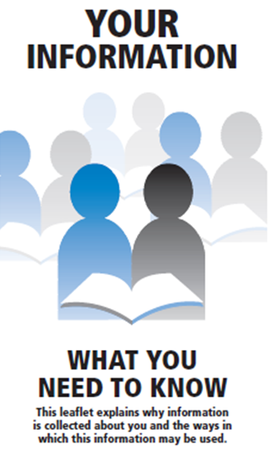
Updated August 2013
HOUNSFIELD SURGERY
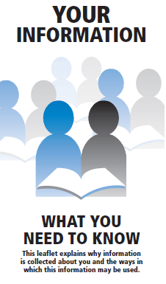

How your records are used to help you

Your records are used to guide professionals in the care you receive to ensure that:

your doctor, nurse or any other healthcare professionals involved in your care has accurate and up-to-date information to assess your health and decide what care you need full information is available if you see another doctor, or are referred to a specialist or another part of the NHS there is a good basis for assessing the type and quality of care you have received your concerns can be properly investigated if you need to complain

How your records are used to help the NHS

Your information may also be used to help us:
· audit NHS accounts and services
· prepare statistics on NHS performance
· investigate complaints, legal claims or untoward incidents

Some of this information will be held centrally, but where this is used for statistical purposes stringent measures are taken to ensure that individual patients cannot be identified. Anonymous statistical information may also be passed to organisations with a legitimate interest, including universities, community safety units and research institutions.

Where it is not possible to use anonymised information, personally identifiable information may be used for essential NHS purposes. These may include research and auditing services. This will only be done with your consent, unless the law requires information to be passed on to improve public health.

How we keep your records confidential

Everyone working for the NHS has a legal duty to keep information about you confidential.

You may be receiving care from other organisations as well as the NHS (like Social Services). We may need to share some information about you so we can all work together for your benefit. We will only ever use or pass on information about you if others involved in your care have a genuine need for it.

We will not disclose your information to third parties without your permission unless there are exceptional circumstances, such as when the health or safety of others is at risk or where the law requires information to be passed on.

Anyone who receives information from us is also under a legal duty to keep it confidential

We are required by law to report certain information to the appropriate authorities. This is only provided after formal permission has been given by a qualified health professional. Occasions when we must pass on information include:
- notification of new births
- where we encounter infectious diseases which may endanger the safety of others; such as meningitis or measles (but not HIV/AIDS)
- where a formal court order has been issued

Our guiding principle is that we are holding your records in strict confidence

