Omron M6 Data Collection Sheet

Patient Name:

Patient DOB:

- Take readings in the morning and in the evening
- record two readings on each occasion, a minimum of one minute apart
- perform recordings for 7 days

Date of 1st recording: Date to be returned:
Day | Morning |  | Evening
1 | Top figure | Top Figure | Top Figure | Top Figure
 | Bottom Figure | Bottom Figure | Bottom Figure | Bottom Figure
2 | Top Figure | Top Figure | Top Figure | Top Figure
 | Bottom Figure | Bottom Figure | Bottom Figure | Bottom Figure
3 | Top Figure | Top Figure | Top Figure | Top Figure
 | Bottom Figure | Bottom Figure | Bottom Figure | Bottom Figure
4 | Top Figure | Top Figure | Top Figure | Top Figure
 | Bottom Figure | Bottom Figure | Bottom Figure | Bottom Figure
5 | Top Figure | Top Figure | Top Figure | Top Figure
 | Bottom Figure | Bottom Figure | Bottom Figure | Bottom Figure
6 | Top Figure | Top Figure | Top Figure | Top Figure
 | Bottom Figure | Bottom Figure | Bottom Figure | Bottom Figure
7 | Top Figure | Top Figure | Top Figure | Top Figure
 | Bottom Figure | Bottom Figure | Bottom Figure | Bottom Figure

Admin / Post Admin add figures and perform the maths before passing to Dr. Check patients maths
Total S ÷ 24 = Code via template – average home systolic
Total D ÷ 24= Code via template – average home diastolic

Pass to requesting clinician’s incoming post - Clinician to add comment to patient records.

Omron M6 Patient Instructions

To help ensure a reliable reading, avoid eating, smoking, or exercising for at least 30 minutes before taking a measurement. Remove any tight-fitting clothing from your upper arm.

1. Sit on a chair with your feet flat on the floor and place your arm on a table so that the arm cuff will be at the same level as your heart.

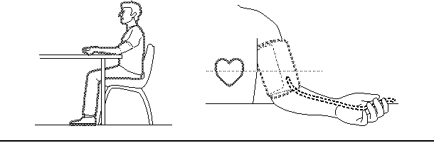

2. Apply the arm cuff to your upper arm. The coloured marker should be centred on the inside of your arm and point down the inside of the arm, so that the air tube runs down the inside of your forearm and is in line with your middle finger.

3. Secure the cuff around your arm using the fabric fastener strip, ensure that your arm is supported by the table and completely relaxed.

4. Press the O/I START button, ensure that you are relaxed

When measurement is complete, the monitor displays your blood pressure and pulse rate, and automatically deflates the cuff.

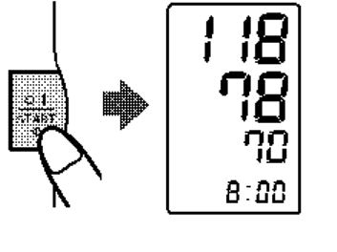
Top Figure
Bottom Figure

Please contact the Surgery 5 working days after you have returned your readings, if you have not been contacted. Your Doctor will have left a message for you.

