NEWLAND SURGERY

PATIENT PARTICIPATION DES REPORT 2013- 2014

Profile of practice population and Patient Reference group (PRG)

Newland Surgery is a two partner practice and is supported by a female locum doctor at present. The practice has two Practice Nurses, one Healthcare Assistant and a well established practice administrative team. The practice list size is 3750 patients.

The Practice has 8 PRG members at present.

Members of the PRG group have been encouraged to join by the posters displayed in the waiting area. Four members have been requested to join directly by the receptionists. The PRG Group is a face to face group at present however the practice is trying to recruit members virtually (correspond/feedback by email) should they wish to join the group. The PRG Group does not have any virtual members who are interested to date. The practice continues to encourage patients to join the PRG group.

Differences between the practice population and members of the PRG.

The table above represents the PPG group profile. There is substantial variation between the group and the practice profile. The practice has been trying extensively to recruit new members. We have used a variety of methods to recruit and are still continuing to advertise and recruit more members.

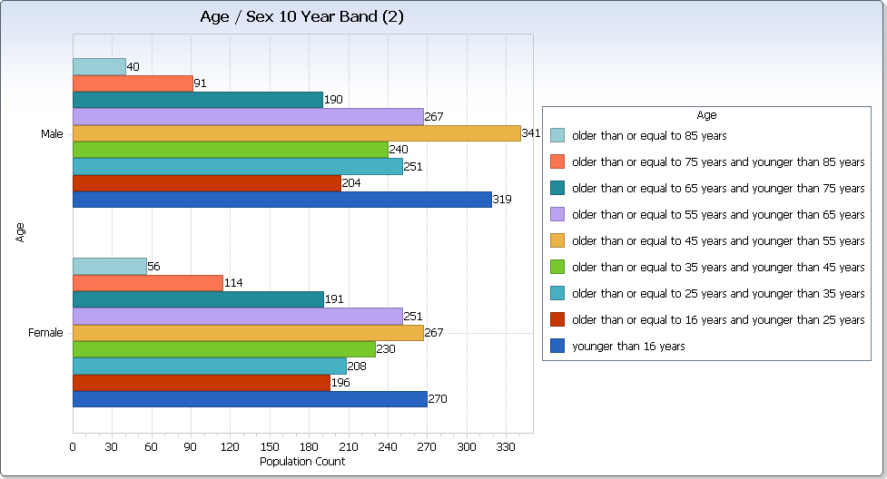

Practice Age profile:

Practice population profile | PRG profile | Difference
Age
% under 16  16% | % under 16  Nil
% 17 – 24  11% | % 17 – 24  1 patient | 1 Patient
% 25 – 34  12% | % 25 – 34  1 patient | 1 patient
% 35 – 44  13% | % 35 – 44  Nil
% 45 – 54  16% | % 45 – 54  Nil
% 55 – 64  14% | % 55 – 64  1 patient | 1 patient
% 65 – 74  10% | % 65 – 74  2 patient | 2 patient
% 75 – 84  6% | % 75 – 84  3 patient | 3 patient
% over 84  3% | % over 84  Nil
Ethnicity
White | White
% British Group  94% | % British Group  0.18% 7 Patients | 0.18% 7 Patients
% Irish  0.1% | % Irish
Mixed | Mixed
% White & Black Caribbean  Nil | % White & Black Caribbean
% White & Black African  0.2% | % White & Black African
% White & Asian  0.04% | % White & Asian
Asian or Asian British | Asian or Asian British
% Indian  0.4% | % Indian
% Pakistani  0.2% | % Pakistani
% Bangladeshi  Nil | % Bangladeshi
Black or Black British | Black or Black British
% Caribbean  Nil | % Caribbean
% African  0.9% | % African | 0.02%  1 patient
Chinese or other ethnic group | Chinese or other ethnic group
% Chinese  0.6% | % Chinese
% Any other  0.3% | % Any other
Gender
% Male  1943 | % Male  2 Male | 0.1%  2 Male
% Female  1783 | % Female  6 female | 0.34%  6 Female

Methods Used To Recruit:

Posters displayed around the surgery
Doctors requesting patients during consultation
Nurses requesting patients during consultation
Midwife : requesting mothers to be, during antenatal clinics
Local Parent Craft & Mums & Tots Group ; Practice Midwife Given PRG posters to display on notice board.
Health Visitor has been requested to try and see if she can encourage mothers with children
Link on practice website encouraging patients
Receptionists asking patients directly
Posters requesting patients to join the group virtually has also been displayed.

2 : Local Practice Survey

The practice survey was developed in collaboration with the PRG group last year. This year the PRG group agreed that the practice utilise ‘CFEP’ a different survey company to analyse the survey data and produce a report. CFEP produce the survey report in a different format and other practices had given positive feedback about CFEP.

The practice also looked at themes emerging from complaints received over the last few years. No apparent theme could be identified.
However the PRG group produced a separate survey questionnaire asking the following questions in relation to some complaints and from the main practice survey carried out last year.

- Telephone System : Please tick
When you contact the surgery by telephone, would you prefer to;

- listen to an auto attendant message requesting you to hold (you are charged for this ) until a staff member becomes available (current system at the moment) or

- hear the engaged tone in which case you can ring back later (no charge).

- Repeat Prescriptions :
Please can you tell us of any problems you have had over the last 12 months on the requesting or collection of your repeat prescription and whether this has been at the surgery or pharmacy. Please give as much detail as possible to help us improve our service.

Planned practice changes

There are no major planned practice changes for 2014-15

National GP Patient Survey

Overall, the practice was pleased with the national GP patient survey carried out last year and the PRG group included a number of similar questions from the national survey into the bespoke practice survey.

Care Quality Commission (CQC) related Issues

The practice has designated two representatives from the PRG group should the CQC wish to contact them.

The practice discussed CQC with the PRG group again. The PRG network representatives also gave feedback about how the CQC inspections were undertaken in other practices.

The practice is registered with the CQC and the CQC will inspect all practices every two years to ensure that practices comply to the “essential standards of quality and safety”.

3 Survey Results

The survey was mainly paper based and it was available online for patients to complete via the practice website. A plastic box was placed in the waiting area for patients to submit their completed questionnaires.

The practice survey was carried out over a four week period during February 2014. The survey questionnaires were distributed mainly by the practice receptionists. The receptionists encouraged patients to fill the form whilst they were in the surgery to ensure questionnaires were returned.

One hundred and thirty questionnaires were distributed. The practice received back 118 completed questionnaires. The practice required approximately 100 completed questionnaires for its list size of 3750 patients. The completed questionnaires were posted to CFEP who analysed the results and produced a report back to the practice. (survey report enclosed)

The survey was completed by patients between the ages of 16 to over 75.

4 Action Plan

A copy of the survey report was circulated to all members of the practice team and copies were also emailed to the PRG group members to analyse and bring identified areas for discussion and action to the PRG meeting in March 2014.

The survey results were discussed in detail with the PRG group on the 18th March 2014 including the action points from last years survey and the following actions were identified and agreed for this year

Action Points for 2013-14 :

The following action points were agreed last year by the PRG Group;

- Online appointments to be available to patients

‘Q6 Which of the following methods would you prefer to use to book appointments at your practice?’

In person 22.1% By Phone 68.2% Online 8.4%

Completed : 8.4% of patients would like to book online and as a result of this the practice has installed EMIS Access to allow patients to book online if they so wish. We have only allowed a few appointments to be bookable online at the moment and we will review this as the demand increases. Patients will have to register for this service. Patients will be given a ID number and password to access online appointments.

2 Online repeat medication requests to be available to patients

Completed : Requesting repeat medication online is now available to patients.
Patients will have to register for this service. Patients will be given a ID number
and password to access online repeats.

- To ease access to improve urgent on the day appointments for patients who need to be seen urgently.

Completed : The practice has discussed this will all reception staff (16th Oct 2013). The practice has a very flexible approach to urgent appointments. If a patient requests to be seen the same day for a urgent appointment ; reception staff take the symptom details and inform the patient that a GP will either telephone back or request for the patient to come in.

- To obtain feedback from patients regarding the telephone system. If the patients preferred to listen to a auto attendant message (cost to patients) or get a engaged tone when they called.

Ongoing : The practice is continuing to obtain more feedback. The completed survey forms returned so far shows an equal split between the two options. The PPG group will decide which option to implement over the next 6 months.

- To obtain more specific feedback from patients with regards to the problems
patients are experiencing with the request and collection of repeat medication.

Ongoing: The survey forms completed so far have not highlighted any major problems that patients are experiencing with the repeat prescription system. The practice will continue to hand out more survey forms.

Action Points for 2014-15

New Survey by CFEP: Survey Report and Action Plan

The survey results were reviewed and discussed at the PRG meeting in March 2014.
The survey was also reviewed and discussed at the Practice Staff meeting in March 2014.

85% of all patient ratings about this practice were good, very good or excellent. The practice was pleased with the result.

The survey was carried out over a period when either one of the two doctors was on leave. It was suggested that the survey be carried when both partners are present, which may slightly improve the result.

After reviewing the survey report, annual complaints, comments and suggestions. The PRG group agreed on the following action points for the coming year.

Action Points for 2014-15

1 : To look at the option of texting patients to remind them about appointment times.

2: To implement the Electronic Prescribing Service (EPS). This service will allow patients to nominate a Pharmacy of Choice from whom they can collect their repeat medication. The patient does not need to collect a prescription from the surgery. The electronic script will be sent to the Pharmacy of choice.

3: The practice is looking into starting a Ultrasound Scan Clinic at the surgery provided by The Grange Medical Centre. This will be an additional service, which will benefit our patients as they will be able to have a scan closer to home.

4 & 5 : To continue with same action points as last year. To be reviewed again in June 2014.

4 Action Plan : Summary of Progress

We have just completed our Action Plan meeting on the 18th March 2014 and will feedback in due course on the summary of progress.

Action Point 1: To go live with texting patients by Sept 2014

Action point 2: To go live with the Electronic Prescription Service by Dec 2014

Action Point 3: To start Ultrasound Scan Clinic as soon as possible by June 2014

Action Point 4 and 5 from last year : To be taken forward and reviewed again in June 2014.

5. Confirmation of Opening Times

The surgery is open between 8am and 6.30pm Monday to Friday
Extended hours Monday 6.30pm – 8.30pm

The survey included questions around access, extended hours and opening times.

84.7% responded that the practice is open at times that are convenient to them.

The practice provided Saturday morning surgeries for three months during January, February and March 2014 to help with winter pressure demand.

The PRG group discussed access and extended hours provision last year and agreed that the extended hour’s arrangement at present was reasonable. The practice resources were limited for a small practice for extended hours to be provided in the evening or on a weekend.

The group also discussed the new GP contract which is to be reviewed in the near future by NHS England, which may involve seven day working. The practice is not too keen on the proposal.

6. Availability of Information

The survey results, actions identified and the PRG report for 2013-14 have been made available to all PRG members. Members of the PRG group have been sent a copy by email.

The results, action plan and report are also accessible to all patients attending the surgery. The information is all displayed on the PRG notice board within the practice for all patients. The above information will be accessible to all patients, the wider population, consortia, local LINK or CQC and will be available online via the practice website.

The PRG Survey results and DES Report are both available via the practice website. Please access the practice website and click on ‘Survey report’ on the right hand side.

www.thenewlandsurgery.co.uk

March 2014

