PPG & Survey Results Report

Patient Reference Group
The patient group comprises 75 members

Distribution Details
Attendance  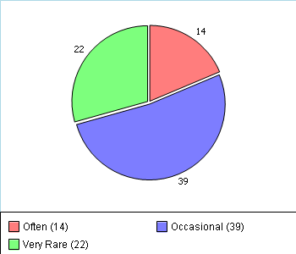 | Gender  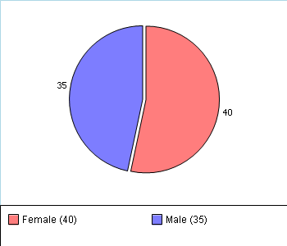
Ethnicity  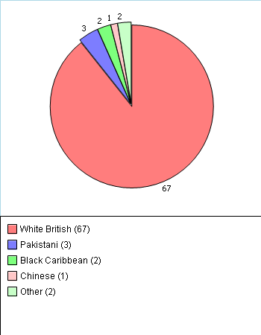 | Age  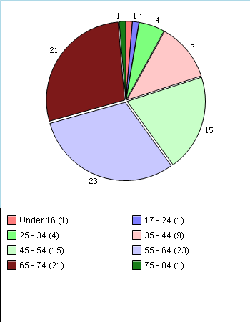
Survey Results

GPAQ V3 2012/2013
Number of Responses: 428
We would be grateful if you would complete this survey about your general practice. Your doctors want to provide the highest standard of care. Feedback from this survey will help them to identify areas that may need improvement. Your opinions are very valuable.
Please answer ALL the questions that apply to you. There are no right or wrong answers and your doctor will NOT be able to identify your individual answers.
Thank you.

About Receptionists and Appointments
Q1 How helpful do you find the receptionists at your GP practice?
Very helpful 51%
Fairly helpful 38%
Not very helpful 7%
Not at all helpful 1%
Don’t know 0%
No response 3%
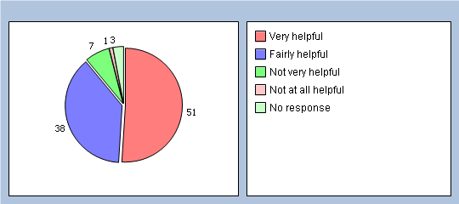
Q2 How easy is it to get through to someone at your GP practice on the phone?
Very easy 24%
Fairly easy 55%
Not very easy 13%
Not at all easy 3%
Don’t know 0%
Haven’t tried 1%
No response 4%
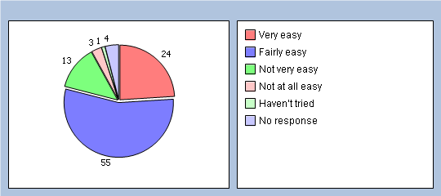

Q3 How easy is it to speak to a doctor or nurse on the phone at your GP practice?
Very easy 16%
Fairly easy 36%
Not very easy 9%
Not at all easy 4%
Don’t know 3%
Haven’t tried 28%
No response 4%
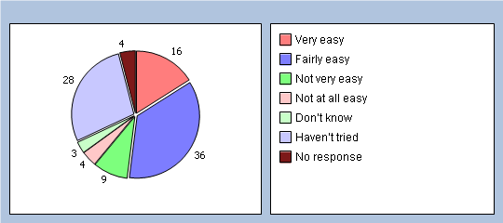
Q4 If you need to see a GP urgently, can you normally get seen on the same day?
Yes 73%
No 13%
Don’t know / never needed to 11%
No response 3%
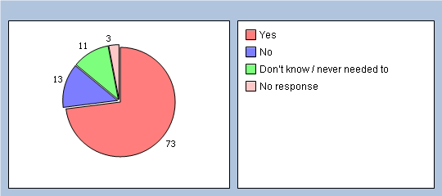

Q5 How important is it to you to be able to book appointments ahead of time in your practice?
Important 74%
Not important 25%
No response 1%
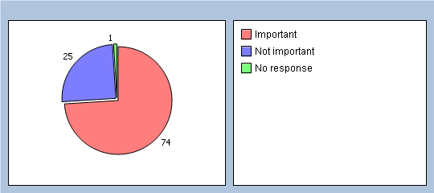
Q6 How easy is it to book ahead in your practice?
Very easy 12%
Fairly easy 28%
Not very easy 31%
Not at all easy 7%
Don’t know 4%
Haven’t tried 15%
No response 3%
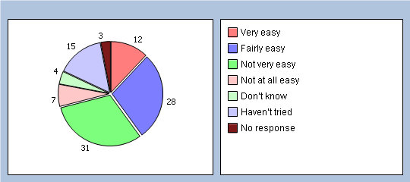
Q7 How do you normally book your appointments at your practice? Please tick all boxes that apply.
In person 56%
By phone 91%
Online 4%
Doesn’t apply 0%
Q8 Which of the following methods would you prefer to use to book appointments at your practice? Please tick all boxes that apply.
In person 57%
By phone 89%
Online 34%
Doesn’t apply 0%

Thinking of times when you want to see a particular doctor:
Q9 How quickly do you usually get seen?
Same day or next day 11%
2-4 days 25%
5 days or more 39%
I don’t usually need to be seen quickly 4%
Don’t know, never tried 18%
No response 3%
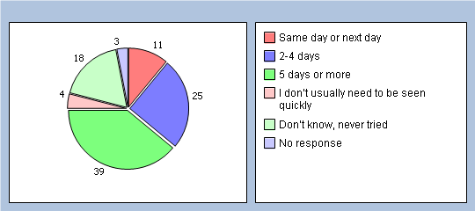
Q10 How do you rate this?
Excellent 11%
Very good 11%
Good 16%
Fair 22%
Poor 13%
Very poor 2%
Does not apply 19%
No response 6%
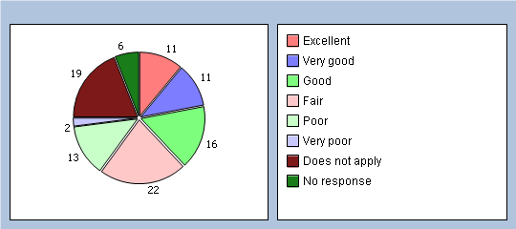

Thinking of times when you are willing to see any doctor:
Q11 How quickly do you usually get seen?
Same day or next day 65%
2-4 days 24%
5 days or more 5%
I don’t usually need to be seen quickly 1%
Don’t know, never tried 2%
No response 3%
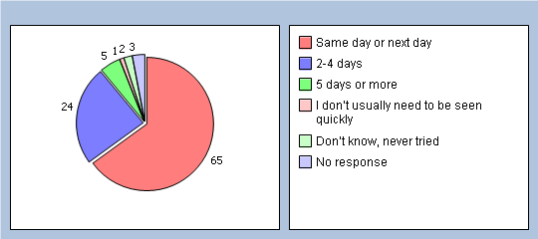
Q12 How do you rate this?
Excellent 32%
Very good 31%
Good 16%
Fair 10%
Poor 3%
Very poor 1%
Does not apply 3%
No response 4%
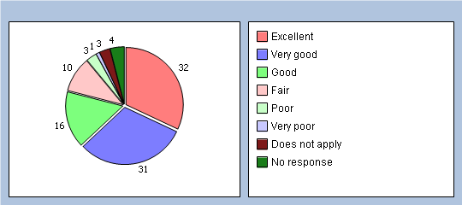

Thinking of your most recent consultation with a doctor or nurse
Q13 How long did you wait for your consultation to start?
Less than 5 minutes 10%
5 – 10 minutes 42%
11 – 20 minutes 34%
21 – 30 minutes 9%
More than 30 minutes 3%
There was no set time for my consultation 0%
No response 2%
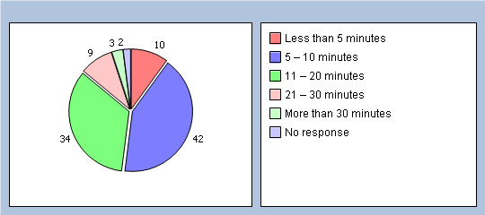
Q14 How do you rate this?
Excellent 13%
Very good 30%
Good 25%
Fair 21%
Poor 5%
Very poor 3%
Does not apply 0%
No response 3%
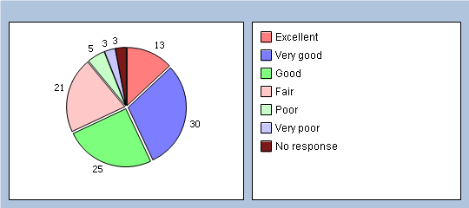

About opening times
Q15 Is your GP practice currently open at times that are convenient to you?
Yes - Go to Q17 80%
No 17%
Don’t know 0%
No response 3%
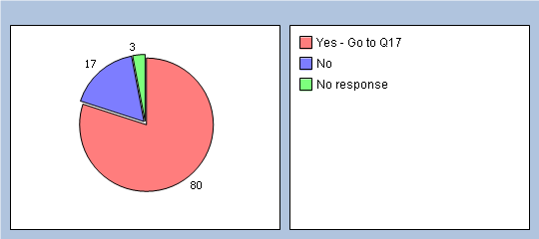
Q16 Which of the following additional opening hours would make it easier for you to see or speak to someone? Please tick all boxes that apply.
Before 8am 4%
At lunchtime 11%
After 6.30pm 4%
On a Saturday 5%
On a Sunday 1%
None of these 1%

About seeing the doctor of your choice
Q17 Is there a particular GP you usually prefer to see or speak to?
Yes 52%
No - Go to Q19 46%
There is usually only one doctor in my surgery - Go to Q19 0%
No response 2%
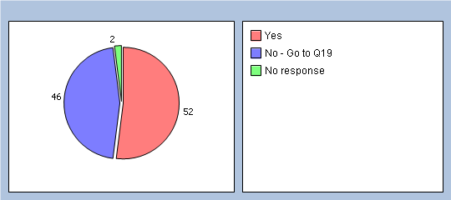

Q18 How often do you see or speak to the GP you prefer?
Always or almost always 8%
A lot of the time 15%
Some of the time 24%
Never or almost never 3%
Not tried at this GP practice 1%
No response 49%
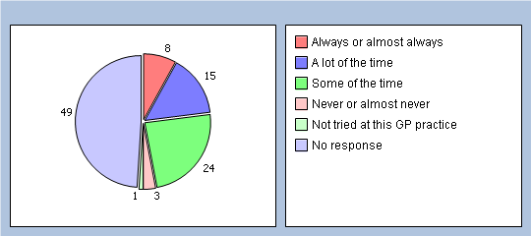

How good was the last GP you saw at each of the following?
(If you haven’t seen a GP in your practice in the last 6 months, please go to Q25)
Q19 Giving you enough time
Very good 58%
Good 34%
Fair 4%
Poor 0%
Very poor 0%
Does not apply 0%
No response 4%
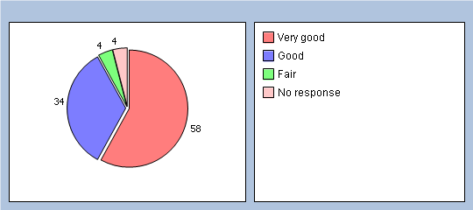

Q20 Listening to you
Very good 64%
Good 29%
Fair 3%
Poor 0%
Very poor 0%
Does not apply 0%
No response 4%
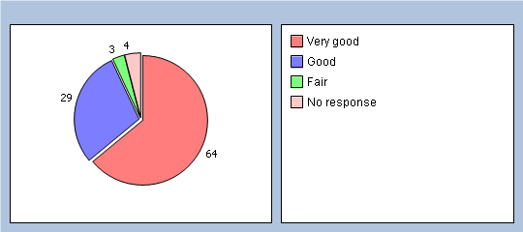
Q21 Explaining tests and treatments
Very good 53%
Good 30%
Fair 9%
Poor 0%
Very poor 0%
Does not apply 3%
No response 5%
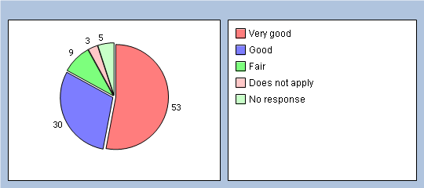

Q22 Involving you in decisions about your care
Very good 51%
Good 34%
Fair 8%
Poor 0%
Very poor 0%
Does not apply 3%
No response 4%
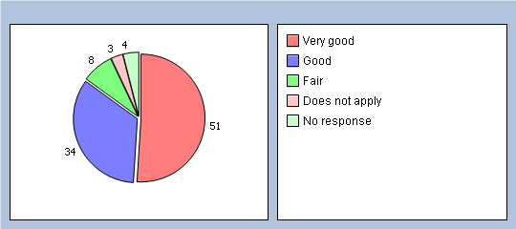
Q23 Treating you with care and concern
Very good 60%
Good 32%
Fair 4%
Poor 0%
Very poor 0%
Does not apply 0%
No response 4%
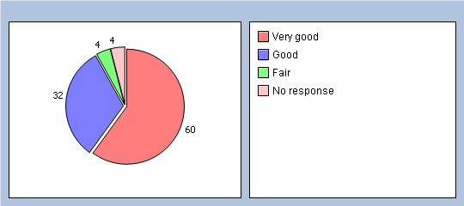

Q24 Did you have confidence and trust in the GP you saw or spoke to?
Yes, definitely 83%
Yes, to some extent 13%
No, not at all 1%
Don’t know / can’t say 0%
No response 3%
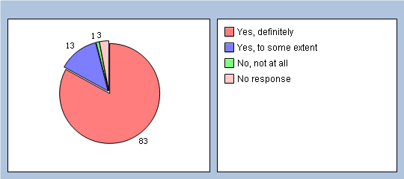
If you know the name of the GP you last saw, please write it here:

How good was the last nurse you saw at each of the following?
(If you haven’t seen a nurse in your practice in the last 6 months, please go to Q31)
Q25 Giving you enough time
Very good 30%
Good 23%
Fair 3%
Poor 0%
Very poor 0%
Does not apply 1%
No response 43%
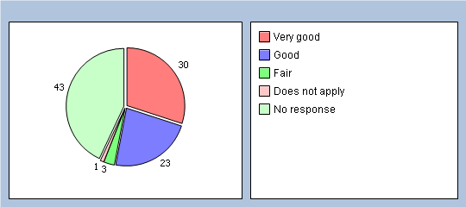

Q26 Listening to you
Very good 29%
Good 23%
Fair 3%
Poor 1%
Very poor 0%
Does not apply 1%
No response 43%
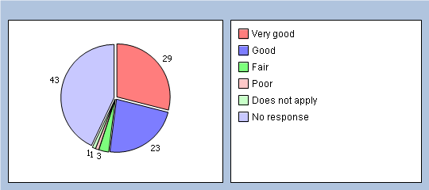
Q27 Explaining tests and treatments
Very good 26%
Good 22%
Fair 3%
Poor 0%
Very poor 0%
Does not apply 5%
No response 44%
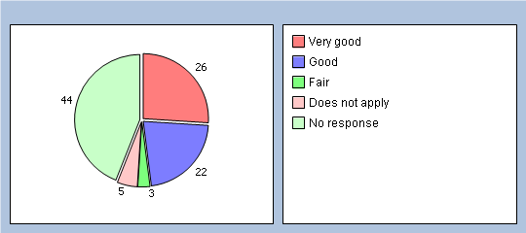

Q28 Involving you in decisions about your care
Very good 27%
Good 20%
Fair 4%
Poor 0%
Very poor 0%
Does not apply 6%
No response 43%
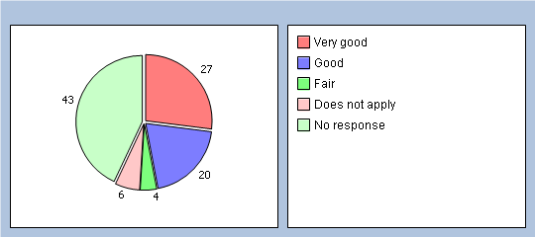
Q29 Treating you with care and concern
Very good 30%
Good 23%
Fair 3%
Poor 0%
Very poor 0%
Does not apply 0%
No response 44%
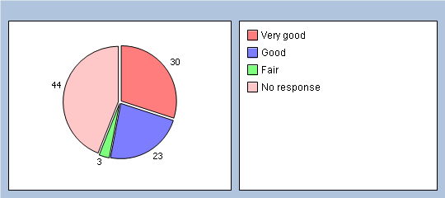

Q30 Did you have confidence and trust in the nurse you saw or spoke to?
Yes, definitely 47%
Yes, to some extent 8%
No, not at all 1%
Don’t know / can’t say 1%
No response 43%
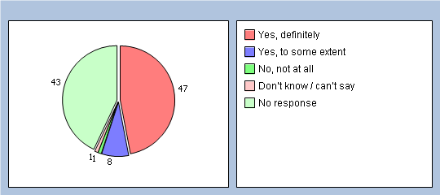
If you know the name of the nurse you last saw, please write it here:

About care from your doctors and nurses

Thinking about the care you get from your doctors and nurses overall, how well does the practice help you to:
Q31 Understand your health problems?
Very well 88%
Unsure 8%
Not very well 1%
Does not apply 0%
No response 3%
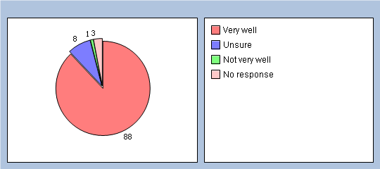

Q32 Cope with your health problems
Very well 86%
Unsure 8%
Not very well 1%
Does not apply 2%
No response 3%
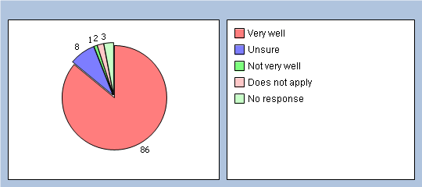
Q33 Keep yourself healthy
Very well 82%
Unsure 9%
Not very well 2%
Does not apply 4%
No response 3%
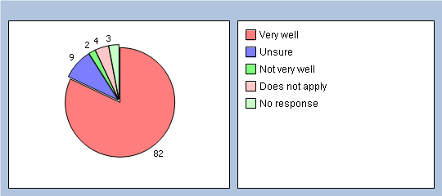

Q34 Overall, how would you describe your experience of your GP surgery?
Excellent 32%
Very good 41%
Good 17%
Fair 6%
Poor 0%
Very poor 0%
No response 4%
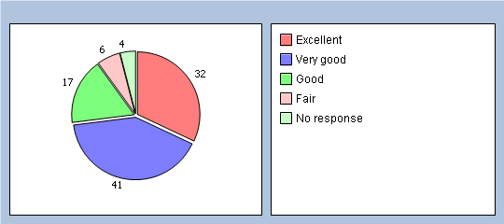
Q35 Would you recommend your GP surgery to someone who has just moved to your local area?
Yes, definitely 60%
Yes, probably 32%
No, probably not 2%
No, definitely not 1%
Don’t know 2%
No response 3%
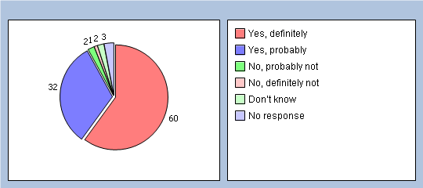

It will help us to understand your answers if you could tell us a little about yourself
Q36 Are you?
Male 48%
Female 50%
No response 2%
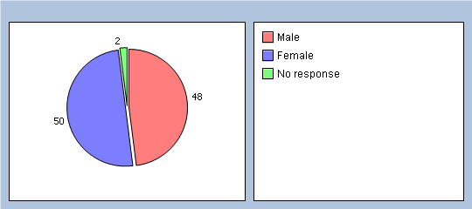
Q37 How old are you?
Under 16 0%
16 to 44 48%
45 to 64 27%
65 to 74 14%
75 or over 7%
No response 4%
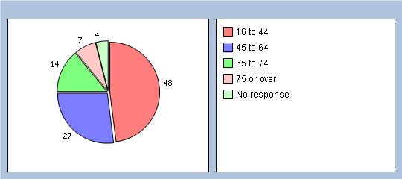

Q38 Do you have a long-standing health condition?
Yes 46%
No 47%
Don’t know / can’t say 3%
No response 4%
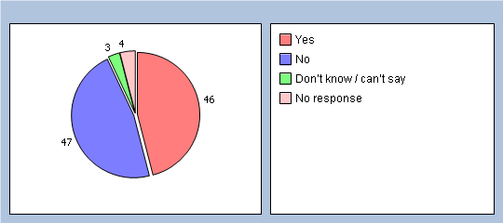
Q39 What is your ethnic group?
White 43%
Black or Black British 19%
Asian or Asian British 21%
Mixed 10%
Chinese 0%
Other ethnic group 2%
No response 5%
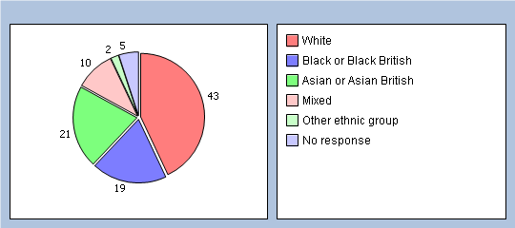

Q40 Which of the following best describes you?
Employed (full or part time, including self-employed) 38%
Unemployed / looking for work 10%
At school or in full time education 4%
Unable to work due to long term sickness 8%
Looking after your home/family 10%
Retired from paid work 23%
Other 0%
No response 7%
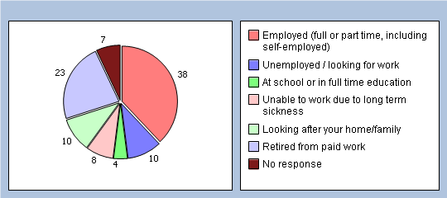
Finally, please add any other comments you would like to make about your GP practice:
© 2011 GPAQ V3 including all individual questions is copyright University of Cambridge/University of Manchester

