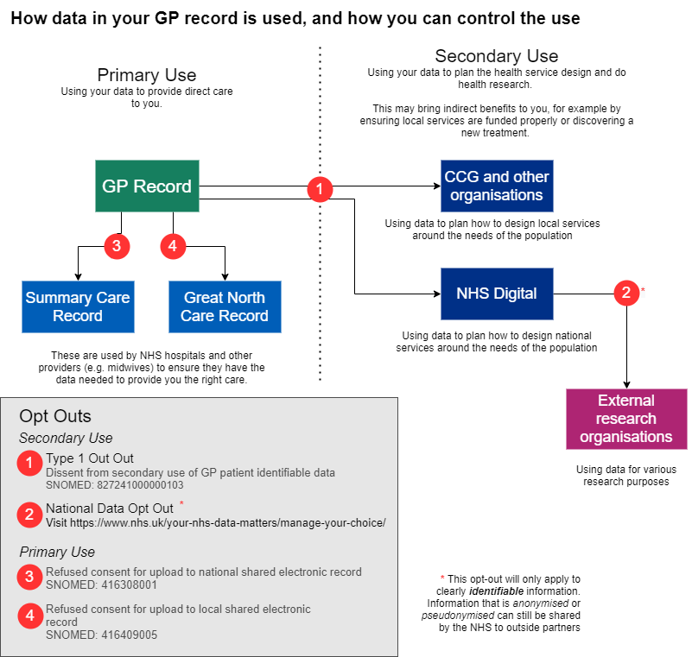Click on the above diagram to view in full resolution

