THE BELLINGHAM PRACTICE
NEWSLETTER – SPRING 2023



PRACTICE TEAM NEWS

Dr Mandy Gray is retiring from the partnership at the end of March. Please see a message from her towards the end of this newsletter. We wish her well for a long and happy retirement.

Dr Julia Pennington will be joining the practice partnership on 3rd April. Some of you may remember her from her placements at Bellingham when she was on the GP training scheme. Since qualifying as a GP she has been working as a salaried GP at Northumberland Health (Widdrington and Felton surgeries).

GP Registrars
We have 4 GP Registrars on placement at the practice until August :
Dr Katie Sissons, Dr Fletcher Schofield, Dr Eleanor Walker and Dr Gemma Philpott
This is the final training placement for all of them and we are asking patients to provide their consent to record telephone and face to face consultations to help the the GP Registrars with submissions for their exams. If you do not wish to have your consultation recorded that is absolutely fine.

Staffing update
Vicky Duncan has been appointed to a new Senior Receptionist role in addition to her role as Practice Medicines Manager and working as a Healthcare Assistant.

Danelle Dodds started on the Kickstart programme for 6 months in March 2022 and secured a permanent post in the administration team at the end of her placement.

Sarah Short jointed the reception/administration team in December and Caroline Dilger in January.

Healthcare Assistant apprentice Ellie Henderson joined the practice in March 2022 and combines learning on the job with training at Northumbria Healthcare. Ellie is now taking bloods, recording blood pressures, administering injections and performing ECGs and will continue to expand her role as time progresses.

Danelle and Ellie are now leading the practice reaccreditation process for the You're Welcome programme - this is an initiative that looks to making the practice friendly and welcoming to young people.

Kath Bainbridge, our senior Healthcare Assistant is taking on Nurse Associate training supported by the practice. This has just started and is a 2 year programme. This will enable Kath to take on additional duties to support the nursing team at the end of the training.

MEDICAL STUDENT PLACEMENTS

Two Year 4 medical students Newcastle University have been on placement with us on alternate Wednesdays since September – Joe Bews and Subhi Loganathan.
Their placement finishes at the end of March

Three Year 5 medical students were on placement with the practice in the autumn and they will each be returning for a 4 week placement from the end of March – end of June. Christine Huon, Isabelle Kenworthy and Benedict Li.

We would like to thank all the patients who consent to have a student sitting in their consultation, or have a supervised appointment with the students – this is an important part of their training and we get very positive feedback regarding their experiences at the practice.

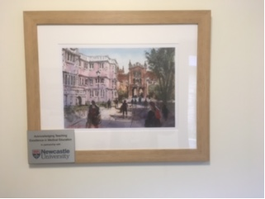

We recently received a framed print of the Newcastle University buildings as a thank you and acknowledgement of teaching excellence in medical education. This is on display in the corridor containing the doctors' consulting rooms

West Northumberland Primary Care Network
The Bellingham Practice is part of the West Northumberland Primary Care Network (PCN). Primary Care Network's aim to deliver improved levels of care for patients by connecting the primary healthcare teams across the area with local community service providers. This allows a new more streamlined, multi-disciplined personalised and co-ordinated approach to patient care.

The other practices in the West Northumberland PCN are are Branch End, Burnbrae, Corbridge, Haltwhistle, Humshaugh & Wark, Prudhoe, Scots Gap, Sele and White Medical Group. The network also provides services to Adderlane and Riversdale surgeries.

The practices in the West Northumberland PCN worked together to provide the local covid vaccination clinics – initially at the Primary Care Centre in Hexham and then at Hexham Mart.

PCN appointment hubs
The funding for Enhanced Hours provision changed in October 2022 and is now being provided through Primary Care Networks. The local PCN has set up a number of "appointment hubs" to provide appointments on weekday evenings and on Saturdays.
Appointments are available at Corbridge on weekday evenings and at Hexham Primary Care Centre every Saturday. Bellingham and Prudhoe surgeries are providing appointments on 2 Saturdays every month

The hubs offer pre-bookable, routine GP, Nurse and Health Care Assistant sessions. If you require more information or would like to book an appointment please contact us on 01434 220203 as all appointments must be booked through your GP Practice. This service is not for urgent care needs.

Women's Health appointments are available on Tuesday evenings (Corbridge) and Saturdays (Hexham) which may be useful for booking smear tests outside of normal working week, or coil insertion or removals (we do not do coil insertions at Bellingham).

Primary Care Network staff
PCNs receive funding to provide staff in a variety of roles who work across the practices in the network. West Northumberland PCN employs staff in the following roles who are providing appointments for patients at Bellingham:

First Contact Physiotherapist – for patients with musculoskeletal problems (including sports injuries), spinal pain (including neck, thoracic and low back problems, gait and balance problems. The FCP service provides rapid access to specialist assessment via telephone and will arrange onward management or referral if required. Helen Mathie is our current FCP.

Primary Care Mental Health Practitioners provide mental health support for patients in the PCN member practices. Valerie Humble is supporting the patients at Bellingham.

Living Well Co-ordinator - the Living Well Service supports people with emotional wellbeing, finance and benefits, social networks, employment & skills, family relationships and parenting, healthy lifestyles and housing. The Living Well Co-ordinators will support each patient either by face to face or telephone and find out exactly what the patient needs. This can be linking them in with local support groups or referring to other agencies that can provide further support. Practice staff can refer you to the Living Well Service or you can self refer by contacting them on 01434 600599

PCN Clinical Pharmacists – carry out structured medication reviews on specific groups of patients, support the Practice Medicines Manager with the annual service level agreement, perform audits to improve prescribing and patient safety and is available to assist with medication queries. Alison Smith is our clinical pharmacist.

Respiratory Diagnostic Service – spirometry and Feno testing across 4 sites for patients who are suspected of having asthma or COPD. The service provides interpretation of results and recommendations to support clinicians in future management of patients.

The West Northumberland Primary Care Network has a Facebook page which is regularly updated with news about what the PCN is doing, information from member practices, local organisations and groups, the NHS, events and ways to get involved

We have had confirmation that Covid Spring Boosters will be going ahead starting in early April until end of June, for:

Patients 75+ (on or before the 30.6.23)
Patients in Older Adult Care homes
Patients age 5+ who are immunosuppressed

The Primary Care Network is starting to plan provision of covid vaccination clinics for the spring boosters and more information will be provided when it is available.

It is really helpful patients who have mobile phones share their numbers with us (and inform us if they change their number). This is a really easy way of us getting information out to a lot of people very quickly

Life is starting to return to more normal ways of working at the surgery, but we are still asking patients and staff to wear a face mask and continue to triage requests for doctors appointments – this is to ensure that patients can be seen by the most appropriate person, and also it may be more efficient to arrange a blood test or an x-ray before you see a GP.

Working during the pandemic saw us adopting lots of new ways of working, many of which have become very useful and convenient for patients. For example:

Our eConsult service is available 24 hours a day from our website home page if you want to submit a query or request medical advice. The website address is www.thebellinghampractice.co.uk
These requests come into a secure admin mailbox and are processed each day by reception staff who will book the eConsult into a dedicated appointment slot. Depending on the content of your query you may receive a telephone call from a GP or be asked to come for an appointment, or receive advice on self-care. Occasionally some responses to questions on eConsult lead to instructions advising you to contact NHS 111, call 999 or contact the practice.

You can now submit photographs of your medical problem (for example a rash or an injury) using either eConsult or a link we can send to your smartphone

We can now email or text Fit Notes

We can send out questionnaires to ask you about a variety of issues such as asthma or alcohol, smoking status, advice before a PSA test. Your response is filed into your record and a member of the clinical staff is notified.

Batch messaging to notify patients of dates for flu clinics or covid vaccination clinics.

You can use the NHS App to access a range of NHS services on your smartphone or tablet – view your GP medical record securely, order repeat prescriptions, check your symptoms, look up your immunisation record, register your organ donation decision, get a NHS Covid Pass

However we do recognise that some of our patients do not have access to mobile phones or the internet so please be assured that not everything needs to be done online and we will continue to provide a variety of ways of contacting the practice in order to avoid "digital exclusion".



Digital Support Session Thursday 16 March

The PCN has recently provided Digital Support sessions at Ponteland and Hexham
and are helping the practice to host a session at Bellingham Surgery on 16th March.
The feedback from the initial sessions has been very positive.

If you are interested in getting some support to access your healthcare online please contact the surgery and book a slot at this session. You will receive one to one time to increase your knowledge and build confidence in using digital services. If there is lots of interest we will provide more sessions to support patients to use the various digital services that are now available on your phone, tablet, laptop or computer.

Examples of things we could cover (or you may have your own requests) :

- submit an online consultation via the practice website (eConsult),
- order your repeat prescriptions online
- use the NHS App or Online access via the practice website
- check your blood test results online
- view your immunisation history
- view recent consultations and letters in your medical record
- send a photograph to the practice
- use a QR code



The practice Patient Participation Group held a meeting on 23rd February. Most of the topics discussed are covered in this newsletter.

If you are interested in joining this group, which is now planning to meet on a quarterly basis, please contact Jayne Reed

Practice Research SOLID Study:
SOLID is study where individuals with risk factors for fatty liver disease will have a liver health check to identify advanced liver fibrosis/cirrhosis when they attend their primary care annual chronic disease review- practice staff are being trained to deliver this service.
To start with we are identifying diabetics but this research study will be rolled out to other long term conditions once training has been completed.
Dr Helen Jarvis is the lead GP on this and Heidi Moore, one of our Healthcare Assistants, has undergone training.

NEWS ABOUT OTHER SERVICES

The administration base for the Northumberland 0 – 19 Health Service base for our area has recently moved to St Matthew's House in Hexham. The new contact number for this service is 0300 373 2488.

For families with young children we recommend you use the Healthier Together App which provides advice on a range of childhood illnesses and when to contact a health professional. Or if you prefer, use the Healthier Together website at nenc-healthiertogether.nhs.uk)

For some services you can self-refer without needing to speak to a GP first.

- For physio please contact the JMAPS service (Joint Musculoskeletal and Pain Service by calling 03301 244 652. They can help you manage back pain, sciatic, soft tissue problems, joint pain, persistent musculoskeletal pain conditions)
- For help with mental health contact Talking Matters on 0300 303 0900

- If you are newly pregnant, you can refer yourself to maternity services by ringing 0191 293 2545

- For assistance with non-medical matters such as housing issues, benefits, legal advice, please contact the Living Well Coordinators on 01434 600599.

Message from Dr Mandy Gray

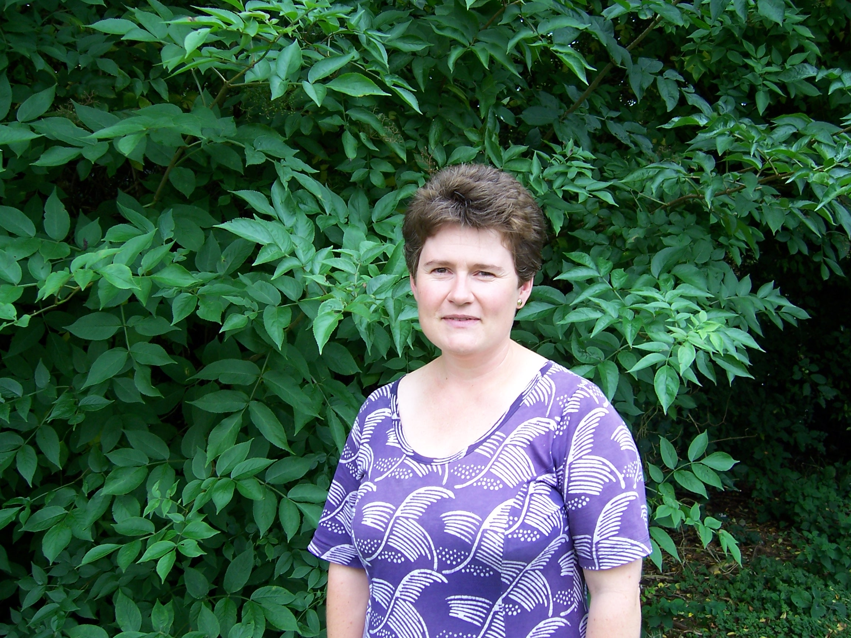

It is with mixed feelings that I approach my retirement from The Bellingham Practice. It is a decision which has been several years in the making and has been influenced by feeling secure that I am keeping up to date with all the changes in medical practice generally and retaining the energy and enthusiasm to enjoy learning new and different things.

There are two things that I recall very clearly from early February 1996 when I first arrived.
One being that as I stepped out of the car the snow was level with the top of my wellies!
The second was feeling extremely daunted after sitting in morning surgery with my trainer and observing him gather all the information about the most pressing problem of the day for each patient, updating on other medical conditions and catching up on the family, all within the 10 minutes or so allocated for each appointment. How was I ever going to achieve this? It remains a work in progress.

I spent six months working as a Registrar and was fortunate to be offered regular locum work following on from that. During that time, I worked as a locum GP in a few practices in the west of Northumberland which was very helpful in confirming my beliefs that Bellingham was the place that I wished to settle. We bought our home in the North Tyne valley and our daughters arrived. Soon after that I was offered a role as a salaried doctor in the practice and two years later the opportunity to apply for partnership, taking on this role in 2001.

Over the years much has changed in the team, the building, the villages and communities we serve, the NHS as a whole and the world beyond. Yet a lot also remains very similar. There is good continuity within the team. For some it remains a place to spend most of a working lifetime and together we have nurtured the growth and development of the team and the building to maintain a GP surgery in the community delivering care to you, our patients and fulfilling the standards required of us.

Another constant is our commitment to teaching and training. We are ever grateful for your willingness to welcome, consult with and get to know the medical students, student nurses and GP Registrars who spend time in the practice with us. The majority of those who come to Bellingham during their training enjoy the experience and some look for the opportunity to stay. Dr Andy Sewart, Dr Helen Jarvis and my successor Dr Julia Pennington are all former GP Registrars.

We are also grateful to those of you who agree to have a member of staff who is undergoing in house training present during your consultations.

Although there have been challenges over the years it has been possible to work through and overcome these with the skill and dedication of the team and with your ongoing support.

It is at this time that I look back and reflect on the many experiences of my time as a GP and the unique opportunity this has allowed me to share in your life experiences. Undoubtedly some of these have been very difficult and there have been tears but there have also been joys and some laughter.

None of the training that I received in medical school or beyond prepared me for the enormous change which occurred in Spring 2020 with the impact of the pandemic. An event which tested all of our resilience, ability to adapt and resourcefulness in completely new ways, both in our personal and working lives. We all adopted new ways of working. I valued the fact that I still went to my usual place of work with my colleagues and although consultations were almost entirely on the phone, I could at least picture most of you as we spoke. Many of you adapted to working from home whilst educating your children without the presence of family and friends for support. Who knew that Zoom and Teams meetings would become our normal way of meeting with family, friends and colleagues?

So what does the future hold?
I am planning to spend a lot more time out in the fresh air transferring my caring responsibilities to our garden and our beekeeping. I still have a great deal to learn but look forward to being able to sit down with a cup of tea and see what I have achieved after a day of work.

Our daughters live away from Northumberland now, so I am looking forward to having more opportunity to travel to visit them and other family.
The work of the practice will continue just the same because it is a team not merely a collection of individuals. The partnership transition was expected, prepared for and all is now ready.

There is nothing more certain than change in our lives and that is certainly true in the NHS.

The team at Bellingham will continue to adapt to the changes that are required of them, maintaining the outward impression, very often that nothing has changed, but with the reality of many hours of meetings and systems changes that make all this possible. What I have come to refer to as the invisible work of General Practice.
They will continue to value your support and kindness as I have done.

I am now reminded of an expression that I was taught as a child.

Thank you for having me. I have had a lovely time.

With best wishes

Mandy Gray

BANK HOLIDAYS
GOOD FRIDAY 7 APRIL & EASTER MONDAY 10 APRIL

MONDAY 1ST MAY, SPRING BANK HOLIDAY MONDAY 29TH MAY & AN
ADDITIONAL BANK HOLIDAY THIS YEAR ON MONDAY 8TH MAY (FOR THE KING'S CORONATION)

If you need advice for a minor/mild illness or injury you could either contact your local pharmacy for help or look at the self-care advice that is available from the NHS at www.nhs.uk

If you want to check your symptoms, there is an on-line symptom checker available at www.111.nhs.uk, which will re-direct you to a health professional if you need to be consulted by someone.

Over the bank holiday weekends you can ring NHS 111 at any time of the day or night for non- emergency health advice and information. NHS 111 can help you to access a GP appointment or see a pharmacist over the bank holiday – this is to ensure that patients who really need emergency care (in A&E departments) receive the treatment they need as quickly as possible and that people who can be cared for elsewhere are not waiting in busy A&E departments.

The NHS 111 service is available 24 hours a day, 365 days a year.
Calls are free from landlines & mobile phones.

For access to the out of hours dental service ring NHS 111, or you can access information on the NHS website at www.nhs.uk

If you need any repeat medication over the Bank Holiday weekends , please remember to order well in advance as it can be difficult to arrange during the period covered by the out of hours service.

We hope that you find this practice newsletter informative – please let us know if there is anything you would like to include in future issues.

