Waiting for an answer……………………
Do you feel that Chadsfield Medical Practice doesn’t answer the phones quick enough when you ring?

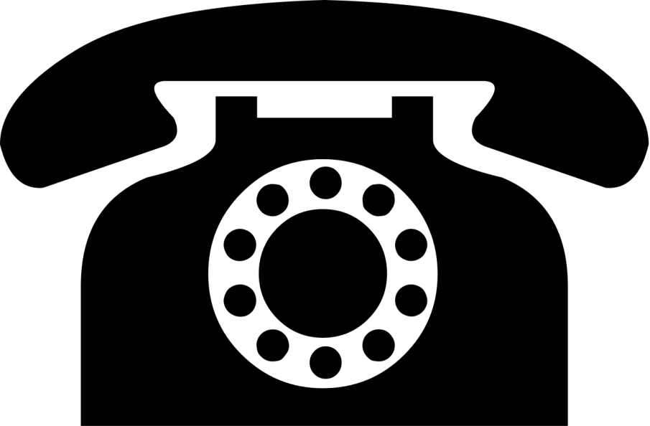

Here at Chadsfield we have 3 lines into the practice and 3 people answering the telephones from 8am. The calls are answered in turn and if all lines are busy you will get an engaged tone.
In April 2017 the CCG had the first part of a compulsory new phone system installed. We are still waiting for the final part of the installation which will allow patients to direct their call to the appropriate department. We anticipate this will be in April 2018
We would like to reinforce that our staff should not expect to receive verbal abuse. Chadsfield Medical Practice has a zero tolerance policy that can be viewed at any time.
Chadsfield would like to apologise for the delays you experience and request your patience when waiting for the phone to be answered.
Chadsfield Medical Practice

