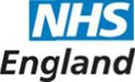

# NHS England : Example Easy Read Format

(Community/mental health)

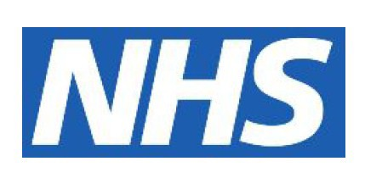

**The NHS Friends and Family Test**

Service Provider:

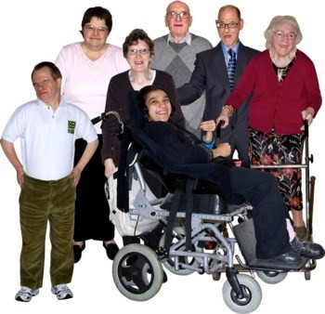

**Would you want your friends and family to**

**have this service if they needed it?**

Yes

Maybe

No

Don’t

Know

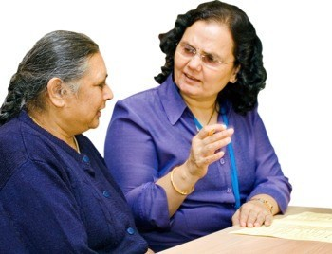

**Did the staff explain things well?**

Yes

Maybe

No



**Were Staff friendly and helpful to you?**

Yes

Maybe

No

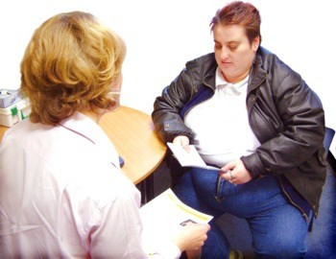

**Did the staff listen to you?**

Yes

Maybe

No

**1**

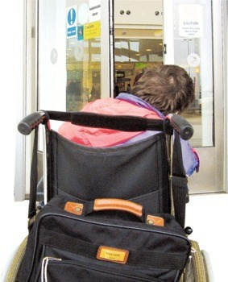

**Did the staff explain what will happen next with**

**your health care?**

Yes

Maybe

No



**What was good about the visit?**

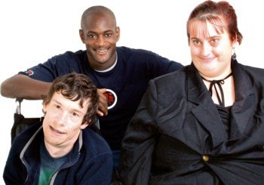

**Did the staff listen to your carer or family?**

|  |  |  |  |  |  |  |  |  |  |  |  |  |  |
| --- | --- | --- | --- | --- | --- | --- | --- | --- | --- | --- | --- | --- | --- |
|  | Yes |  | Maybe | | |  | | No | |  | N/A | |  |
|  |  |  | |  |  | |  | |  | |  |  | |

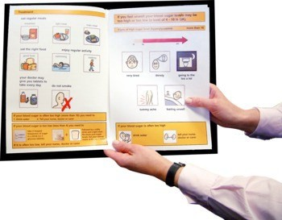

**Were you given easy to understand information**

**about the service?**

Yes

Maybe

No

**Thank You 2**



**What would have made the visit better?**

NHS England, licensed user of Photosymbols. Produced by Thames Valley Area Team