Antibiotic Amnesty 2022
Toolkit v1

An Antibiotic Amnesty is being held this November throughout the entire Midlands. The amnesty begins on Tuesday 1 November 2022 and ends on Wednesday 30 November 2022.

We are encouraging members of the public, as well as health and social care staff, to return old or unused antibiotics to their nearest pharmacy. Safely disposing of old or unused antibiotics via a local pharmacy will help to keep antibiotics working, tackling the rise of antibiotic resistance.

Please find suggested social media copy to share from Monday 24 October 2022 until the end of November. The following general use resources, available to download here, are also available for the following platforms:

- Email signature
- Web banner
- TV screen
- Instagram
- Instagram story
- Facebook
- Twitter

Two A4 posters are also available – one for general use and the other for pharmacy use only. The general use poster directs people to hand in their old or unused antibiotics at any local pharmacy, whereas the pharmacy use only poster is intended to be used in a pharmacy and directs people to return their antibiotics to that pharmacy.

Resources are available to download here in the following languages:

- Arabic
- Bengali
- English
- Farsi
- Kurdish Kurmanji
- Kurdish Sorani
- Pashto
- Polish
- Punjabi
- Romanian
- Somali
- Tigrinya
- Urdu

Helpful links:
- NHS Birmingham and Solihull – Antibiotic Amnesty 2022
- NHS Birmingham and Solihull – Antibiotics awareness
- NHS - Antibiotic resistance
- NHS – Find a pharmacy

Suggested posts for social media

When posting on social media, please use #antibioticamnesty where possible.

Suggested copy | Image
Do you have any unused or old antibiotics at home?  👨‍👩‍👦‍👦 People across the #Midlands are being asked to return them to any local pharmacy as part of an Antibiotic Amnesty taking place throughout November.  ➡️ Find out more here: https://bit.ly/3Thscha | 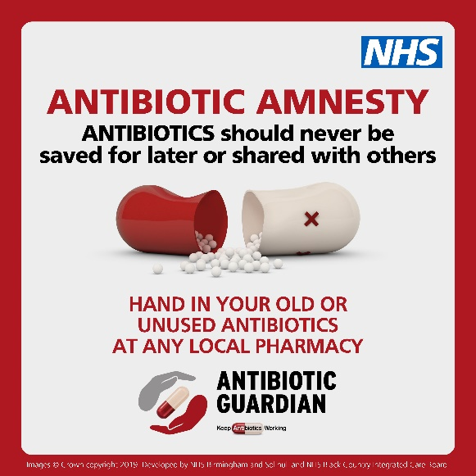  FORMAT: Static image available for:  - Facebook  - Twitter  - Instagram  Alt / Descriptive text:  An image of an antibiotic drug capsule broken in two. The text reads: Antibiotic Amnesty. Antibiotics should never be saved for later or shared with others. Hand in your old or unused antibiotics at any local pharmacy. Antibiotic Guardian. Keep antibiotics working.
This November, join our Antibiotic Amnesty.  💊 If you have old or unused antibiotics at home, please take them to a local pharmacy in the Midlands.  ➡️ Follow the link to find out why you should never save antibiotics for later or share them: https://bit.ly/3Thscha | FORMAT: Static image available for:  - Facebook  - Twitter  - Instagram  Alt / Descriptive text:  An image of an antibiotic drug capsule broken in two. The text reads: Antibiotic Amnesty. Antibiotics should never be saved for later or shared with others. Hand in your old or unused antibiotics at any local pharmacy. Antibiotic Guardian. Keep antibiotics working.
Did you know that antibiotics should never be saved for later or shared with others?  💊 If you have old or unused antibiotics at home, join our Antibiotic Amnesty and take them to your nearest pharmacy.  ➡️ Learn more about our #antibioticamnesty: https://bit.ly/3Thscha | FORMAT: Static image available for:  - Facebook  - Twitter  - Instagram  Alt / Descriptive text:  An image of an antibiotic drug capsule broken in two. The text reads: Antibiotic Amnesty. Antibiotics should never be saved for later or shared with others. Hand in your old or unused antibiotics at any local pharmacy. Antibiotic Guardian. Keep antibiotics working.
An Antibiotic Amnesty is held across the Midlands this November.  💊 Anyone with old or unused antibiotics should take them to a local pharmacy, where the antibiotics will be disposed of safely.  ➡️ Follow the link to learn more: https://bit.ly/3Thscha | FORMAT: Static image available for:  - Facebook  - Twitter  - Instagram  Alt / Descriptive text:  An image of an antibiotic drug capsule broken in two. The text reads: Antibiotic Amnesty. Antibiotics should never be saved for later or shared with others. Hand in your old or unused antibiotics at any local pharmacy. Antibiotic Guardian. Keep antibiotics working.
This November, you can help to keep antibiotics working by taking your old or unused antibiotics to your nearest pharmacy.  📍 Find your nearest pharmacy: https://bit.ly/3u33Vjl  ➡️ Follow this link to learn more: https://bit.ly/3Thscha | FORMAT: Static image available for:  - Facebook  - Twitter  - Instagram  Alt / Descriptive text:  An image of an antibiotic drug capsule broken in two. The text reads: Antibiotic Amnesty. Antibiotics should never be saved for later or shared with others. Hand in your old or unused antibiotics at any local pharmacy. Antibiotic Guardian. Keep antibiotics working.
How can you keep antibiotics working?  👩‍⚕️ Only use antibiotics when prescribed by a certified health professional  💊 Always follow a health professional’s advice when using antibiotics  ❌ Never use leftover antibiotics  👪 Never share antibiotics with others  🚽 Never throw antibiotics in the bin or down the sink or toilet – always return to any local pharmacy for safe disposal.  🐶 And if you’re a pet owner, return unused antibiotics to the vets  📅 This November, join our Antibiotic Amnesty and take your old or unused antibiotics to your nearest pharmacy in the Midlands.  ➡️ Find out more here: https://bit.ly/3Thscha | FORMAT: Static image available for:  - Facebook  - Twitter  - Instagram  Alt / Descriptive text:  An image of an antibiotic drug capsule broken in two. The text reads: Antibiotic Amnesty. Antibiotics should never be saved for later or shared with others. Hand in your old or unused antibiotics at any local pharmacy. Antibiotic Guardian. Keep antibiotics working.
This November, supporting our Antibiotic Amnesty and taking your old or unused antibiotic to your local pharmacy is a great way that you can help to combat antibiotic resistance.  📈 The more antibiotics are used, the greater the risk of antibiotic resistance. Only take antibiotics when advised by a healthcare professional.  🏥 A growing number of infections, such as pneumonia and gonorrhoea, are becoming harder to treat, as the antibiotics used to treat them become less effective.  💊 Without effective antibiotics, many routine treatments will become increasingly dangerous.  🦴 Setting broken bones, operations, and treatments for cancer all rely on antibiotics that work  ➡️ Find out more here: https://bit.ly/3Thscha | FORMAT: Static image available for:  - Facebook  - Twitter  - Instagram  Alt / Descriptive text:  An image of an antibiotic drug capsule broken in two. The text reads: Antibiotic Amnesty. Antibiotics should never be saved for later or shared with others. Hand in your old or unused antibiotics at any local pharmacy. Antibiotic Guardian. Keep antibiotics working.

ENDS

