Patient Reference Group
Annual Report 2011/12

Phase 1 – Creating the Tenbury PRG

Introduction
The purpose of the Patient Reference Group (PRG) DES is to engage patients and to involve them in decisions about the range and quality of services provided by the practice.

Developing the Group
In March 2011 Tenbury Surgery began to undertake work to create a new Patient Reference Group (PRG). Discussions were held with the Partners and the Practice Manager of the surgery and it was decided that due to the rural locations of many patients a virtual PRG group would be the most suitable for Tenbury Patients.

Tenbury Surgery hoped to be able to invite as many patients as possible to join the PRG and in October, when the new Assistant Practice Manager joined the surgery, the PRG recruitment began.

Posters were displayed in the waiting areas and on the surgery website, leaflets were placed on the chairs and given to attending patients, letters were sent to a wide demographic of patients of the surgery asking if they would be willing to participate, and the Assistant Practice Manager undertook face-to-face recruitment with patients whilst they were waiting for their appointments (see Appendix 1 for literature).

Our aim was to develop a large virtual group made up of a diverse cross section of our patients. Although the PRG was to be a virtual group, it was noted that not all patients may be connected to the internet and thus it was agreed that postal members would be accepted to ensure there were no exclusions.

To date our practice list is 9,300 patients for both Tenbury Surgery and Clee Hill Surgery. We have so far recruited 18 members.

Although a large proportion of patients declined to join the group, patients have been completing the surveys both online and at the surgery, where the current survey is left in the waiting area on the chairs.

The survey method consists of mainly closed; structured; leading questions. By constructing the surveys in this method the results would provide us content validity from which we can gain an understanding of feelings and behaviour patterns from patients who use the services of Tenbury Surgery.

By undertaking these surveys we are hoping for more than statistical numbers to form our results, we are after a more in-depth and qualitative outcome to help improve the surgery and patient’s experiences when they attend.

A description of the profile of the members of the group:
We wanted patients from all spectrums to join our group so that we could have a true representation of the practice population as possible. In order to try and capture a fair demographic representation for the PRG we first looked at the demographics of the surgery as a whole.

In regards to Ethnicity, although we invite our patients to inform us of their ethnicity on their registration forms, the majority decline to do so. However, through local knowledge of Tenbury patients we can note that the majority of the practice population are of White British ethnicity; we have a small minority of Eastern European patients; a smaller minority of travellers; and a transient number of international patients who come to us from the international school in Tenbury.

In relation to our PRG the demographics are as follows:

The above charts show that the PRG is not fully representative of the practice population; however these charts are a good indicator to show us where certain groups are underrepresented in the PRG.

We can see that we need to encourage more men to join the group and that the age ranges of 17-24; 25-34 and 45-54 also need more encouragement to join the group. Under 16’s and 85+ are both 0%. We do not encourage under 16’s to join the group, and ask that they wait until they turn 16. In regards to patient’s over 85 we need to try and encourage these to partake in a method that is appropriate for them, for example postal, or whilst at the surgery spending a few minutes with the Assistant Practice Manager to go through the current practice survey.

In regards to ethnicity it can be noted that all the PRG members when completing their membership form have noted that they are White British. Thus, although we have written to certain patients who we know are from other ethnic backgrounds, we need to try and encourage members from other ethnicities to join our group to make it more representative for our practice population. The lack of uptake from those of Ethnic groups could be down to language barriers and thus the idea of having the information translated into Polish is currently being discussed.

A description of what steps the Practice has taken to ensure that the PRG is representative of its registers patients and where a category of patients is not represented then what steps have been taken by the Practice in an attempt to engage with those patients:

Practice Comments
We feel that we have created a sound PRG membership and we are aware of the areas which are underrepresented. We are still recruiting to our group and currently we are only in the infancy of having a fully operational PRG. However, we have worked hard on recruitment to encourage patients from all demographics to join the group, and we are considerate towards issues regarding access to internet; language barriers; working commitments and family commitments. We did not want patients to feel pressured into joining and thus by leaving the surveys in the waiting areas for completing anonymously allows patients the opportunity to express their thoughts and opinions without having to give up their spare time or commit themselves to the PRG.

Phase 2 – Using the PRG

Inclusion of Members – a description of how the Practice and the PRG determined and reached an agreement on the issues which had priority within the local Practice Survey
When a member signs up for the PRG they are sent a welcome email from the Assistant Practice Manager, a copy of the Aims and Objectives of the group and a copy of frequently asked questions (see Appendix 2). We are keen that those who join our PRG understand the role and responsibilities the group has and why they are central to the surgery. The members are also given a point of contact, the Assistant Practice Manager, who is on hand to answer any questions and to listen to any suggestions from the members. All the information and updates are also available to view on the surgery website http://www.tenburysurgery.co.uk/ppg.aspx which prospective members, existing members and members of the public can refer to for information.

Survey 1 - Issues of Priority
The PRG were asked to feedback to us their view on the prioritisation of 6 key areas relating to the surgery. These areas were:

- Environment of Surgery

- Attitude of Staff

- Access to Services

- Quality of Appointments

- Medication

- Provision and Display of Medication

We asked the PRG group and patients who wished to partake on line to rank these areas in the order of importance with 1 being most important and 5 being least important.

We applied the method of the ‘majority vote’ to choose the area to look at first, with the other areas falling into place according to the results. We felt that this was the fairest way to class the area deemed as most important by the PRG members, however we allowed feedback from the group via email should any of the members have been exceptionally unhappy with how we came to the decision. These results of the Prioritisation Survey can be seen in Appendix 3.

The outcome of this survey was that Attitude of Staff was rated as the top priority. Breaking this category down we decided to look at the staff in their various roles thus survey 1 is on Reception Staff (including admin) and a further practice survey will be compiled for Clinical Staff. This is due to the different roles that the staff perform and the necessity for differing questions.

The PRG members were emailed regarding the outcome of the Prioritisation survey and comments and suggestions were asked for at this point.

A description of how the Practice sought to obtain the views of its registered patients
Survey 2 – Attitude of Reception Staff

The Practice based the survey on a well established questionnaire (Improving Practice Questionnaire) which is widely used within the UK.

The first survey on Reception Staff was sent out in December 2011 to all the members of the PRG and was put on the Surgery website as well as being placed on the chairs in the waiting area.

The survey consisted of 9 closed questions and 5 open questions. Feedback was received from the PRG members regarding the methodology used for the survey, and it was discussed why the surgery had chosen to conduct the survey in the method it had. We encourage members to raise any concerns they may have regarding the survey, the method in which it is conducted or its content as the purpose of the PRG is to offer patients an arena where they can voice their thoughts and opinions and in turn improve the services we offer both all patients.

As the group is a virtual based group the Practice did not feel it fair or appropriate to ask the members to assist with asking patients to complete the survey. Thus the surveys were left in the practice waiting area with a covering letter from the Assistant Practice Manager. The Assistant Practice Manager also spent some mornings in the surgery asking patients if they would be willing to complete a survey whilst they were waiting to see a Doctor or Nurse. The reception staff handed out the survey to patients as they were booking in for their appointment and also encouraged patients to partake.

When the surgery had their information day on the 07 January 2012 (mainly regarding the closure of Tenbury Bridge) the staff used this opportunity to recruit more patients to the PRG and also to hand out a survey to every patient whom attended the surgery that day.

The surgery also used their website as a way of promoting the survey and the PRG enabling patients who do not attend the surgery frequently to still be able to partake and provide their views and opinions.

The survey was conducted between December 2011 and March 2012. A total of 86 completed surveys were returned by the closing date of the 19th March 2012, a further 4 were received after the date and have not been included in the final results. The data was analysed by the Assistant Practice Manager through the use of the My Surgery Office on the surgery website, and a report of the findings was compiled.

How the Surgery sought to discuss the outcomes of the local survey and the Surgery’s action plan together

The surgery analysed the local patient survey which pinpointed the areas where the surgery scored well and also the areas which needed improvement.

The results were discussed via email by the PRG members and an action plan was compiled based upon the results. The action plan was agreed by all and signed off on the 26 March 2012.

The findings and proposals that arose from the Surgery survey
Patients were asked to complete a total of 14 questions (a copy of the questionnaire follows on page 8) all in relation to the Reception staff at Tenbury Surgery.

There was space left for the patients to make comments however some of the comments were not related to reception staff, but the patients wanted them to be noted. In regards to these comments the Assistant Practice Manager has documented the comments and will ensure that they are matched up with the appropriate practice survey that follows.

Positive Responses
All of the staff have seemed more than willing to help even if I have felt like I’ve been a pain.

Overall we are very lucky to have a very good service.

I have always found the staff helpful and polite and understanding when appointments are needed and they have always been compassionate.

In the past 20 odd years I have always been treated well by Dr’s, Nurses, secretaries and all in reception.

As a newish patient I have been very impressed with the overall friendliness off all staff and doctors in comparison to my old surgery where I felt a nuisance all of the time.

Absolutely no complaints at any time!

Simply the best!

We’ve never encountered such a lovely GP practice before. Don’t change anything!

Responses found to be less positive
Having to queue at reception collect a number for your already booked appointment when there is only one receptionist on duty can cause you to be late for your appointment.

The overall appointment system, if you are too unwell to present yourself for a number at 8am you cannot always get in to see the Dr of your choice.

Turn off the music.

Not ignoring patients at the reception desk, even if the staff member is in the middle of something just a quick glance to let the patient know they have been seen and acknowledged.

Do not like the openness of the desk, people waiting can hear everything.

A summary of any evidence including statistical evidence relating to the findings or basis of proposals arising from the local Practice survey:

Tenbury Wells Surgery

Attitude of Reception Staff

Number of Responses: 86

Staff at the Surgery are friendly:
Strongly agree 63%
Agree 33%
Neither agree nor disagree 0%
Disagree 1%
Strongly disagree 0%
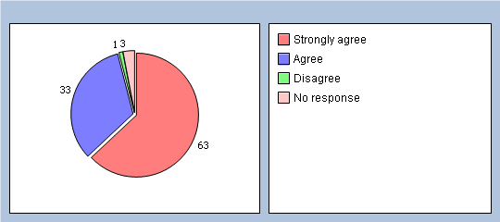

When I present myself at the Reception Desk I am always greeted with a smile and made to feel welcome:
Strongly agree 59%
Agree 38%
Neither agree nor disagree 1%
Disagree 1%
Strongly disagree 0%
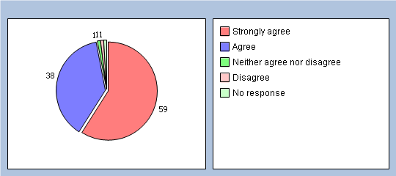

Staff are helpful with making me appointments:
Strongly agree 60%
Agree 36%
Neither agree nor disagree 2%
Disagree 0%
Strongly disagree 0%
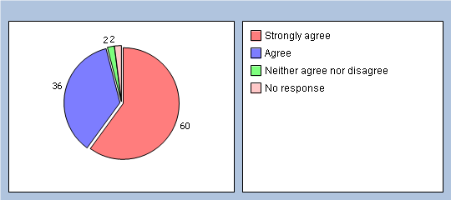

Do you feel that the staff at the Surgery spend enough time listening to you?
Yes 97%
No 2%
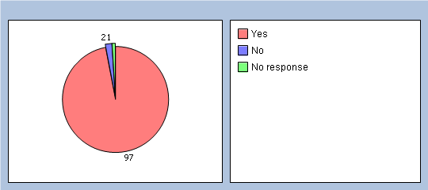

Do you feel that the reception staff are approachable?
Very 89%
Fairly 9%
Not very 1%
Not at all 0%
Don't know/Haven't made contact 0%
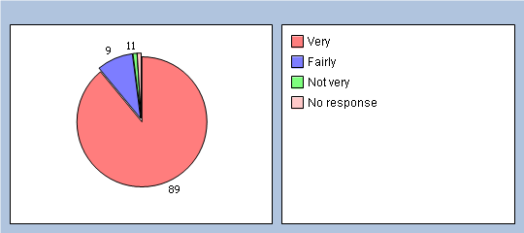

Are the staff able to give helpful advice when needed?
Yes 97%
No 0%
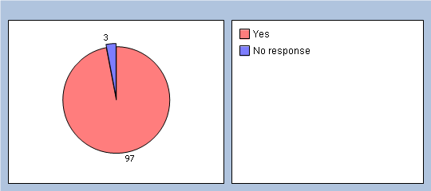

If no please provide comments

Are you able to talk to the staff in private?
Yes 68%
No 9%
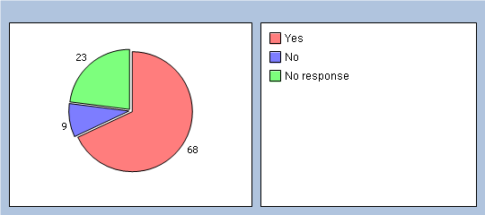

If you have a concern are the staff available to help resolve it for you?
Strongly agree 32%
Agree 50%
Neither agree nor disagree 12%
Disagree 1%
Strongly disagree 0%
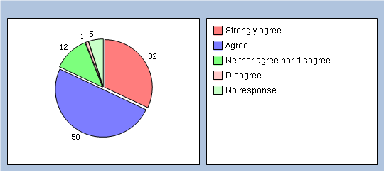

Last time you attended or contacted the surgery did you feel that the staff treated you with care and concern?
Strongly agree 62%
Agree 36%
Neither agree nor disagree 0%
Disagree 1%
Strongly disagre 0%
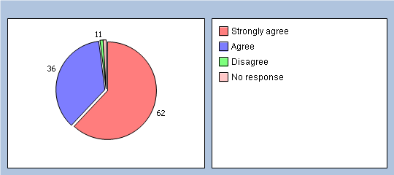

Do you feel that the staff know about the other services offered in the Surgery?
Yes 86%
No 3%
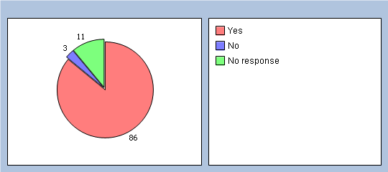

If no please provide comments

Have you ever seen staff behave in an unprofessional manner?
Yes 0%
No 100%
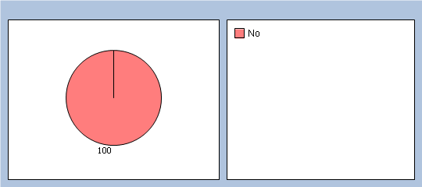

If yes please provide comments

Have you ever had an encounter when you felt that a member of staff was rude to you?
Yes 1%
No 98%
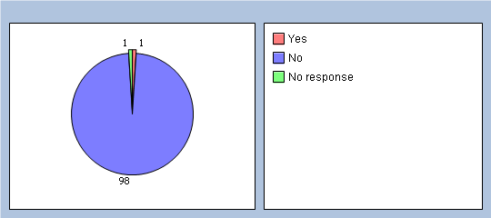

If yes please provide comments

How do you feel about the level of service you receive from the Surgery?
Very good 89%
Fairly good 8%
OK 2%
Not very good 0%
Poor 0%
Unsatisfactory 0%
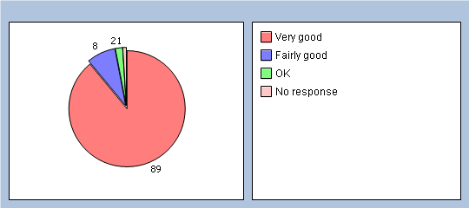

If you could change anything about the staff at the surgery what would it be?
Friendliness 1%
Level of knowledge 5%
Helpfullness 2%
Accessibilty to staff 2%
Nothing 84%
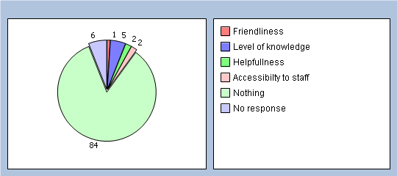

Please feel free to make further comments:

A description of the action which the Surgery intends to take (and if relevant the PCT) as a consequence of discussions with the PRG in respect of the results, findings and proposals arising out of the local practice survey:

It can be seen from the report of the survey that the results of the Attitude of Reception Staff were excellent. After sending the results of the survey to the PRG members the following areas were highlighted for further action to be taken:

- Display a poster advising patients of the opportunity to talk to a member of staff in a private room
- Ensure all staff are aware of all the other services offered by the Surgery and how these can be accessed
- Reduce the information folder that is in the waiting area and create individual and specific information folders
- Be aware that all the information that is passed to the reception staff at Tenbury Surgery, if relevant, should also be disseminated to the staff at Clee Hill
- Visit and explore the appointments system and perhaps changing the system from the current method of being given a number
- Explain to patients the need for the music at the reception desk

An action plan detailing how and when these changes will be made is attached in appendix 4.

A description of the opening hours of the Surgery premises and the method of obtaining access to services through the core hours:

Tenbury Surgery is open Monday to Friday 08.00-18.30. The surgery provides extended hours on a Saturday for both Tenbury Surgery and Clee Hill Surgery patients 08.00-12.15 which enables patients (particularly those who are in full time education/employment) access appointments at the weekends.

Patients can make appointments by presenting at the surgery from 08.00 or by telephoning the surgery from 09.00 hours. The surgery also offers patients the option to ‘see’ available appointments and book them through Emis Access online, this does however exclude open surgery.

We offer a text message reminder service for patients through Mjog to help remind patients when their appointment is.

Clee Hill Surgery is open the following times:

Monday 09.30-10.30
Tuesday 16.00-17.30
Wednesday 09.30-10.30
Thursday Nurse Only 16.20-17.20
Friday 09.00-10.30

All surgeries are ‘open access’ appointments, there are no pre-bookable times for Clee Hill.

A description of the extended hours arrangements the Surgery has entered into and which health care professionals are accessible to registered patients:

Tenbury Surgery offers extended hours for both Tenbury and Clee Hill patients on a Saturday 08.00- 12.15. The appointments offered are both open and pre-bookable. The healthcare professional available for these sessions is one of the GP partners.

Appendix 1

Patient Reference Group - Initial drive for recruitment

We are setting up a PRG and are looking for a representative group from the surgery who would be willing to partake.

Would you be interested in participating in an on-line group to provide feedback on the services you receive here at the surgery and to see if there are areas on which the services can be improved?

There are no face-to-face meetings you would need to attend. What we are asking for is a virtual group who are willing to complete some tick box surveys four times a year. All you will need is a computer and internet access. However, if you are keen to join but are unable to complete the surveys on line then we are happy to post these to you.

If you have any questions or queries you can contact either me or our Practice Manager direct to discuss your concerns.

The first survey will be sent to you in the next few weeks and will ask you to prioritise the objectives to be looked at next year. Following this initial survey we will then contact you again in January with the next survey.

Are there any areas of concern that you have which we can try and incorporate into the surveys/objectives?

If you change your mind you can leave the group at any point, however we would ask that you let us know you no longer wished to partake so we could remove your name from the list to stop you being sent unwanted emails.

Appendix 2

Aims and Objectives

The surgery endeavours to:

- Work together with the representatives of the group

  - Learn more about the patient experience

  - Ensure that services are designed and adapted to respond better to our patient’s needs

  - By working with and listening to patients make long-term improvements

  - Improve the quality of care we provide

  - Identify ways of meeting patients’ needs more appropriately

  - Be able to use information provided by patients to help make improvements

  - Ensure that any changes proposed are agreed by the partners before work begins

Please Note

This is not a forum for personal concerns or complaints to be raised. Complaints need to be handled via the complaints process at the surgery or via the Patient Relations Team at NHS Worcestershire.

Patient Reference Group members are recruited to represent the wider views of patients who are currently registered at Tenbury Surgery and Clee Hill Surgery, not solely the views of the individual.

Patients and carers and their future care and treatment by the surgery or any other NHS service will not be affected by their involvement in this piece of work.

All of the information gathered is stored in a separate database and is not linked to any clinical information or system.

Housekeeping and Terms of Reference

Housekeeping

- The group will be sent an email every three months with a link to the relevant survey.

- The Assistant Practice Manager (APM) will respond to any members query or concerns.

- If a specific issue is wanted to be looked at by the Patient Reference Group then the suggestion will need to be emailed to the APM and put it forward to the other members for approval before submitting it as a survey.

- If you decide that you no longer wish to partake in the group you will need to contact the APM who will deduct you from the mailing list.

- All email addresses of the group members are kept secure and are not shared when bulk emailing.

Terms of Reference

- To provide feedback on behalf of the patients at Tenbury Surgery and Clee Hill Surgery.

- To raise awareness to gaps in service and propose resolutions to help bridge gaps.

- To develop recommendations for service improvement.

- The group will contribute to, and be kept informed of, Practice decisions.

- The group will be kept informed of Practice policies which are amended or introduced. It may express opinions on these policies on behalf of the patients.

- The group will provide feedback and opinions on the educational material relating to healthcare and will provide feedback on the presentation of such material.

- The group will represent the patients at the Practice in seeking to influence local provision of health care.

Patient Reference Group – Frequently Asked Questions

Q Why are you asking people for their contact details?
A We want to talk to people about the surgery and how well we are doing to identify areas for improvement.

Q Will my doctor see this information?
A No. It is purely to contact patients to ask them questions about the surgery and how well we are doing. Your doctor will only see the overall results.

Q Will the questions you ask me be medical or personal?
A They will be general questions about the practice, how we are providing services and what we can do to improve them.

Q Who else will be able to access my contact details?
A No one beyond the practice.

Q How often will you contact me?
A Not very often – we are aiming to complete 4 surveys in the year via the online forum.

Q What is a patient representative group?
A It is a group of volunteer patients who are involved in shaping the services to patients.

Q Do I have to take part in the group?
A No, but if you change your mind, please let us know.

Q What if I no longer wish to be on the contact list or I leave the surgery?
A We will ask you to let us know if you do not wish to receive further messages. If you leave the practice, you will no longer be eligible to remain on the group.

Q Who do I contact if I have further questions?
A Kay Boucker Practice Manager or Amy Louvaine Assistant Practice Manager.

Top of Form

Appendix 3

Prioritisation of Areas to Look At
Survey 1

Q1 Which of these issues would you rate as a priority to look at first?
Environment of Surgery 0%
Attitude of staff 45%
Access of services 36%
Quality of appointments 9%
Provision and display of information 0%
Medication 9%
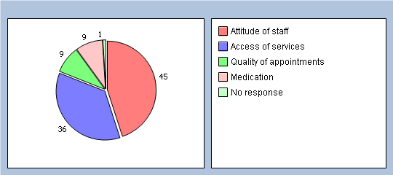

Q2 Which of the same issues would you rate second in importance?
Environment of Surgery 9%
Attitude of staff 0%
Access of services 27%
Quality of appointments 45%
Provision and display of information 9%
Medication 9%
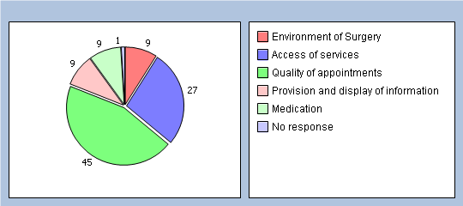

Q3 Which would you rate third in importance?
Environment of Surgery 36%
Attitude of staff 9%
Access of services 9%
Quality of appointments 27%
Provision and display of information 9%
Medication 9%
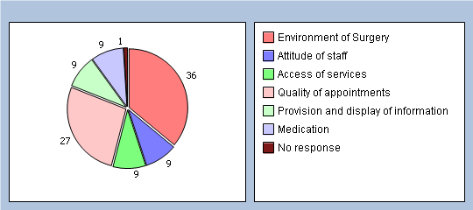

Q4 Which would you rate fourth in importance?
Environment of Surgery 27%
Attitude of staff 27%
Access of services 18%
Quality of appointments 18%
Provision and display of information 9%
Medication 0%
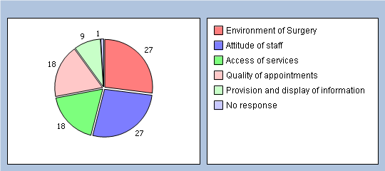

Q5 Which would you NOT consider to be of importance?
Environment of Surgery 18%
Attitude of staff 0%
Access of services 9%
Quality of appointments 0%
Provision and display of information 54%
Medication 9%

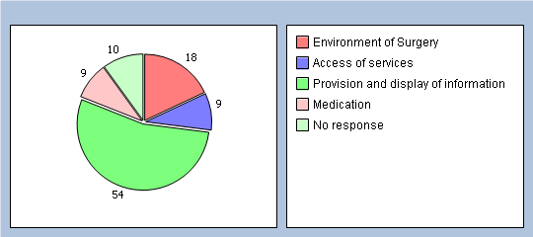

Area for Improvement |  | Recommendation | Action Required | Practice Lead | Timeframe for Change | Comments / Achievements
1. | Advise patients that they can talk to staff in private | Place notices in the Tenbury Surgery waiting areas to advise patients that if they wish to speak to a member of staff in private they can. | - Make a notice advising patients of the option to speak in private  - Place in visible areas of the surgery | Katy Writtle | By the 2nd week in April 2012
2. | Staff Training for both Clee Hill and Tenbury reception staff on other services offered both at the Surgery and through outside organisations | Look at the other services offered by the Surgery and conduct relevant training for the reception staff (Clee Hill and Tenbury) on these other services. This could include bringing in outside agencies to provide training. | - Make a list of other services offered  - Compile relevant training programmes for the staff  - Bring in outside trainers if appropriate eg. Carers association  - Include a staff training session for Customer Services | Amy Louvaine | April 2013 | - Carers Training – completed 07 February 2012  - Organise session with Jo Eggleton from Spire for Staff Customer Services Training  - Organise a session with the local pharmacy  - Organise a session regarding the local community transport
3. | Have a smaller information file in reception | Break down the information file that is currently in Tenbury Surgery reception into more bite sized information relevant to specific areas. | - Introduce to the waiting area a carers file  - Provide individual folders/leaflets for specific services | Amy Louvaine  Katy Writtle | End of April 2012

Continued
4. | Ensure there is good communication between staff at Tenbury and Clee Hill Surgeries | Audit the messages sent to staff to ensure that Clee Hill are being included and are receiving the relevant messages. | - Keep an audit trail of emails and important messages that are passed on to Clee Hill  - Monitor the audit trail to ensure that Clee Hill staff are picking up the messages  - If it is a paper copy message ask for staff to initial the document once it has been viewed. | All Staff | Ongoing
5. | Look at the appointment system | This will be looked at it the next practice survey to gain an insight into patients views on the way the surgery runs the appointment system | - Conduct a practice survey on the appointment system  - Gain an understanding of patients views on the current appointment system  - See if the system could be changed / improved for patients | Amy Louvaine | April – June 2012
6. | Music in reception | Create a sign for patients explaining why the music is on at the reception desk | - Advise patients through a poster why music is played at a low volume at the reception desk | Amy Louvaine  Katy Writtle | April 2012

