Taunton Road Medical Centre

LOCAL PATIENT PARTICIPATION REPORT
2013/2014

- A description of the profile of the members of the PPG

The Taunton Road Medical Centre patient participation group is still a rather new group which are looking to expand its numbers.

The current profile of the group (prior to the survey this year) is as follows:

 | 0-16 | 17-64 | 65+
Number of male pt. group | 0 | 1 | 2
Number of female pt. group | 0 | 5 | 2

The group meet regularly – approximately every 6 - 8 weeks. The Practice Manager, IT and Estates Manager and Lead GP attend. The lead GP rotates, as we have two lead GPs.

Currently, the medical centre undertakes the organisational aspects of the group to enable the members to focus solely on providing feedback, opinions and ideas to the practice. We feel that this is one of the keys to helping support the group.
2. Steps taken by the Provider to ensure that the PPG is representative of its registered patients and where a category of patients is not represented, the steps the Provider took in an attempt to engage that category

As well as the absolute profile above, and how it compares to the practice population, we also review the profile of users of the service. This does support a skew to female patients and towards the higher age bands.

Patient list stats | 0-16 years | 17-64 years | 65+
Patient list | 2760 | 9105 | 2488
% of whole list in this group | 19.2 | 63.4 | 17.4
% of appt time across all | 11 | 57 | 32
% of pt group members | 0 | 0.04 | 0.03

We have recognised for a while that we are underrepresented in the younger age group, particularly those under 25 years of age. The Practice Manager and a representative from the patient group attended Bridgwater College on 5th March 2014 to give a presentation on the need to engage with patients (Appendices 1 & 2). The target audience were the Health and Social Care students and it is hoped that we have encouraged younger patients to join the group. We have tried to increase membership by having a patient group member present whilst running our walk in flu clinics. Other efforts include features on both waiting room plasma screens, information on the website and in the practice leaflet.

As outlined, the patient group numbers shown above were the group at the start of this year.
- 3. Details of the steps taken to determine and reach agreement on the issues which had priority and were included in the local patient survey

As the third year of this work stream, we have an excellent methodology to enable the group to decide which priority to focus on for the current year. The practice and the patient group met on 1st October 2013 to discuss the priorities for the practice.

At the meeting we considered the patient and practice priorities, the public health profile also, recent changes to same day access.

More specifically we reviewed Public Health data considering areas such as deprivation, disease prevalence for long term conditions.

Within the practice we considered our own services: reception, the building as a whole, clinical care, appointment availability and the information available to patients. We also recognised the continual focus and strive for improvement in these areas.

After in depth discussions and debate the group decided the survey would be asking patients on their experience of the duty team – the change made to same day access.

(Component 2)
4. The manner in which the Provider sought to obtain the views of its registered patients

The group considered the most appropriate methodology to collect patient views. This included a discussion on focus groups, interviews, postal surveys and a practice-based survey.

For logistical reasons and to support a high response rate, the group opted to use a one-to-one survey in the first instance and that it would be conducted by the group during the walk in flu clinics.

The one to one survey was followed up four months later by a postal data collection, using the same Duty Team Patient Perspective Survey questionnaire (Appendix 3)

With the direction from the group, the IT and Estates Manager and Practice Manager designed the survey paper. This was fully circulated to the group and all feedback incorporated into the final document. The design favoured a single sheet of A4 and thus the layout was constructed accordingly.

We decided to run the initial survey during the walk in flu clinics as in previous years the walk in clinics have catered for 500 + patients attending the surgery.

Therefore having agreed the format, it was decided the questionnaires would be distributed by the Patient group, to all patients attending the flu clinic on 5th October 2014. For safety and support, practice staff were on hand to assist.

During the walk in flu clinic the patient group member was handing out practice information packs to patients. The packs included the TRMC Newsletter, HealthPoints, Birthday Review information, GPES leaflets, Waste Medicine campaign material, Antibiotics Don’t Work leaflets, TRMC Patient Focus Group information, practice leaflets etc. All group members had a name badge and an explanation of the survey was displayed in reception during the walk in clinic.

Once completed, all surveys were coded on excel and analysed by the IT and Estates Manager and Practice Manager.

The first survey was followed up four months later by a postal survey. Patients who had had Duty Team contact/appointments were randomly selected and the questionnaires returned anonymously

(Component 3)
5. Details of the steps taken by the Provider to provide an opportunity for the PPG to discuss the contents of the action plan in Section 7 (of this template)

The group met again for on 2nd December 2014 to consider the results of the survey and discuss any actions to take.

The results were presented by the IT & Estates Manager. This included a review of the scope of the work and the aim of the survey. See the appendix 1.

The response rate was far higher than anticipated, with the survey having a confidence level of just under 50%

We then had a long discussion about the results and how best to use them to improve patient awareness.

The group decided that the results of the survey should be communicated to all patients at the surgery and this would be done using:

- The plasma screens in the waiting area
- Patient newsletter
- The practice website

The survey and results would be condensed into a single A4 page to ensure the messages are clear and readily digested.
(Component 4)
6. A summary of the evidence including any statistical evidence relating to the findings or basis of proposals arising out of the local patient survey

Q How easy was it to get through to the surgery via telephone?

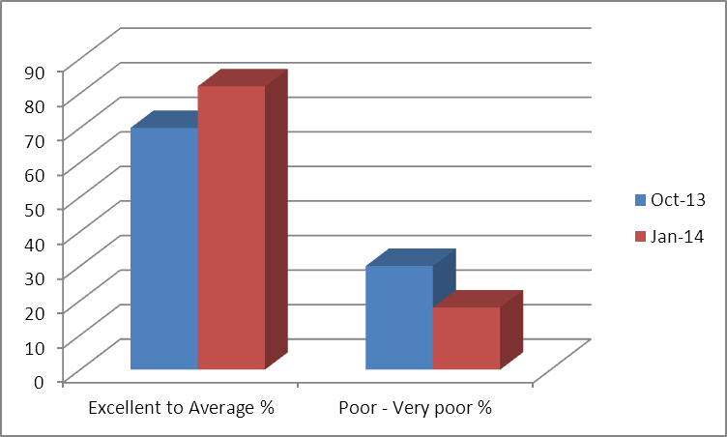

Q How well did the receptionist explain how the duty team consultations work?

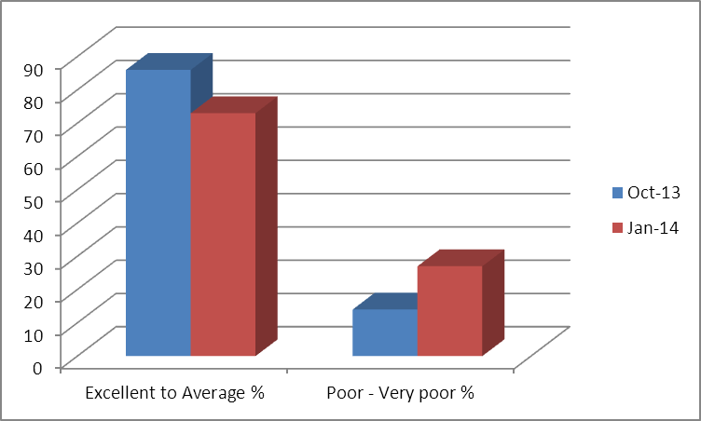

Q How did you rate the overall service?

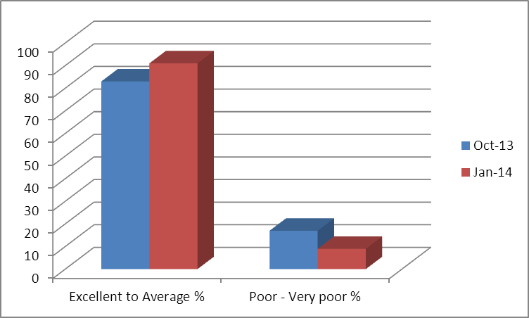

Please see the Appendices 4 & 6 for the complete findings

(Component 4)
7. Details of the action plan setting out how the finding or proposals arising out of the local patient survey can be implemented and, if appropriate, reasons why any such findings or proposals should not be implemented. Include details of the action which the Provider, and, if relevant, the AT, intend to take as a consequence of discussions with the PPG in respect of the results, findings and proposals arising out of the local patient survey where it has participated in the Scheme for the year, or any part thereof, ending 31 March 2014, has taken on issues and priorities as set out in the Local Patient Participation Report

The group decided that there were three main areas of action from the results:
(Component 5)

Findings / Proposals or PPG Priority Areas | Action to be taken (if no action is to be taken provide appropriate reason) | Lead | Timescale | Progress
Telephone Access (additional pressure has been added to the telephone system since the introduction of the new Duty Team system) | Investigate telephone solutions to help resolve current problems.  Ideally upgrade telephone system – to include auto direct facilities and additional lines  More staff to be made available to answer the telephones at peak times. | Practice Manager & IT and Estates Manager | To be completed by January 2014 | New system installed, including additional lines and auto attendant.  Staff rotas reorganised to accommodate patient demand.
Staff Training | Customer care training to be provided for Reception staff.  On-going telephone  Communication skills training. | Drs Speller and Cultan | Ongoing | Training taking place on 27th March 2014 and is to be designed and facilitated by GP Partners
Appointments Online – to help take the pressure off of the telephone lines and enable patients to book appointments when the surgery is closed. | Informatica On-line Appointments programme to be purchased November 2013.  Aim to go live January 2014. | IT & Estate Manager | January 2014 | Went live 20th January 2014 and at the time writing this report, has proved to be very popular with both patients and staff.

8. The opening hours of the practice premises and the method of obtaining access to services throughout the core hours.

The Practice opening hours are 8.00am to 6.30pm Monday to Friday. We are closed over the weekend.

We offer appointments from 6.30pm on Mondays and appointments at 7.45am Monday to Friday, for patients who cannot attend Monday to Friday 8am to 6.30pm and who need a face to face consultation with their a GP.

Patients are able to make appointments by telephoning or visiting the practice or via the website.

Details of the opening hours and all the services offered are available on either the practice web site: www.trmc.co.uk or in the practice leaflet which is given to all new patients and available in reception for all patients.

9. Where the Provider has entered into arrangements under an extended hours access scheme, the times at which individual healthcare professionals are accessible to registered patients.

The Practice offers extended hours from 6.30pm to 7.15pm on Mondays and appointments at 7.45 Monday to Friday. Three GPs are available on Monday Evenings and 2 GPs at 7.45. We also have extended hours available for members of the nursing team both at 7.45am but also after 6.30pm. These are advertised both in our Practice Leaflet, on the website and on the plasma screen in the waiting room.

APPENDIX 1





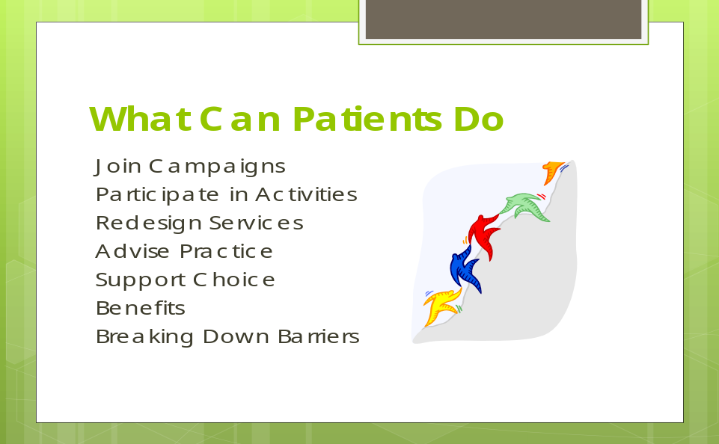

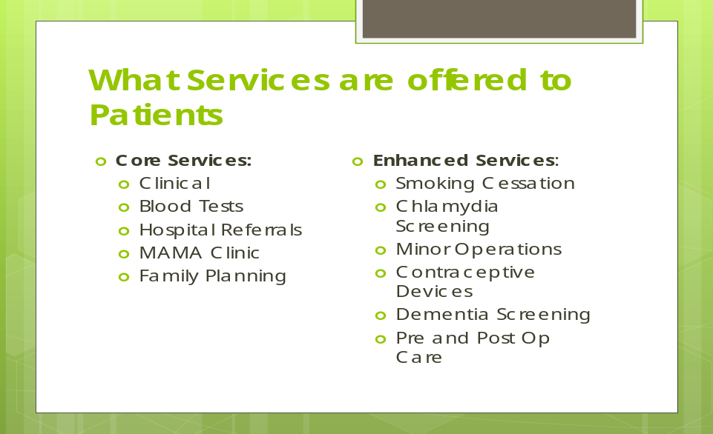



APPENDIX 2



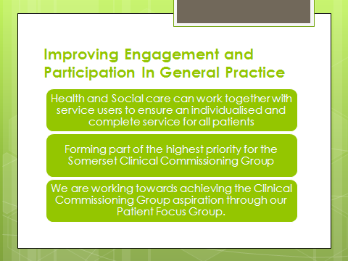



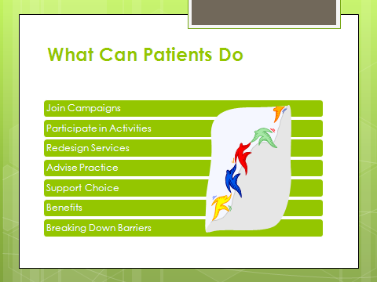

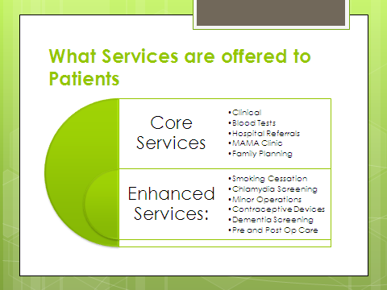

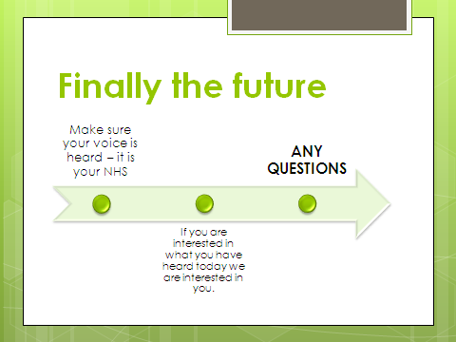

APPENDIX 3

 Taunton Road Medical Centre

DUTY TEAM: PATIENT PERSPECTIVE SURVEY
Background: The Duty Team is for patients who require an urgent appointment which needs to be dealt with before the next available routine appointment. Following a telephone consultation the patient is offered a solution most appropriate to their individual clinical need. This may be medical advice, an appointment with a GP or Nurse, a prescription, an appointment with a HCA for a test etc.,

Please think about the time you had a Duty Team Appointment only and answer each question by putting a ✓ in the appropriate box

1 | How easy was it to get through to the surgery via telephone? | Excellent | Good | Average | Poor | Very Poor
2 | How well did the Receptionist explain how the Duty Team consultations work? | Excellent | Good | Average | Poor | Very Poor
3 | Did the Receptionist explain to you the reasons for the change? | Yes | No
4 | Was your telephone consultation conducted by a GP or a Nurse Specialist? | GP | Nurse Specialist
5 | Were you given a same day emergency appointment? | Yes | No
6 | How do you rate the overall service you received? | Excellent | Good | Average | Poor | Very Poor
7 | What went well?
8 | What could be done better?
9 | Do you have access to the internet | Yes | No
10 | Would you be interested in booking routine appointment online? | Yes | No
About you
Gender:
- Male
- Female

Age band:
- 0-19
- 20-29
- 30-39
- 40-49
- 50-59
- 60-69
- 70-79
- 80+

APPENDIX 4
Taunton Road Medical Centre
DUTY TEAM: AD HOC PATIENT PERSPECTIVE SURVEY
Background: The Duty Team is for patients who require an urgent appointment which needs to be dealt with before the next available routine appointment. Following a telephone consultation the patient is offered a solution most appropriate to their individual clinical need. This may be medical advice, an appointment with a GP or Nurse, a prescription, an appointment with a HCA for a test etc.,

October 2014

Please think about the time you had a Duty Team Appointment only and answer each question by putting a ✓ in the appropriate box

1 | How easy was it to get through to the surgery via telephone? | Excellent  11%) | Good  (32%) | Average  (27%) | Poor  (16%) | Very Poor  (14%)
2 | How well did the Receptionist explain how the Duty Team consultations work? | Excellent  (17%) | Good  (30%) | Average  (39%) | Poor  (11%) | Very Poor  (3%)
3 | Did the Receptionist explain to you the reasons for the change? | Yes  (41%) | No  (59%)
4 | Was your telephone consultation conducted by a GP or a Nurse Specialist? | GP  (84%) | Nurse Specialist  (16%)
5 | Were you given a same day emergency appointment? | Yes  60%) | No  (40%)
6 | How do you rate the overall service you received? | Excellent  (25%) | Good  (33%) | Average  (25%) | Poor  (14%) | Very Poor  (3%)
7 | What went well? See below
8 | What could be done better? See below
9 | Do you have access to the internet | Yes 73% | No 27% | 1 x N/A
10 | Would you be interested in booking routine appointment online? | Yes 62% | No 38%
About you
Gender:
- Male 27%
- Female 73%

Age band:
- 0-19 2%
- 20-29 3%
- 30-39 6%
- 40-49 22%
- 50-59 8%
- 60-69 22%
- 70-79 27%
- 80+ 6%

APPENDIX 5

12-16 Taunton Road, Bridgwater, Somerset. TA6 3LS

Telephone: 01278 720000 Prescriptions: 01278 720005
Fax: 01278 423691 Website: www.trmc.co.uk

GP Partners: Dr G Fergusson, Dr T Taylor, Dr E Morton, Dr S Thio, Dr H Smallwood, Dr T Irvine, Dr R Potts, Dr K Speller, Dr R Cutlan
Practice Manager: Mrs T Pike

6th January 2014
NHS Number 999 999 9573

Private and Confidential

Mrs Twelve Editestpatient

Dear Mrs Editestpatient

Duty Team: Patient Perspective Survey

In July 2013 we introduced a new system (The Duty Team) for patients requiring urgent on the day appointments. Patients are now offered a telephone consultation so an assessment of the appropriate treatment can be completed. This may mean that a patient is treated over the telephone or an appointment is arranged for the same day or in the near future.

I note from your records that you have used this service in the past and I am writing to ask if you would spare a few minutes to take part in a short survey. Our aim is use the results to determine how patients perceive the Duty Team system, in order for us to understand what is working well and identify any changes that may be required.

If you are happy to take part in this survey, please find enclose a questionnaire and a stamped addressed envelope for your use. Please be aware your reply will be completely anonymous.

We would like to take this opportunity to thank you for your co-operation and support, which is much appreciated by the practice team.

Please return the completed survey to the surgery by Friday 31st January 2014.

Yours sincerely

On behalf of the GP Partners at TRMC

APPENDIX 6
Taunton Road Medical Centre
DUTY TEAM: POSTAL PATIENT PERSPECTIVE SURVEY
Background: The Duty Team is for patients who require an urgent appointment which needs to be dealt with before the next available routine appointment. Following a telephone consultation the patient is offered a solution most appropriate to their individual clinical need. This may be medical advice, an appointment with a GP or Nurse, a prescription, an appointment with a HCA for a test etc.,

January 2014

Please think about the time you had a Duty Team Appointment only and answer each question by putting a ✓ in the appropriate box.

1 | How easy was it to get through to the surgery via telephone? | Excellent  (9%) | Good  (32%) | Average  (41%) | Poor  (9%) | Very Poor  (9%)
2 | How well did the Receptionist explain how the Duty Team consultations work? | Excellent  (23%) | Good  (41%) | Average  (9%) | Poor  (23%) | Very Poor  (4%)
3 | Did the Receptionist explain to you the reasons for the change? | Yes  (36%) | No  (64%)
4 | Was your telephone consultation conducted by a GP or a Nurse Specialist? | GP  (91%) | Nurse Specialist  (9%)
5 | Were you given a same day emergency appointment? | Yes  (50%) | No  (50%)
6 | How do you rate the overall service you received? | Excellent  (23%) | Good  (41%) | Average  (27%) | Poor  (9%) | Very Poor  0
7 | What went well? See below
8 | What could be done better? See below
9 | Do you have access to the internet | Yes 73% | No 27% | 1 x N/A
10 | Would you be interested in booking routine appointment online? | Yes 62% | No 38%
About you
Gender:
- Male 36%
- Female 50%

Did not respond 14%

Age band:
- 0-19 0
- 20-29 9%
- 30-39 4.5%
- 40-49 9%
- 50-59 23%
- 60-69 36%
- 70-79 14%
- 80+ 4.5%

