THE SURGERIES
Crescent Bakery
Monday-Friday open 8:30am-6.30pm, Wednesday’s until 8pm.

Appointments (&repeat prescriptions) 226339
Emergencies & other queries 226336
Health Visitor 584813
District Nurse 250516

Healthy Living Centre
Weekdays 8:30-5:30pm

Appointments 548298
Prescriptions 548297
Enquiries 548299

TO SEE THE DOCTOR
We operate an appointments system at 10 or 15 minute intervals. You may make an appointment by telephoning, or by visiting the surgery. We operate a triage system to assess urgent patient requests, every morning from 8am-10.30am.

TELEPHONE ADVICE
If you need advice from one of the medical team, the receptionist will take a note of your details and arrange for the appropriate member of the team to telephone you at the end of surgery.

REPEAT PRESCRIPTIONS
Repeat prescriptions may be ordered by completing the repeat prescription slip, via our website at www.crescentbakerysurgery.nhs.uk
or by post.

Telephone requests are only taken from the elderly or infirm and only between 12.30pm-4.30pm.

THE PRACTICE TEAM
MEDICAL

3 full time Doctors
3 part time Doctors
3 part time Nursing Sisters
1 part time Healthcare Assistant
1 Health Visitor
District Nursing Team
1 Community Midwife

ADMINISTRATION

1 full-time practice manager
1 part-time assistant practice manager
2 part-time medical secretaries
6 part-time receptionists
1 part-time summariser

All the practice staff are happy to answer any questions you may have regarding the Practice. The Medical Team are available to help and advise you on all aspects of health.

OTHER SERVICES AVAILABLE
(Please ask at reception for details)

ANTE NATAL CLINIC
CHILD HEALTH
IMMUNISATION AND BABY CLINIC
(Thursday 12.30-2:30pm Crescent Bakery)
FAMILY PLANNING
MINOR SURGERY & WART CLINIC
ASTHMA CLINIC
DIABETIC CLINIC
SPIROMETRY CLINIC
NHS HEALTH CHECK
NEW PATIENT HE ALTH CHECK
IMMUNISATIONS (including Yellow Fever & other travel vaccinations)
CRESCENT BAKERY
CONSULTATION TIMES
Monday-Friday

The surgery is open from 08:30-18:30 with regular surgeries in the mornings and afternoons

Surgeries run by 6 GPs.

Lunchtime and evening appointments are also available.

HEALTHY LIVING CENTRE CONSULTATION TIMES

Doctors’ appointments are available as follows:

Monday morning 09:00-11:00 – Dr Das
Tuesday mornings 9:30-11:30 – Cameron
Wednesday morning 9:30-11:30 – Dr Das
Thursday afternoon 2:30-4:30pm – Dr Rea
Friday afternoon 2:30-5pm – Dr Trueman

There is a highly experienced nurse at the centre each day between 08:30 and 17:30

HOME VISITS
If you are too ill to attend surgery, a doctor will visit you at home. Please telephone for a visit before 10:30am if at all possible, to enable the doctors to plan their visits.

OUT OF HOURS
(When Surgeries are closed) If you need a doctor urgently please telephone 08454 220220. Your call will be transferred to the Gloucestershire Out of Hours Service who will take your details and pass them to the duty doctor. You will always be able to contact a doctor out of hours.
GENERAL INFORMATION

Crescent Bakery Surgery covers the central Cheltenham area and those surrounding areas up to a radius of 5 miles from the centre of town.

Unfortunately there are no car parking facilities at Crescent Bakery. However, there are car parks within easy walking distance of the Practice. There is ample parking at the Healthy Living Centre.

The Primary Health Care Team at Crescent Bakery Surgery aims to provide you with a comprehensive, friendly and efficient health care service. However, we are aware that, from time to time, there may be aspects of our service that you feel could be improved. We would welcome any comments from our patients in this respect.

Similarly if you have a complaint about the Practice in general, or a member of staff in particular, we operate a Complaints Procedure in accordance with Primary Care Trust Guidelines. In the event of a complaint, you should contact the Practice Manager who will be pleased to discuss any problems with you in person.

For those of you with access to the internet information about the NHS is available from the
NHS Gateway at http://www.nhs.uk

We also have a website available at:

www.crescentbakerysurgery.nhs.uk

WHERE THE PRACTICE IS SITUATED
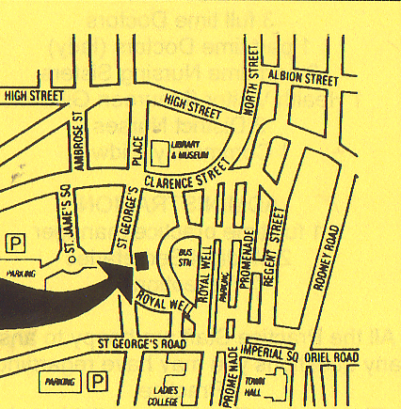
OTHER USEFUL TELEPHONE NUMBERS

Gloucestershire Hospitals NHS Trust (for Cheltenham General Hospital and Gloucester Royal Hospital)
08454 222 222

Cheltenham & Gloucester Nuffield Hospital
(Private)
246500

Social Services Office
532500

Cheltenham Police
0845 090 1234

NHS Direct
0845 464 748

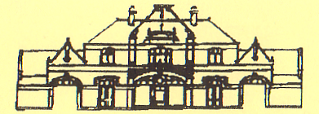
CRESCENT BAKERY SURGERY

St George’s Place, Cheltenham,
GL50 3PN
 226339/226336
&
The Healthy Living Centre,
Cassin Way, Cheltenham, GL51 7SU
 548298/548297/548299

Dr Mark Trueman – Senior Partner
BSc. MBBS. DRCOG. DA. MRCA. DCH.
FP Cert.

Dr Susan Das – Partner
MBBS. MD. DFSRH. MRCGP

Dr Ian Cameron – Partner
MB ChB. MSc. DTMH. DME

