Hightown Surgery

September 2018

Staff Update.

Dr Rachael Urquhart.

We are very pleased to announce that Dr Urquhart became a partner in the practice in June.

Dr Amila Subramaniam.

Dr Subramaniam has completed her time as a Registrar and will remain at the practice as an Associate Doctor.

Dr Stella Rutter.

We welcome Dr Rutter as an Associate Doctor. Dr Rutter trained at Kings College London and registered in 2011.

Reception Team

Dawn, Rachel, Bev and Wendy have joined our Reception Team.

2018 Flu Vaccination Programme

This year, three types of flu vaccine will be used in the flu programme.

* Adjuvanted trivalent for over 65’s
* Quadrivalent for 18 - 65’s in a clinical risk group.
* Attenuated nasal spray for 2 and 3 year olds.

The vaccines recommended for each age group are proven to be the most effective that gives them the best protection against flu.

The 2018/2019 flu clinics will run from September through to November.

All patients who are eligible under the NHS national programme will receive a letter confirming their clinic date and asking them to contact our Reception team to book an appointment slot.

Patient Self-referral services

**Did you know there are a whole range of services that you can access directly without the need for a referral from your GP?**

These include:-

* NHS Child and Adolescent Mental Health Services (CAMHS)
* Talking Space (18+ Mental Health Services)
* Achieve – Healthy Weight Loss Oxfordshire.
* Smokefree Life Oxfordshire
* Oxfordshire Community Bowel and Bladder service.
* Turning Point

Further details and links to these services websites are available on the Hightown website under clinics and services.

Happy 45th Birthday

Hightown Surgery

As the NHS celebrates 70 years we are also proud to have reached our 45th birthday.

Hightown Surgery was founded in July1973 by Dr Michael Sheldon. For the first few months he worked from a porta cabin in the grounds of Horton Hospital. In1977 the practice moved to Oxford Road and then in 1988 we moved to our current location in Hightown Gardens.

**1973 events**

* David Bowie killed off Ziggy Stardust
* Terrorist attacks hit British mainland
* Electricity rationing to businesses
* UK entered the European Economic Community (which became the EU)
* Television classics Last of the Summer Wine, Some Mothers Do Ave Em and Are You Being Served debuted.
* Average house price £9,942
* Thousands strike over pay and prices.

**How things have changed over the years.**

1977 - practice population 2000

2018 - practice population 11,500

1977 - 500 prescriptions processed per month

2018 - 500+ prescriptions processed per week

Prescription requests via fax and Hightown Surgery website ending soon…..

From 1st October 2018 you will no longer be able to order repeat prescriptions via fax

From 1st January 2019 you will no longer be able to order your repeat prescriptions via the Hightown website.

Please sign up for Patient Online Services which is a more secure system.

With Patient Online Services you will be able to continue to order prescriptions online as well as benefit from other features such as booking and cancelling appointments.

To register our Reception team will need to see two forms of identification for you. One should be photographic and one should be proof of address. Our reception team will then give you a letter with your username, password and information about where to log on. Your password can be changed to something that you can remember once you have registered with an online services provider.

STOPTOBER

Stoptober, the 28-day stop smoking campaign from Public Health England, is back from 1st October.

Stoptober has driven over 1 million quit attempts to date and is the biggest mass quit attempt in the country. It is based on research that shows that if you can stop smoking for 28-days, you are five times more likely to stay smokefree for good.

Use PullQuote to excerpt text from the main text of a story to draw a reader’s attention to the page. See page 4 for an example.

\\Pigeon\shared\Jennifer\word clipart\JAZZ.WMF



[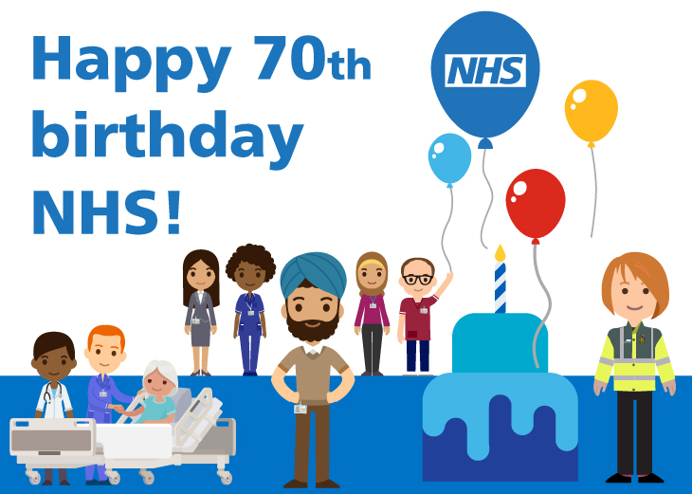](https://www.england.nhs.uk/nhs70/)

Happy 70th Birthday NHS

|  |  |
| --- | --- |
| Inside This Issue | |
| 2 | 2018 Flu Campaign & Self-referral services |
| 3 | Car Park works – repeat prescription ordering – Health Campaigns |
|  |  |
|  |  |
|  |  |





Car Park Works

We apologise for the recent reduced spaces and odour in our car park. This was due to work on the brook being completed on behalf of Sainsbury’s.

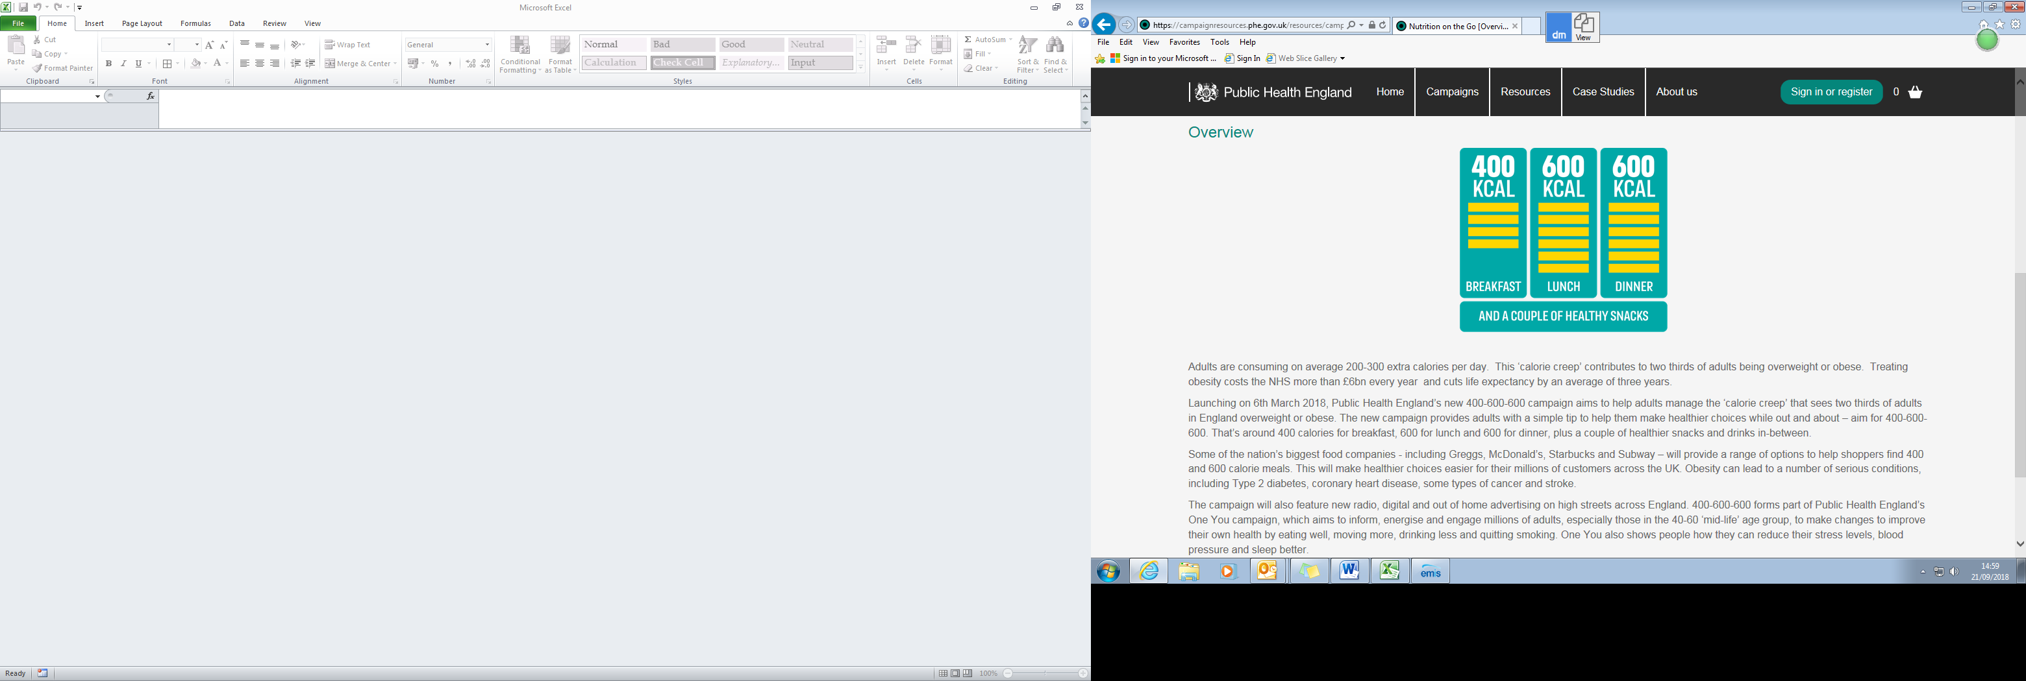

Adults are consuming on average 200-300 extra calories per day.

This ‘calorie creep’ contributes to two thirds of adults being overweight or obese.

Treating obesity costs the NHS more than £6bn every year and cuts life expectancy by an average of three years.

Public Health England’s campaign provides adults with a simple tip to help them make healthier choices – aim for 400-600-600. That’s around 400 calories for breakfast, 600 for lunch and 600 for dinner, plus a couple of healthier snacks and drinks in-between.



