Chorleywood Care generosity helps fund improved Asthma diagnosis for Gade Surgery Patients
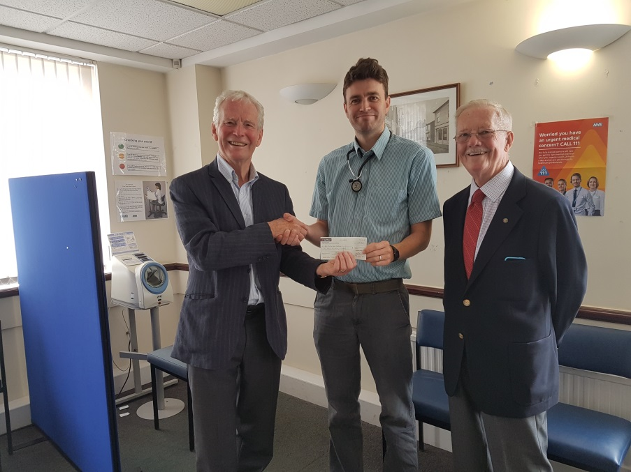
Seen here, Partner Dr Tom Dewhurst receives a cheque for £1000 from Peter Briscall, Chairman of volunteer group Chorleywood Care, alongside Treasurer John Parton

In November 2017 NICE (National Institute for Clinical Excellence) issued new guidelines for the diagnosis and monitoring of patients with asthma including a recommendation to offer a FeNO test as part of the testing and monitoring of adult patients.
FeNo is a simple breath test measuring levels of Nitric Oxide being produced in a patient’s airways. Nitric oxide is produced naturally in the airways but in an asthmatic patient the levels are higher as a result of inflammation.
The test is quick and simple to perform and the results are easy for the clinician to interpret. For a patient already diagnosed and on treatment, the system offers improved monitoring of current medication. However the equipment needed is currently expensive.
Fortunately, a timely approach by Peter Briscall on behalf of Chorleywood Care members, resulted in a generous contribution towards the cost of the first monitor at the branch surgery. The unit has now been purchased and, following staff training, will be put to good use.
The Partners would like to thank the generosity of Chorleywood Care who regularly volunteer to transport elderly and frail patients to hospital and GP appointments. Previously the group have donated funds for the purchase of a waiting room BP unit at Chorleywood surgery.
Anyone interested in volunteering to support the group, either as a driver or in a support role should telephone on 01923 284440 or for more information check their website at chorleywoodcare.org.uk

