The National Health Service provides most health care to most people free of charge, but there are exceptions. The NHS does not employ GPs, it has a contract with them to provide NHS general medical services for their patients. Sometimes, however, GPs are asked to provide additional services, which fall outside their contract with the NHS, and in these circumstances, they are entitled to make a reasonable charge for providing them. | Hickings Lane Medical Centre  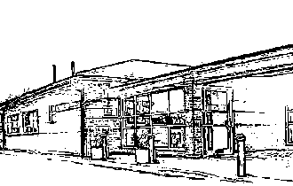  Fees for Non-NHS Work
Certificates and Forms  Passport  Holiday Cancellation  Fitness to attend/Participate  Insurance Claim Form (Accident or sickness)  Private Medical Insurance Claim or Pre-Treatment Form  Private Sick Note  Freedom from infection certificate  Child Minder Forms  Simple Letter (To Whom It May Concern)  Standard Letter | £15.00  £25.00  £25.00  £25.00  £25.00  £15.00  £20.00  £20.00  £10.00  £20.00
Medicals and Reports  HGV/Taxi/PSV Medical Examinations  Reports (Solicitors/Employers)  Seat Belt Exemption | £80.00  £80.00  £50.00
Travel  Fitness to fly/travel | £25.00

